Community Impact Report 2022
Pūrongo Whakaaweawe Haporia

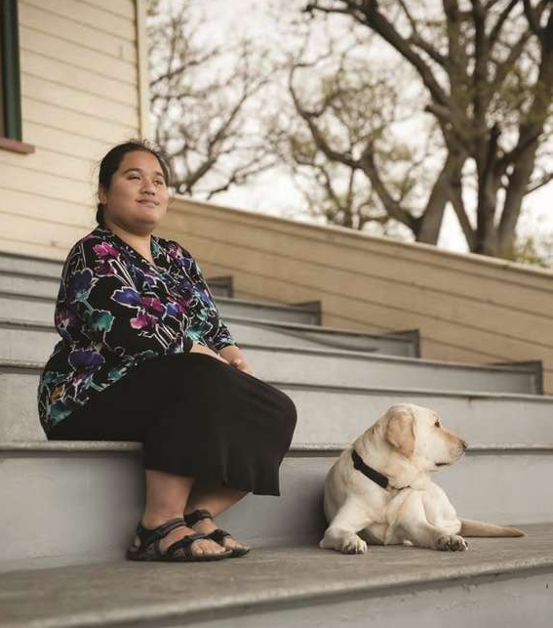

Adapted in 2022 by Accessible Formats Service, Blind Low Vision NZ,
Auckland
Total print pages: 54
Total large print pages: 87

Notes for the Large Print Reader
Print page numbers are indicated as:
Page 1
Main text is in Arial typeface, 18 point.
Headings are indicated as:

Heading 1

Heading 2

Heading 3

Omissions and alterations
Some images have been omitted.
The typeface has been enlarged in most of the diagrams.
Transcriber's Notes
Some page layouts have been edited for clarity.
Transcriber's notes are indicated with [TN] and are in a separate box where possible.

Page 2

Community Impact Report 2022

Pūrongo Whakaaweawe Hapori
Nāu te rourou, nāku te rourou,
ka ora ai te iwi.
With your food basket and my food basket the people will thrive.

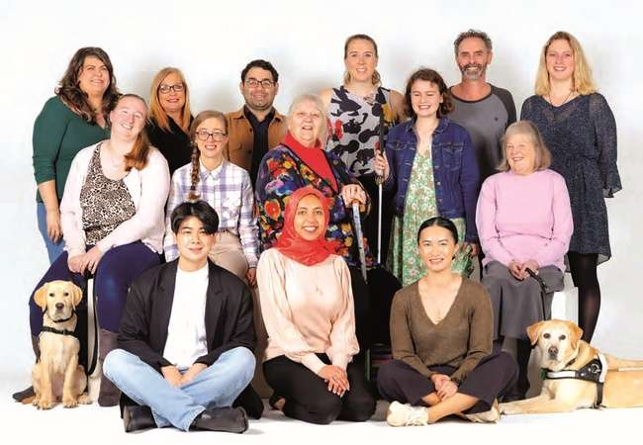

Page 3

Nga kai oroto

Contents
Section | Print Page | Large print page
The Year in Review | 4 | 3
Who we help | 8 | 8
A snapshot of blindness in Aotearoa | 10 | 12
Our Services | 12 | 16
Support Grants | 13 | 17
Our People | 14 | 19
Fundraising Highlights | 16 | 22
Volunteer Highlights | 20 | 29
Policy and Advocacy Highlights | 24 | 35
Guide Dogs Services Highlights | 28 | 41
Library Highlights | 34 | 53
In Gratitude and Gifts in Wills | 40 | 62
Financials | 42 | 69
The Board | 44 | 73
Executive Leadership Team | 46 | 77
Page 4

Pūrongo Arotake i Tēnei Tau

The Year in Review
Kia ora,
Blind Low Vision NZ continues to support kiwis who are blind, deafblind or have low vision to live the life they choose. It's thanks to our generous donors, our passionate volunteers and our enthusiastic staff that this is all possible.
It has been another busy year and we're proud to say our client base has increased to 15,049 clients. We're excited to see that our brand awareness, campaigning and partnerships have helped us to reach a younger demographic with an increase of 9.5% of new clients under 65 years of age.
We have widened our reach through partnerships and third party providers, allowing us to connect with and provide services to more people, across more of the country, especially those in rural parts of Aotearoa.
This reflects and aligns with our ongoing key priorities, as outlined in our 2020−2024 Strategic plan, Our Vision, Your Future: Independence, Educate and Equip, Social Inclusion and being a For Purpose Organisation. We have been able to help more people than ever before to be independent, by educating and equipping them with the tools and resources to be successful. Empowering clients opens many doors and supports them on their identified goals and how they choose to participate in society. Our clients are our organisation's purpose, and we continue to be people centred, knowledge based, adaptable and to drive positive change.
Our South Auckland office went through a major revamp this year, and alongside Fale Kotuku, our new indoor Mobility Training facility, and existing Guide Dog facility, this will soon be the largest Blind Low Vision NZ campus in New Zealand.
The South Auckland location sets the new standard for a collaborative working environment with an open plan office area, meeting spaces and areas for service delivery. In addition, and to be completed before the end of 2022, it will also be home to an exceptional blind sports arena with built-in seating and changing rooms. The arena will be available to use for events across our stakeholder groups, and will also provide an opportunity to bring our donors into direct contact with our work—a critical component of our funding. Overall our South Auckland complex
Page 5
will provide a new and modern space for our clients to receive our services, attend events and make use of the recreation centre. It will be a place where people can gather and connect with one another.
April 2022 saw the launch of our Guide Dog Kennel Build capital appeal, asking our generous supporters and the public of New Zealand to help Blind Low Vision NZ to raise $6 million to ensure we can build a new and fit-for purpose kennels for our guide dogs in training. Our current kennels are now 35-years-old, have reached their end of life, and unfortunately are no longer conducive to the optimum development of our guide dogs in training. Through donations received to date we have reached $4 million. Although we are getting close to our target, we still need the generous support of our donors in reaching the full amount required to build these important kennels for our dogs.
The build of our new kennels is part of our holistic approach to breeding, training, and graduating successful guide dogs. From continually reviewing our processes and protocols, to keeping up with international best practice standards. Our kennel rebuild is the next step in the shaping of the future success of guide dogs across New Zealand, graduating more successful dogs and ensuring our service is amongst one of the best in the world. Ultimately, building new kennels for our guide dogs in training will ensure happier, healthier dogs who are ready to take on the role of providing independence to people who are blind, deafblind or have low vision across the country.
This year Blind Low Vision NZ implemented the implemented a 4 Day Working Week (4DWW). After a successful six-month trial, staff reported they were able to maintain productivity and in many cases improve productivity, in addition to which the majority of staff who participated felt that the 4DWW had improved their work/life balance. With an overwhelming majority of staff supportive of continuing the initiative, combined with the maintained or improved productivity and increased work/life balance, we decided to continue with the change and are one of the first organisations in Aotearoa to do so. With an extra day during the week, staff can try
Page 6
new things that they've always wanted to do, catch up with friends and whānau or get a head start on daily life errands. Studies have shown that when a staff member's wellbeing is supported by their employer, they are more successful in their jobs. Which, as a result, means that the support we provide to our clients can only benefit.
In October 2021, Eye Health Aotearoa (EHA) launched their first Love Your Eyes campaign. The EHA Trust is the unified voice for the New Zealand eye health sector. It is estimated that 180,000 kiwis are blind, deafblind or have low vision, but we expect those numbers to increase to 225,000 by 2028. The Love Your Eyes campaign aimed to spread awareness and educate kiwis about the importance of eye health care. The event was held at Land's End Bluff with a panel of speakers, where over 60 people streamed in. It was an internationally recognised success. The International Agency for the Prevention of Blindness (IAPB), who work in partnership with the World Health Organisation to reduce blindness globally, invited EHA to become a member, resulting in Aotearoa now being part of a global conversation.
The passionate people at Blind Low Vision NZ continue to advocate for people who are blind, deafblind or have low vision. Seeing our clients being able to participate how they choose in society makes all the hard work worth it. Each year we find ways to push the boundaries, but we can't do it alone. It's with the support of our volunteers, donors and the general public of Aotearoa that we can achieve an inclusive and accessible Aotearoa.
We've got another big year ahead and look forward to sharing this journey with you all.
John Mulka
Blind Low Vision NZ
Chief Executive
Judy Small
Royal New Zealand Foundation of the Blind (RNZFB)
Board Chair

Page 7
Me mahi tahi tātau hei whakapakari
te hunga kāpō.
Work together to give strength to people who are blind, deafblind or have low vision.
Page 8

Ka āwhina mātou i a wai

Who we help
Blind Low Vision NZ in numbers
TN: Continues on next page.

Clients by age
0–21 | 8%
22–44 | 12%
45–64 | 16%
65–75 | 12%
76+ | 52% | 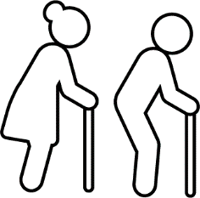

Clients by region
Upper North | 3191
Auckland | 3790
Lower North | 2624
Wellington | 1360
South Island | 1955
Christchurch | 2129
Total | 15,049

Total clients who received services in FY22:  7351 | 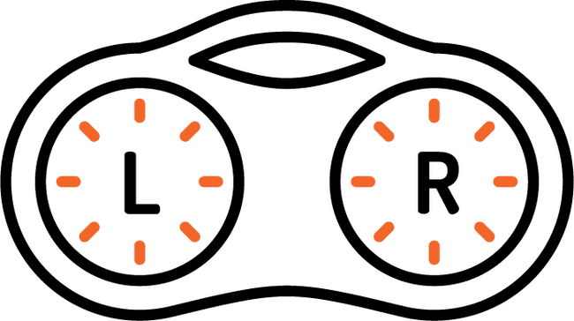
We received 27,712 calls in the last year.
Books in our accessible library: 36,000
Total Library loans = 358,000  All types books, magazines and newspapers. | 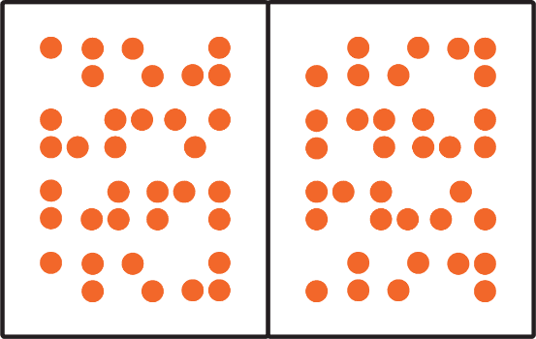
Page 9
Kahore e Mutunga ki te ora.
Life without limits.
Page 10

He tīpako matapōtanga i Aotearoa

A snapshot of blindness in Aotearoa
Some people assume that blindness, deafblindness or low vision is rare and that it could never happen to them or someone they love. But it's more common than you might think.
Every 2.5 hours someone in NZ develops blindness.
4% of Kiwis are currently living with blindness or low vision. | 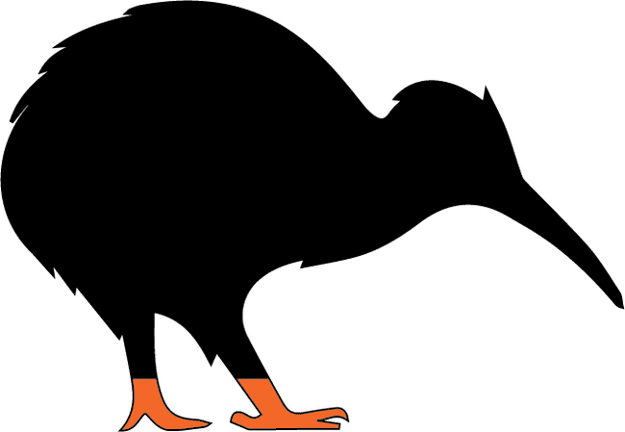
1 in 5 people will experience blindness, deafblindness or low vision in their lifetime.
50% of sight loss  is preventable,  25% of sight loss  is treatable. | 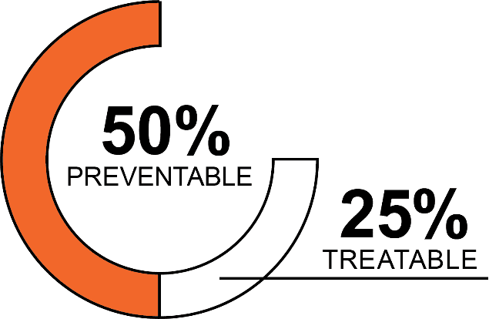
By 2030 the number of Kiwis with blindness, deafblindness or low vision is likely to increase by over 25%. | 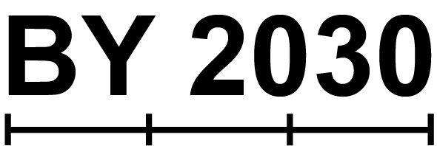
Over 70% of Kiwis aged 40–49 do not have regular eye examinations. | 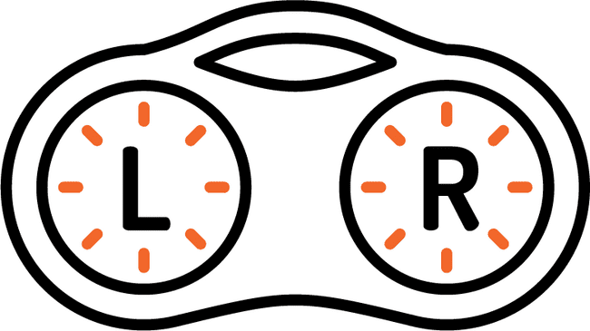
Cataract surgery has good success rates, but leads to vision loss in 5% of cases.
The number of Kiwis with age-related macular degeneration is projected to increase by 70%.
Page 11
40+: An estimated 2% of Kiwis over 40 have glaucoma. Half of them are unaware of this.
57% of working age people who are blind, deafblind or have low vision are currently in work compared to 77% of the NZ working-age population.
74% of Blind Low Vision NZ clients live in their own homes, either alone or with a partner and/or children. | 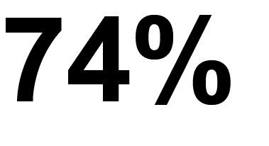
Every day an average of
9 New Zealanders turn to
Blind Low Vision NZ for support.

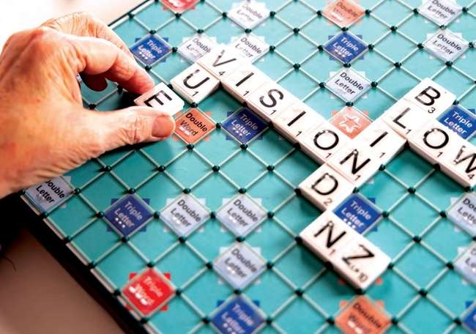
There are also many people in Aotearoa who (sometimes unknowingly) have diseases that may lead to blindness, deafblindness or low vision. These diseases are often treatable if diagnosed in time, which is why raising awareness is an important part of what we do at
Blind Low Vision NZ.

Page 12

Ā Mātou Ratonga

Our Services
TN: Icons in the print are omitted.
- Employment readiness for career stability
- A wide range of mobility services to help you get around
- Emotional support for your wellbeing
- Learn skills to help retain your independence
- Support & community for growth and social inclusion
- Accessible library for knowledge enrichment
- We offer a range of specialised services for Māori, Pasifika, youth and children
- We provide support for businesses around accessibility
- We provide support and assistance for your technological needs
- Our guide dogs help people get around safely and confidently, they also make wonderful companions
Page 13

Support Grants
Blind Low Vision NZ administers a number of funds that provide additional financial help and support to people who are blind, deafblind or have low vision. If you need financial assistance meeting the costs of vision rehabilitation, or tertiary education we may be able to help.

Sir Arthur Pearson Memorial Fund
The Pearson Fund can provide grants to applicants for a range of items that support with the additional cost of being blind, deafblind or have low vision.

Kindred Sharp Children's Trust
This Trust provides grants to children aged 15 or below (up to age 16) who are registered with Blind Low Vision NZ. Grants may be approved for the funding of equipment, improving quality of life, or personal development programmes. Henderson Fund This Trust seeks to provide assistance for those who are blind, deafblind or have low vision up to the age of 21 years in the New Plymouth, Wanganui, Manawatu, Wairarapa and Wellington areas.

Henderson Fund
This Trust seeks to provide assistance for those who are blind, deafblind or have low vision up to the age of 21 years in the New Plymouth, Wanganui, Manawatu, Wairarapa and Wellington areas.

The Shirley Owen Trust
If you are a client of Blind Low Vision NZ, and you are learning a classical instrument, or having singing lessons, you can apply for some funding assistance through the Shirley Owen Trust.

Oppenheim Tertiary Education
Trust Fund
The Oppenheim Trust Tertiary Education Fund for those studying in 2023 is now open for applications.

Forsyth Fund
The Forsyth Fund welcomes applications for financial assistance to clients of Blind Low Vision NZ who live within the boundaries of The Waikato Regional Council, or The Waikato District Health Board.
For more information about our funds and trusts please contact 0800 24 33 33 or email us at pf@blindlowvision.org.nz
Page 14

Ō Mātou Tāngata—ngā Kaimahi o Kāpō Matarehu Aotearoa

Our People

Blind Low Vision NZ Employees

Staff:
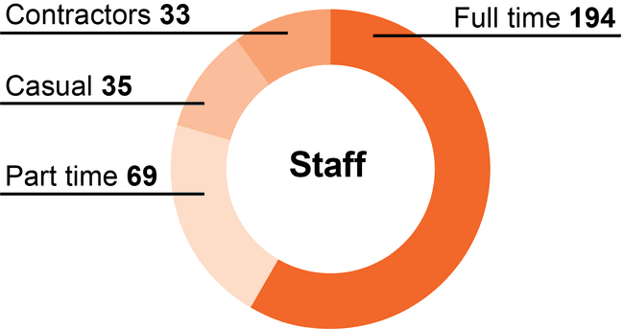

Gender:
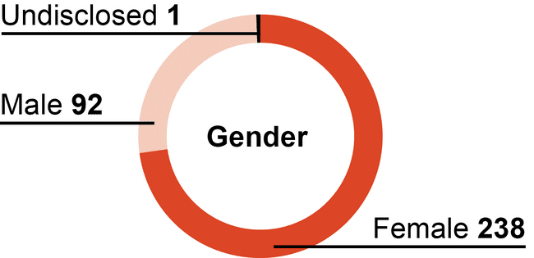

Client:
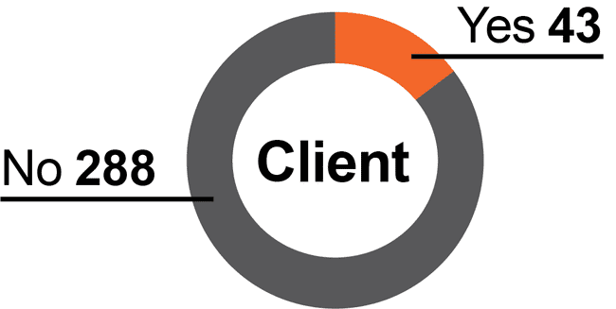

Age:
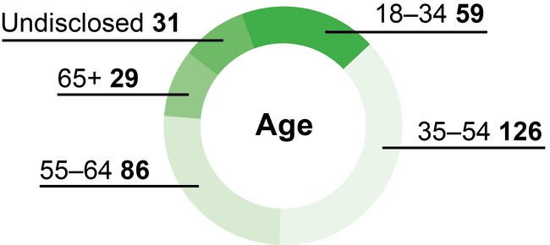

Ethnicities:
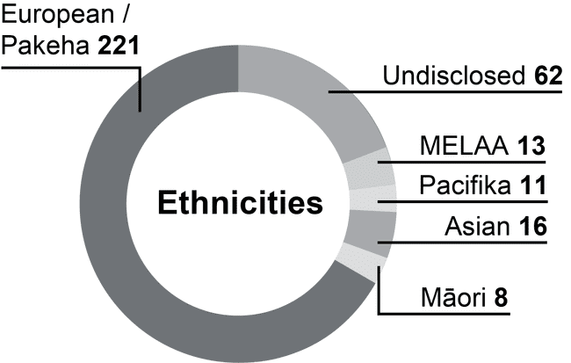
Page 15
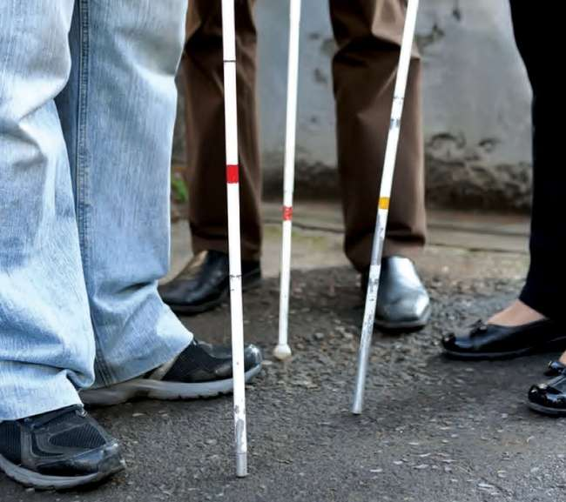
Every year we check in with our staff to see how they're going. This year we did two surveys, one for employee engagement and another about the implementation of the
4 Day Working Week (4DWW). We're pleased with the results of both surveys.

Employee Engagement Survey
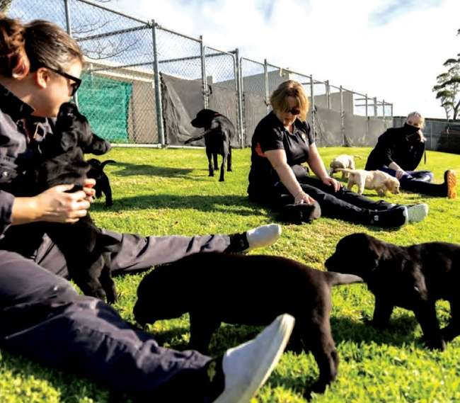
- 77% were happy with work and life blend
- 93% of staff know what they need to do to be successful in role;
- 86% of respondents know how their work contribute to the goals of Blind Low Vision NZ;
- 86% were able to arrange time out from work when they need to.

4DWW Survey
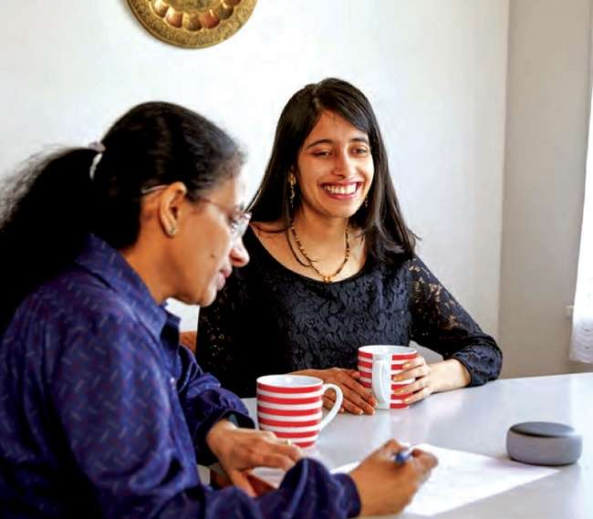
- 86% of respondents were very supportive of 4DWW 86% of respondents felt that 4DWW had improved their work/life balance;
- 82% of respondents found that 4DWW was effective in improving employee satisfaction;
- 85% of respondents were supportive of continuing the 4DWW initiative.
Page 16

Hiranga Mahi Moni

Fundraising Highlights
The Fundraising department is Blind Low Vision NZ's main source of income, and we are always looking at ways to improve from the previous year. Our team is passionate about raising funds to be able to support Kiwis who are blind, deafblind or have low vision.
We had great success this year with the Guide Dog Puppy Appeal, where we surpassed our target of $263,000 and reached $524,498. We understand that times have been tough and many are struggling with the increased of cost of living, so we are so grateful to the generosity of the New Zealand public who continue to donate to Blind Low Vision NZ.

Guide Dog Kennel Build Appeal
In March 2022, we also launched the Guide Dog Kennel Build Appeal, a much-needed campaign to invest in the future of guide dog training.
Why? There are currently around 180,000 people in Aotearoa who are blind, deafblind or have low vision, but this is expected to increase to 225,000 by 2028. Those who have a guide dog often talk about how the relationship changed their lives for the better, how their guide dog gave back their independence and enabled them to live the life they chose.
To meet the growing need and reduce the current two-year waiting time for a guide dog, we urgently need to build new kennels.
The new kennels will provide a state-of-the-art home for our guide dogs and give them the best chance to successfully complete their training. Training a guide dog is one of the most intensive programmes of all service dogs. Sniffer dogs within customs for example, are trained to use their natural instincts to do their job. But guide dogs are trained to go against some of their natural instincts, such as sniffing the ground, scavenging and becoming distracted by other dogs.
Blind Low Vision NZ Guide Dogs currently has a world class breeding centre, and the new state-of-the-art training centre will provide real-life scenarios for guide dogs in training, such as negotiating a train platform, lifts and escalators—all within the Guide Dogs Centre. There will be physiotherapy room to exercise the dogs to build up their muscle, balance and stability. This is important when they are out in the community guiding their handler. It will also be used to rehabilitate dogs that have been sick or injured.
Page 17
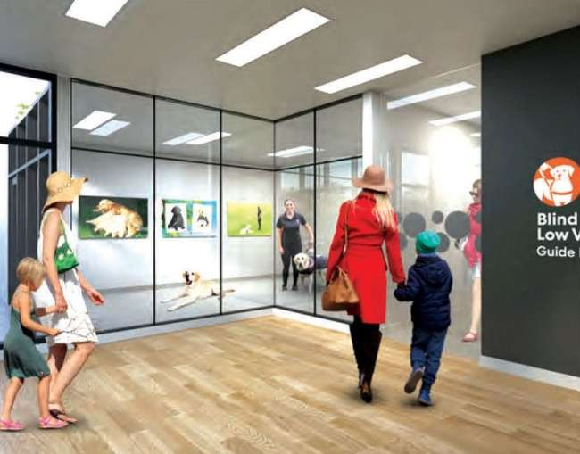
Most importantly, a separate isolation pod will be built to house sick dogs. This is critical to stop the spread of Kennel Cough, a respiratory disease that's highly infectious and very common throughout the community.
As you can imagine, this is a substantial project, the total cost being $6 million. 100% of the funding for the kennels will come from the community and generous Blind Low Vision NZ donors.
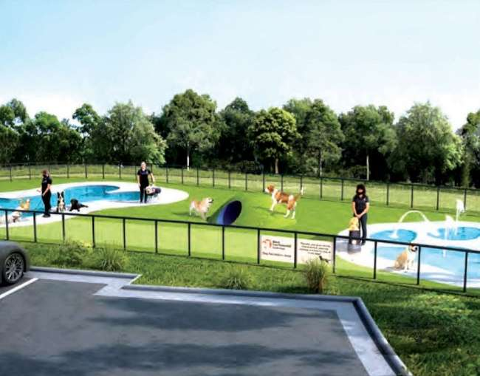
We have asked like-minded New Zealanders
to make a gift to ensure this important project becomes a reality. To date, over half the funds have been raised.
We all are very excited by this project, as the kennels have been designed to ensure the dogs have the best opportunity to become successful guide dogs. In turn ensuring a life of independence for New Zealanders, a life without limits.
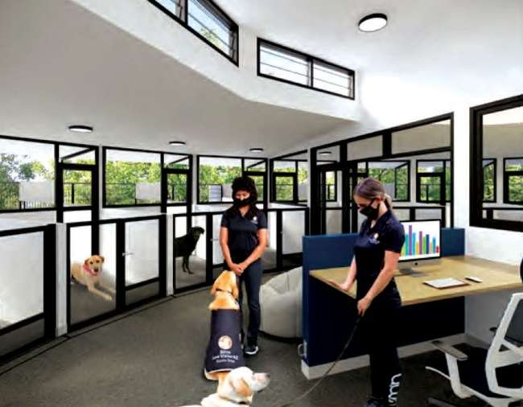
Page 18
Fundraising Highlights

I te Hapori

In the Community

Pinehurst School Fundraiser
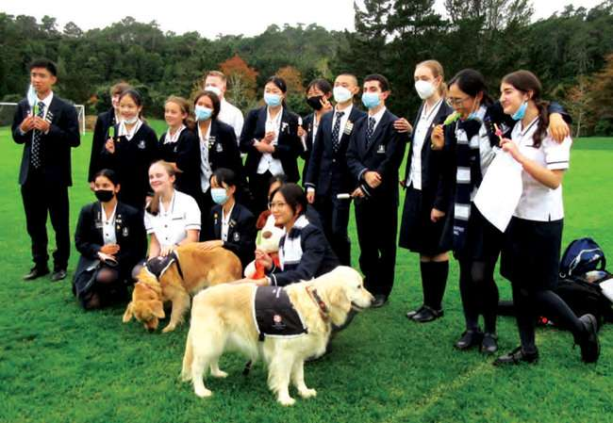
Pinehurst School reached out to Blind Low Vision NZ, they were keen to connect with us and run a fundraiser with the Student Council.
They wanted to educate their students on guide dogs, as well as create an event to help student wellbeing and give everyone a fun afternoon. The school had a connection to Blind Low Vision NZ as one of their students is blind.
Blind Low Vision NZ organised for two ambassador guide dogs (Lady and Lottie) and their handlers to attend the school's fundraising event. A Blind Low Vision NZ booth was set up with balloons, plush dog toys, information postcards and spotty socks. The students hosted and drew a raffle on the day for a hamper prize pack.
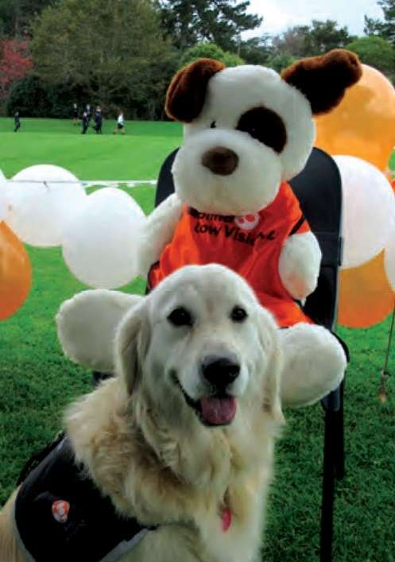
The Student Council had thought of everything for the day. They provided the visiting ambassador dogs and their handles a gazebo for shelter from the sun and rain. The organising team also had the forethought to get an EFTPOS machine and petty cash to help collect card donations as well as cash.
The plushie dogs sold out and all the spotty socks were given out. The students successfully raised $720.95 from just a one-hour lunch break! An amazing result from all involved.
Page 19

SAMOM Community Trust
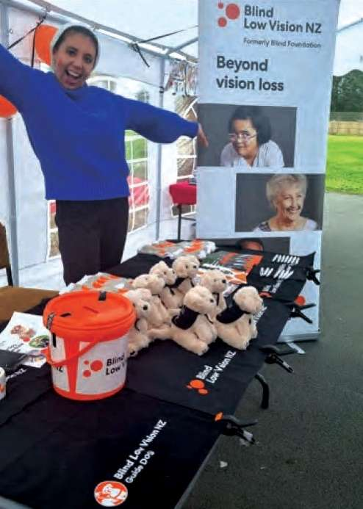
SAMOM (Smiths Ave Mind Over Matter) is a local Community Hub located at the heart of Smith Ave Reserve. It's a co-designed project led by local Stakeholders of Papakura and Auckland Council for 20 years. They organise community-focused projects and events to create a welcoming and safe place for everyone to connect.
To celebrate the marking of Matariki, SAMOM put together an event for the whole community to join. The event celebrated Māori culture through food, craft, arts, singing and wonderfully made poi dance. The two meaning of Matariki are: Mata ariki; "eyes of good", and Mata riki; "little eyes", inspired the people of SAMOM to support Blind Low Vision NZ. They extended the invitation to one of our guide dogs for the community to meet.
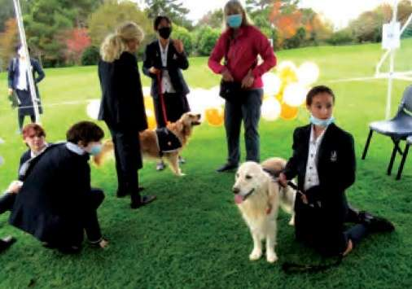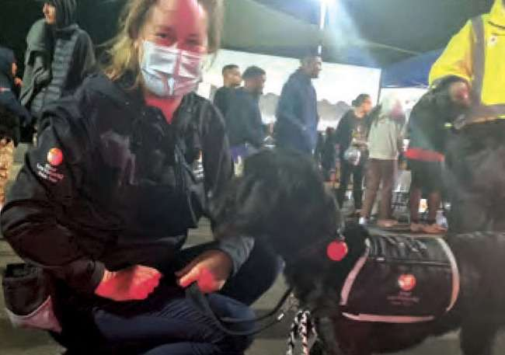
Guide dog puppy, Lily, attended the event and received a heartwarming welcome. Aimee and Kawkab from Blind Low Vision NZ spent the evening sharing and educating people about our services and support. Meanwhile Lily was busy enjoying all the attention and posing for photos. Everyone loved it when she joined the
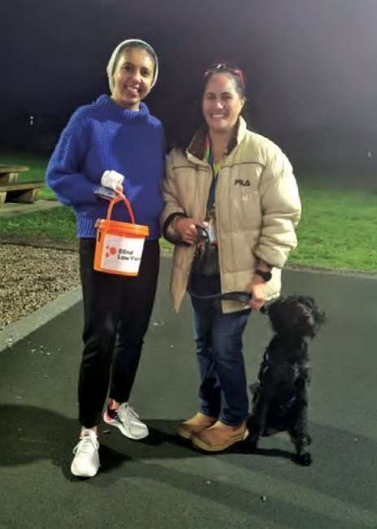
poi dance and the event raised a total of $128 in gold coin donations.
It was a beautiful relationship to build with this small community celebrating a special day and has great potential to grow in the future.

Page 20

Hiranga Tūao

Volunteer Highlights
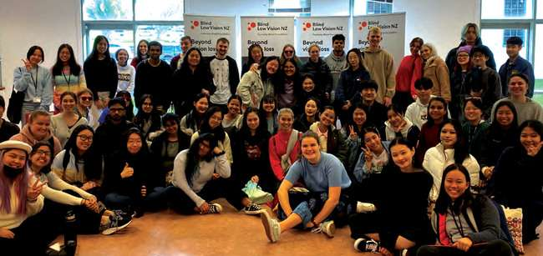
Volunteers are a part of Blind Low Vision NZ's history. We are building upon 132 years of volunteering foundation, by offering a range of innovative types of volunteering opportunities. We know just how invaluable our volunteers are and the role that they play within the organisation.
We connect with diverse communities and have seen how effective it is to have multi-lingual abilities within our volunteer group and how this has positively impacted our clients. The future of volunteering lies in how we connect with our communities and the vast array of skills, life experience, beliefs and perspectives that our volunteers bring with them.

Blind Low Vision Week
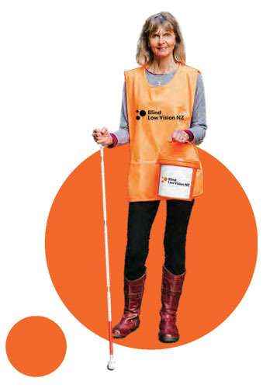
On 25 September 2021, a group of AUT students came to Awhina House in Parnell and volunteered with a variety of fundraising perpetration for the upcoming street appeal—Blind Low Vision Week. Some fundraising staff and clients joined these students to help organise each activity. It was a day full of peeling old stickers of hundreds of buckets, envelope stuffing, and a laugh or two. These students gave Blind Low Vision NZ their time to help create a successful street appeal.
Page 21
The Volunteer department has aligned to Blind Low Vision NZ's values and key priorities. This is reflected in how our teams connect with our volunteers and clients. We are taking steps to future proofing the Volunteer function, by building relationships with tertiary institutions, such as AUT. This will widen our reach to the youth of Aotearoa. We have also been engaging with external organisations, as well as migrant and ethnic communities. The skills and perspectives of our volunteers will help us in so many ways, i.e. Multi-lingual volunteers.
Blind Low Vision NZ volunteers are a big part of the organisation. We simply could not help all of the people we help without them. From providing virtual volunteer support to working with AI technology. We have identified the importance of accurate fit-for-purpose data reporting and collation, proactively engaging with our diverse communities, collaboration, effective communication and training. We are committed to having a lasting, meaningful volunteer function within our organisation.
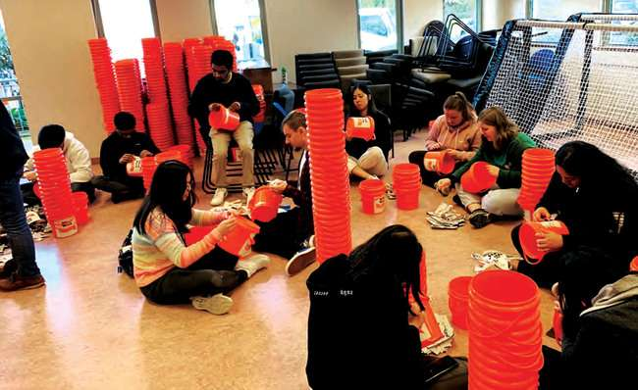
The future of Blind Low Vision NZ's volunteering lies within our organisation's ability to successfully incorporate the following:
- Organisational values
- Key priorities
- Collaboration
- Local community engagement
- Accurate data collection and reporting
- Onboarding and training
A big mihi to all of our wonderful volunteers who give up their own time to help people who are blind, deafblind or have low vision.
Page 22
Volunteer Story

Puppy Raising Becoming a
Way of Life
Veteran Puppy Raiser, Kendall, knows that these four-legged wonders that she raises will go on to change someone's life.
She is now onto her sixth guide dog puppy, Orissa, and still loves every minute of it. She started as a Puppy Raiser just before her 21st birthday, after she was able to secure a job that would work with the training of her puppy. Kendall has become a dedicated Puppy Raiser over the years, knowing that these puppies will change someone's life.
Kendall says every puppy presents a new challenge. Learning how they think and how they learn best can certainly keep you going!
The hardest part for Kendall is giving the pups back. She says "it is the most brutal day of her life."
But the overwhelming joy she experienced when her previous puppy Carly qualified as a guide dog made all the heartbreak worth it, knowing that she was going to help someone who has waited a very long time.
"I love seeing the smaller pups learn in general, they have a lot to learn and seeing them suddenly click and do what you asked perfectly—like the simple task of leaving food alone on the floor, it's a rewarding moment, seeing them progress. When training the older pups I love to do destination walks and get them to find things or places for me." Kendall said.
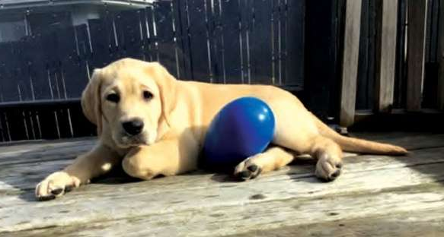
Guide dog puppy Orissa is super sweet and affectionate. She is always on the move and doing something, but also has a feisty streak in her. She is a true lab and loves anything to do with food which has helped her pick up her commands really fast—along with being super smart. Her favourite toy is her Mega Egg—She loves to thrash it around!
Page 23
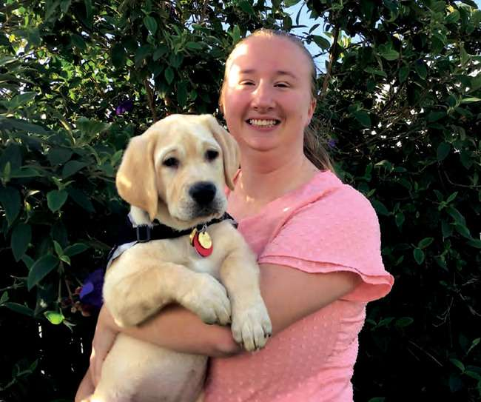
"You know you have been in Kmart's Pet aisle too many times when your dog can lead you perfectly from the door to the toys without fail!"
Page 24

Hiranga Kaupapa Here,
Kaupapa Whiri

Policy and Advocacy Highlights
The Policy and Advocacy team at Blind Low Vision NZ turns ideas into action to create positive change at central and local government levels. Advocacy is about using evidence and people power to encourage public support for a particular cause or policy. We advocate for the change that people who are blind, deafblind or have low vision need and want. We produce evidence-based solutions and work collaboratively to achieve results, advocating for an accessible society here in Aotearoa.
To do this, we dedicated our time working on multiple projects with various partners, to build their visibility and spread awareness.
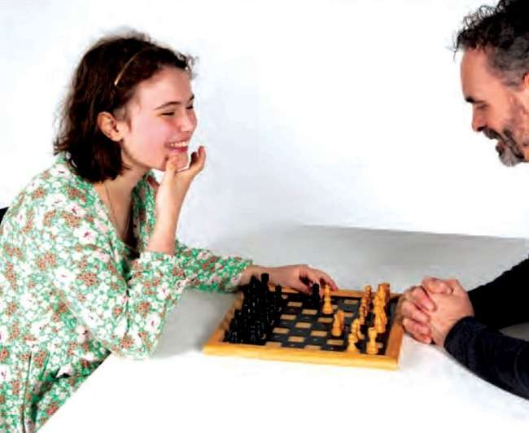

Here's an overview of our activity in "FY22:"
- Progressed accessibility legislate on with the Government.
- Further built out the case for why accessibility legislation must have an easy to use barrier reporting system, accessibility standards that are enforceable, an independent regulator, and a disputes resolution process.
- Increased the number of Access Matters Campaign supporters by 5000.
- Activated and prepared all supporters to get ready to make a submission for when the Government's "Accessibility for New Zealanders Act" bill is introduced into Parliament and referred to Select Committee.
- Celebrated World Sight Day in Aotearoa New Zealand with an event in Land's End Bluff that was live streamed to the rest of the world.
- Commissioned and completed the Eye Care Situation Analysis Tool (ECSAT) survey for New Zealand to get an understanding of Aotearoa's eye care and vision health services.
- Campaigned for New Zealand's first ever National Eye Health Survey.
Pages 25-26
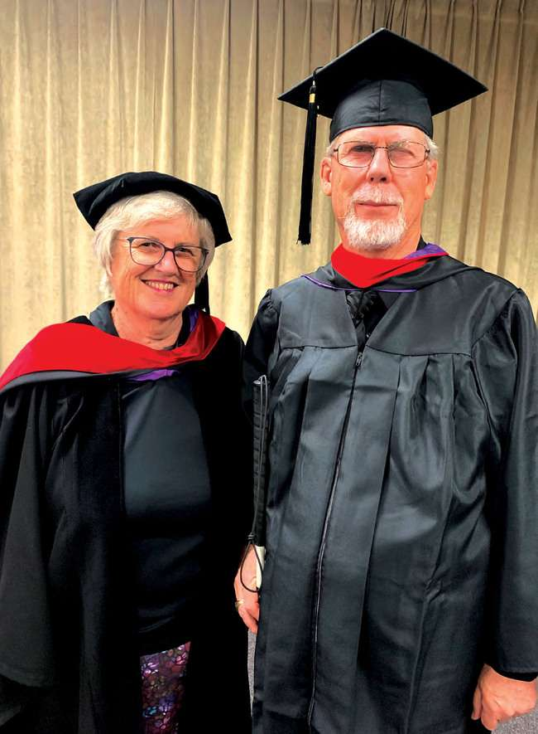
"After six years of university study, I graduated with my Masters Degree in Theology. I attribute this achievement to an inner determination to look beyond my sight loss, the use of accessibility technology, and a desire to give back to the community".
—Paul Geerson
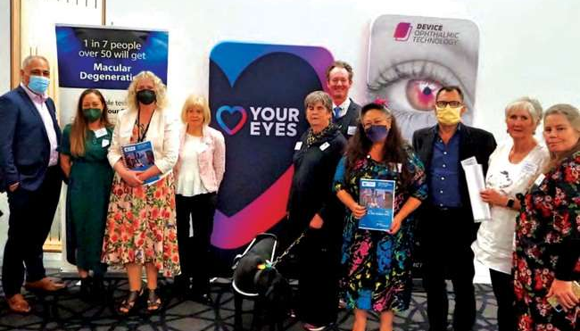
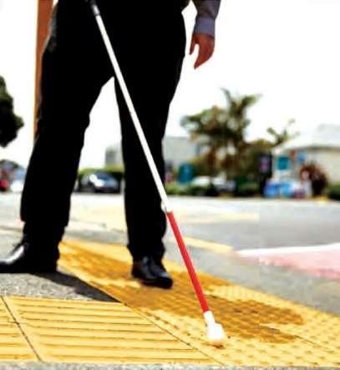
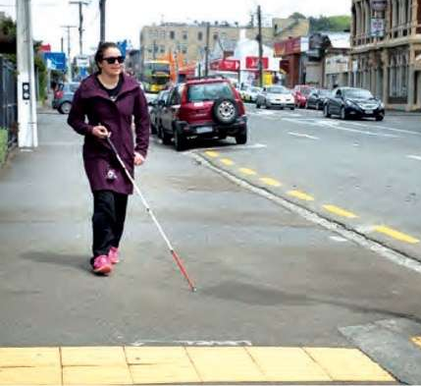
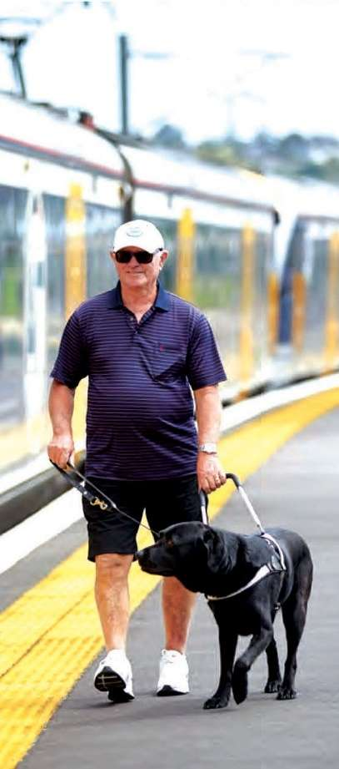
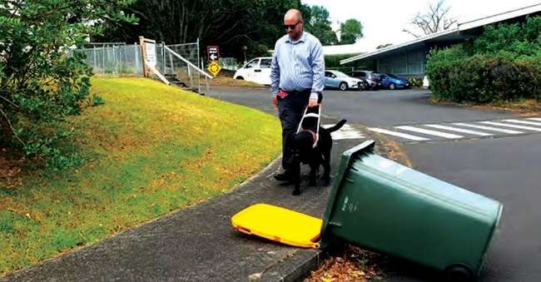
Page 27

Eye Health Aotearoa
On World Sight Day, 14 October 2021, Eye Health Aotearoa (EHA) launched their first Love Your Eyes campaign. The campaign was recognised internationally and New Zealand is now part of the global conversation. Despite the COVID-19 restrictions, the event at Land's End, Bluff was able to proceed. Around 60 people attended the New Zealand event and it was the first to be livestreamed worldwide. The event included a panel discussion on eye health and was home to the Southernmost eye testing site in the world on World Sight Day. The panel members were Ms. Penny Simmonds MP, Dr Liz Craig MP, and Blind Low Vision NZ clients, Carolyn Weston, and Pic Picot. We also held an art competition for local schools in the lead up to the event. The finalists of the competition had their art pieces on display at the event, and the winners were announced live on the day.
EHA commissioned the University of Auckland School of Optometry and Vision Science to complete the first ever Eye Care Service Assessment Tool (ECSAT) for Aotearoa. The final completed ECSAT provides concrete information on the state of eye health services, including vision rehabilitation, in Aotearoa. New Zealand currently has no data on the prevalence of eye disease, blindness and vision loss.

Access Matters
Access Matters campaigners asked to see a model bill that reflects the thirteen principles for strong and effective accessibility legislation and show them what ideal legislation would look like. The Accessible Aotearoa New Zealand Model Bill being drafted provides the legal technical framework.
The Access Denied Diaries initiative was launched as part of the Access Matters campaign. We asked our clients and other people living with disabilities what barriers they are faced with and how this impacts their day-to-day lives. The evidence from this initiative will be included in Select Committee submissions on the Government's yet to be drafted "Accessibility for New Zealanders Bill".
iSee Barriers Project
The iSee Barriers project came to fruition to address accessibility barriers that many people living with disabilities face in their day-today lives. For example, tipped over rubbish bins on the footpath, uneven footpaths, and so on. The iSee Barriers project allows for real time reporting of these issues through the Snap Send Solve app. The Snap Send Solve app enables incident reports of barriers to be easily triaged to the correct government authority or council. The iSee Barriers pilot is being expanded and promoted to clients, blind and low vision consumer organisations and other interested organisations. Data collected from the pilot will inform Blind Low Vision NZ's submission to the Select Committee hearing on the yet-to-be drafted Government's Accessibility for New Zealanders Bill.
Page 28

Hiranga Ratonga Kurī Arataki

Guide Dogs Services Highlights
- 119 Puppies born
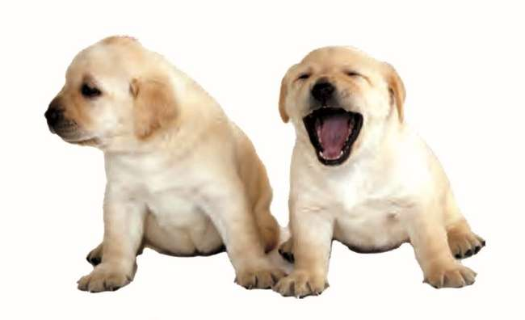

- 150+ Dogs with our volunteer puppy raisers
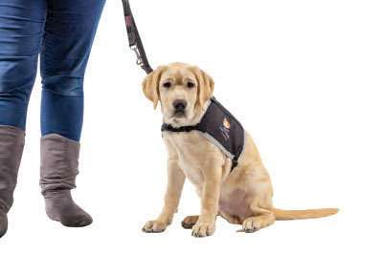
- 148 Active working dogs
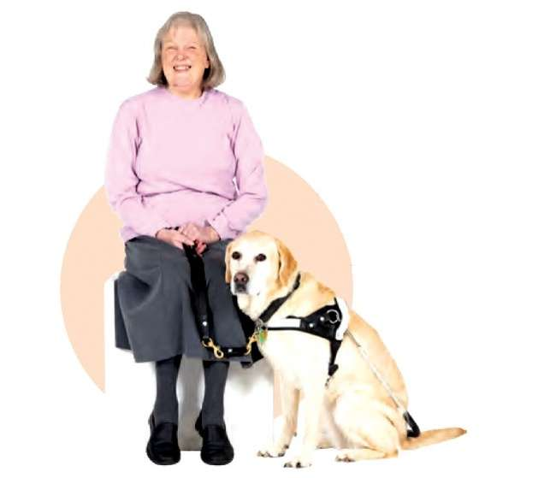
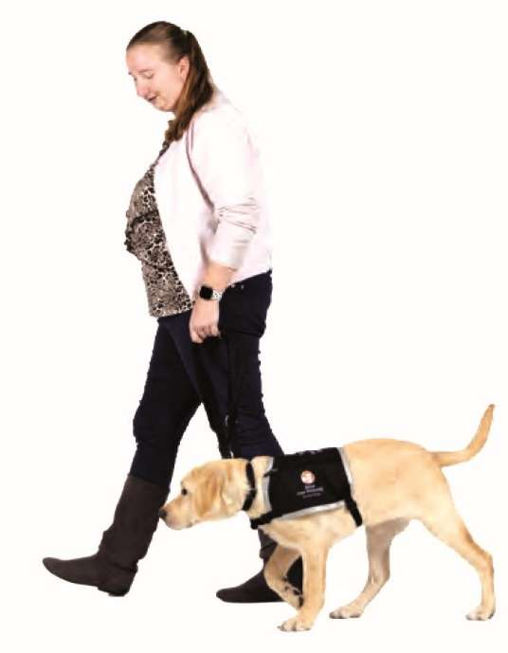
- 26 Qualified guide
dogs from training

Guide Dog Services percentage of targets achieved for the past year:
1. | To increase and breed more puppies for our programme 95%
2. | To increase number of puppies into formal training 80%
3. | Increase the success ratio of dogs in training to be matched 87%
4. | Increase number of handler teams 87%
5. | Successfully recruit and retain suitable qualified staff 68%

Page 29

Projects

Training Centre
Alongside our new Blind Low Vision NZ South Auckland office building (next door to Guide Dogs), there will be our exciting indoor training facility. Including shop fronts, road rossings, an escalator and train/plane/bus carriages, our dogs in formal training will have a chance to experience all these stimulating environments in a controlled way before they go out in the big wide world and experience the real thing.

New Kennel Build
The Guide Dog Kennel Build Appeal commenced earlier this year in April 2022. Our current kennels are now over 30 years old, have reached their end of life, and unfortunately are no longer conducive to the development of our guide dogs in training. This new build will include greater open and shared spaces for our dogs, an isolation unit for when dogs become unwell and require total separation, a therapy pool for swimming and physio along with an enrichment "play park". Ultimately building new kennels for our guide dogs in training will ensure happier, healthier guide dogs for our clients.
Read more about the Guide Dog Kennel Build Appeal on page 16–17.

Vision Loss Assistance Dogs
Blind Low Vision NZ is currently piloting a new service within Guide Dogs for Blind Low Vision NZ clients. This service will re-purpose dogs that do not qualify as a fully trained guide dog, but have the skills to help our clients in other areas in an assistance/ companion role.
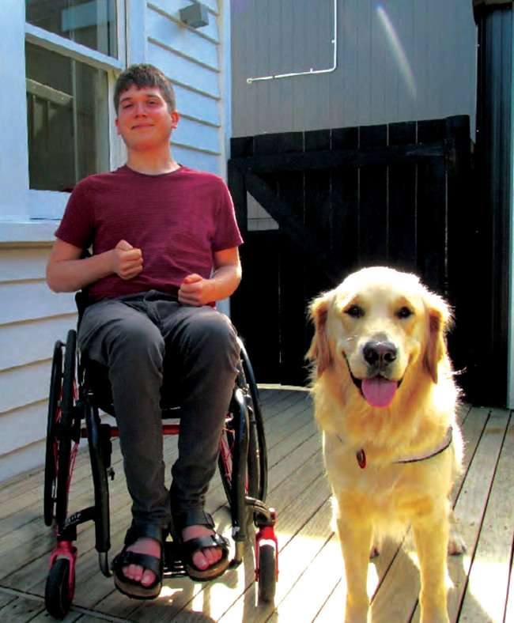
Blind Low Vision NZ's first Vision Loss Assistance Dog, Mason with his handler
Page 30

COVID-19 and Lockdowns
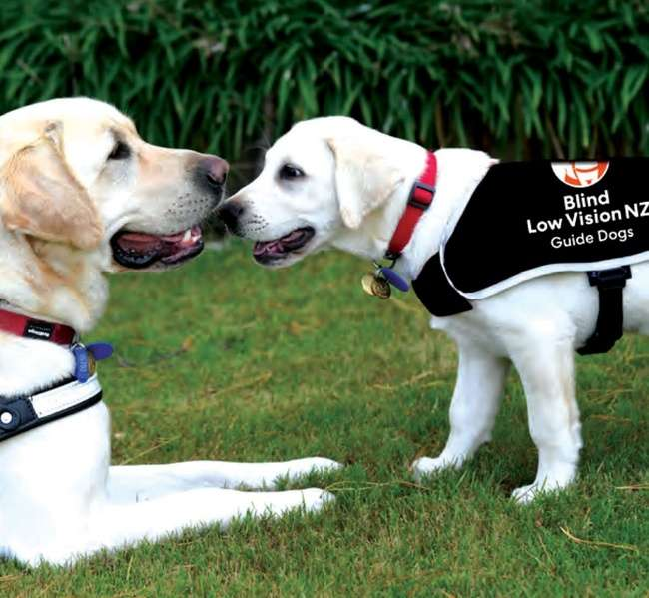
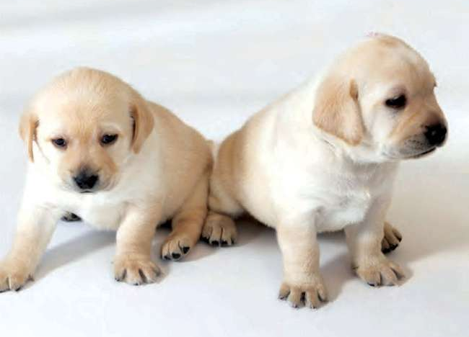
As we all have experienced over the past couple of years COVID-19 has impacted on our lives, at home and at work. Our guide dog training was also affected and required us to consider alternatives, when on 17 August 2021 the Delta variant was discovered in the community. Auckland, home to the Blind Low Vision NZ Guide Dogs training programme, was put into a full Level-4 lockdown.
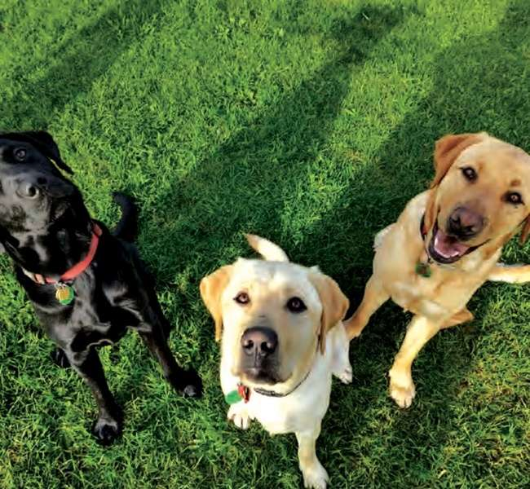
This full lockdown, prohibiting travel for all but essential workers would remain in place in Auckland for over 5 weeks. At this time, a group of six dogs was just weeks from completing their 16-week training programme. Each of the dogs was fostered in a boarding home, the trainers were sent home, and all guide dog training ceased. When it appeared that Waikato would drop to a Level-3 lockdown after 15 days, we applied for and received travel exemptions.
A team of three cadet Guide Dog Mobility Instructors (GDMI) and our Training Operations Manager travelled and based themselves during the week in Hamilton to continue the training in an attempt to qualify these six dogs. The outcome was that our newest cadets had each qualified their first career guide dogs and six waiting handlers were matched with their new mobility partners.
Similar to this, in September we moved 4 dogs to Christchurch to undertake their full 16-week programme down there and a couple of those dogs managed to qualify.
Page 31

Kennel Cough
2021 started with a Kennel Cough outbreak across New Zealand and at the Guide Dog Centre. This resulted in major disruption for us in delivering our training programme and qualified guide dogs to our clients.
We continued to seek expert advice from New Zealand's top specialists, on how best to manage our colony both within our centre and in the community.
The Guide Dog Centre had a strict 6-week lockdown with various control bubbles to limit any possible further infections between dogs on site.
Those guide dog puppies scheduled to come in for training, required strict movement control for two weeks before they arrive at the centre, for training very similar to a Level-4 COVID situation and all dogs were swabbed to try and further identify the pathogen responsible.
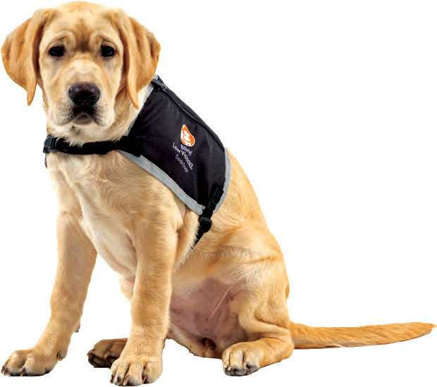

Looking to 2023
- With the international borders opening, we are working closely with Guide Dogs Queensland and have some positive initiatives for our breeding and client services programmes this year;
- We are fortunate to have some experienced GDMI visiting Blind Low Vision NZ Guide Dogs on a consultant basis, to give our Training Operation and Client Services teams much needed assistance and training;
- Canine Cough has been through Auckland earlier in 2022, but fortunately we have not seen this active in those dogs coming into training, we remain vigilant and confident our current procedure will keep this out;
- Planning for the new Kennel Build is well underway and hopefully in the drier months of 2022 we will see work beginning on this exciting project.
Thank you to all of our wonderful guide dog volunteers.
We couldn't do what we do without your contributions and support. Thank you for letting our dogs into your hearts and homes as part of their important training. We are truly thankful, as are our clients.

Page 32
Client Story

Receiving Samara's first guide dog has opened her world up in more ways than she can count.
Samara has lived most of her life with low vision due to a pituitary tumour. Her vision was affected during a surgery she had to try to remove the tumour when she was only nine years old.
She says she has trouble seeing vehicles when crossing the road, would walk into people or objects, and adjusting her eyes quickly when the light changes.
Samara had mostly put up with these challenges over the years, until 2019 when her vision started to deteriorate. That's when she decided to find out more about having a guide dog.
The process of receiving a guide dog can be both exciting and disheartening. Finding the right match between guide dog handler and guide dog can take time. It's important that both are suitable for each other's lifestyle and needs.
Samara says receiving her first guide dog, Carly, in June 2020 was "overwhelming, exciting and also nerve wracking".
Adjusting to life with a guide dog can seem daunting. There many commands to learn and when you step out the front door, you also need to pack a few things for your guide dog.
"I remember my Guide Dog trainer saying it will get easier, however at the time I couldn't see how. Now I am on autopilot most of the time and it is very easy".
Once Samara and Carly got to know each other, life was so much easier from that point onwards.
Samara says "Carly has fitted into my life pretty easily".
The duo walk to and from work in Invercargill daily, about 50 minutes each way. She says Carly has her own bed and toys at the office. She spends most of her day sleeping, but loves when people come to pat her.
Carly loves to visit the ducks at Queens Park, lying in the sun and running around their section with her squeaky toy.
Carly isn't just Samara's guide dog, she is her companion and friend.

Page 33
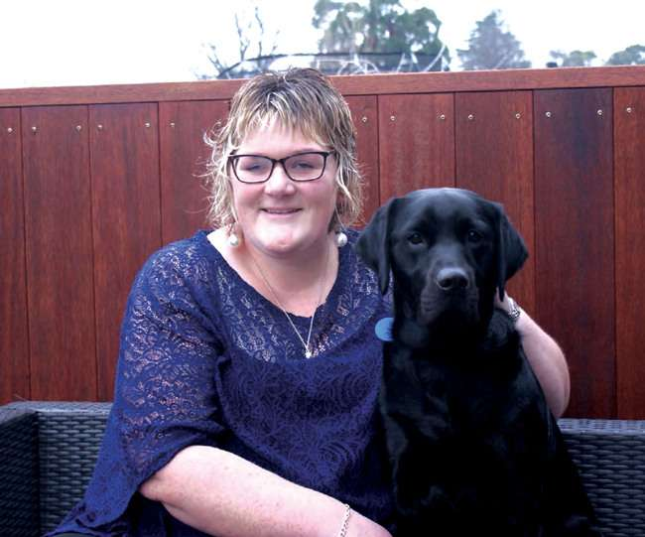
"I am very grateful to for the opportunity to have a guide dog way." Samara continues, "A guide dog changes your life in such a positive way."

Page 34

Hiranga Pātaka Pukapuka

Library Highlights
This year has seen another big step forward with the Library's digital transformation, as our services continue to grow and mature. Our Alexa Skill and the EasyReader app have had significant developments that directly improve the reading experience for our clients. Here are some of the highlights of the library service this year.
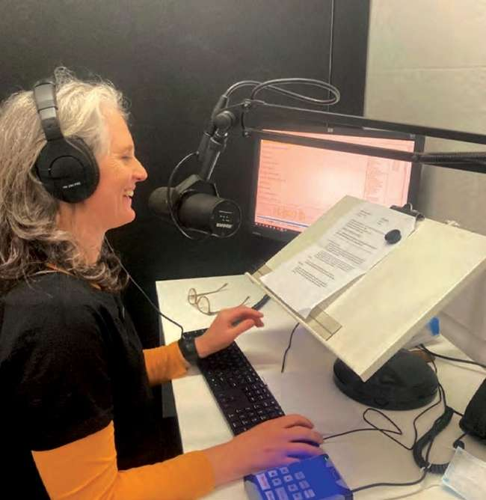

Alexa
Blind Low Vision NZ's Alexa Skill, our flagship library service, continues to develop and improve. In April 2022, over 5,000 books were borrowed, the highest number of books since the Skill was released. A number of enhancements have been made already, with more in the pipeline for next year.

• AI recommendations
Feedback from our clients has indicated they struggle to find new books to read. The catalogue of titles at Blind Low Vision NZ is over 36,000 and covers many subjects. To assist with recommending new books to read we have been focusing on developing a recommendation engine that will suggest books for clients to read based on their reading history, books suggested by other members and the title metadata. We are hoping that by using artificial intelligence we can give accurate suggestions, rather than simply offer titles from the same genre.
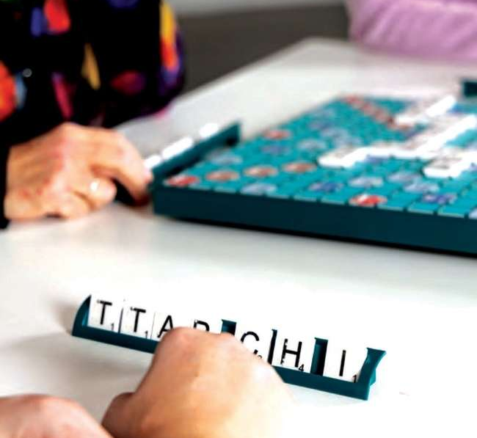
Page 35

EasyReader Project
A big challenge this year has been to retire one of our services, the BookLink Android and iOS apps. With the recent improvements that have been made to EasyReader, it meant that we had a duplication of services. Not only is this confusing to our clients, it meant there was a duplication of resources to keep them going. By committing to Dolphin's EasyReader platform we ensure this service will be more sustainable and a better reading experience for our clients.
To prepare for the change to EasyReader, we created a cross disciplinary project team to advise us on different solutions. By working collaboratively, we have created resources for clients, staff and volunteers. This included traditional instructional manuals and guides in accessible formats, direct Zoom training with staff, and "How to" videos on YouTube for volunteers.
The EasyReader app itself has had considerable improvements this year, it now includes these features.

• Recommended Books
The addition of a recommended books section allows clients to browse a list of books recommended by clients within each subject category.

• ePub Content
The ePub content type is now able to be borrowed from the Blind Low Vision NZ Library, we do not have many titles in this format yet, however will look to add more titles in ePub soon.

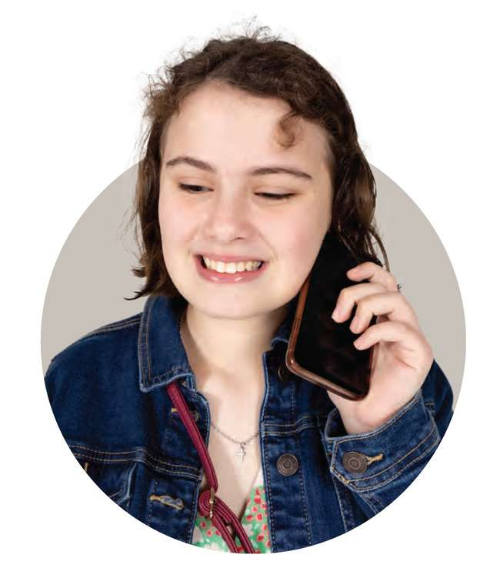
• Newspapers
Clients can now access newspapers over 130 newspapers from throughout New Zealand on EasyReader. These can be read using a synthetic audio option or visually using screen magnification and other assistive technology options.
Page 36

Public Libraries
We continue to further improve our relationship with Public Libraries. Our Engagement Advisor has connected with LIANZA (New Zealand Library Association Inc.) and the National Library to give presentations about accessibility to support Public Libraries. In addition, the Library app has gone through accessibility testing, which is offered by some libraries throughout New Zealand to access audio books. We look forward to working alongside Public Libraries to improve the awareness and availability of accessible digital content.
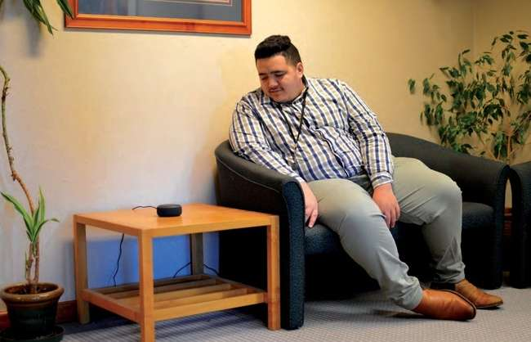

BookDrive
For our clients who are unable to access the internet or are unable to utilise Alexa, we deliver books via USB with the BookDrive service. This service is similar to the retired CD service, however more books can be sent at once. This makes up a smaller proportion of our membership and is decreasing as internet access becomes more widespread.
With the Library service now very much a digital service, it faces the challenge of rapid technological change. Regular updates, improvements and enhancements will be our business as usual. However, we do not forget that the library is a person-centred service and are excited about maintaining and improving the accessible library experience.
Page 37
"If it wasn't for losing my full sight, I probably wouldn't have achieved the things that I have achieved".
—Hannah Pascoe

Page 38
Donor Story

From Client to Donor
Looking back to the day Roger Khan signed up to Blind Low Vision NZ, it was the best decision he ever made. After experiencing first-hand how life-changing their services were, he became a regular donor.
"If it wasn't for Blind Low Vision NZ, I would not be where I am now," Roger says.
Around 20 years ago, Roger gradually began to lose his sight to glaucoma.
When Roger was first struggling with his vision loss, a friend of his suggested he sign up to Blind Low Vision NZ (at the time known as The Blind Foundation). Roger said "no way". Eventually, his friend stopped by his place and told him he wasn't leaving until he did sign up. So, he finally did.
Roger says, "From then on, I've never looked back."
Blind Low Vision NZ gave Roger a pair of sunglasses to help him with the glare from the sun and lights. As his sight got worse, Blind Low Vision NZ set him up with a computer with a screenreading programme called JAWS, and trained him how to use it.
He was surprised at how many services Blind Low Vision NZ had to offer.
At 89 years old, Roger is still very active. He is a member of the Blind Fingers Gardening Group, which meets once a month. At those meetings Roger and the group share tips and tricks on gardening with limited or no sight.
"Gardening is very relaxing. All your worries disappear and you hear birds and bees and other insects. I'd recommend other blind people take up gardening. In fact, I'd recommend everyone did!"
Recently, Roger also tried blind skiing. He says it was a very enjoyable and successful weekend.
After experiencing the overwhelming support of Blind Low Vision NZ, Roger has been a regular donor to the organisation for 16 years. He knows first-hand how Blind Low Vision NZ changes lives and enables people with the tools to be independent and introduce them to a supportive community.
He knows how people who are struggling with their sight loss feel, he's been in their shoes. Now he helps people to reach the point that he is currently at—living a life without limits.

Page 39
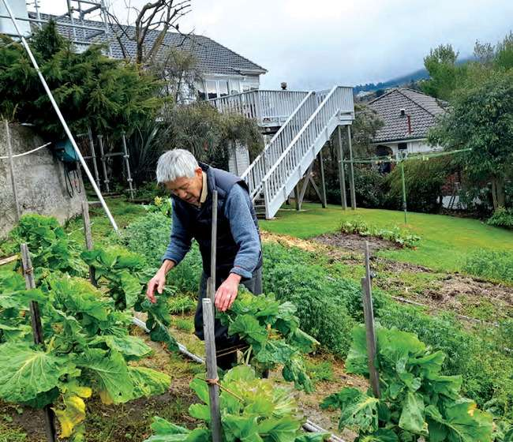
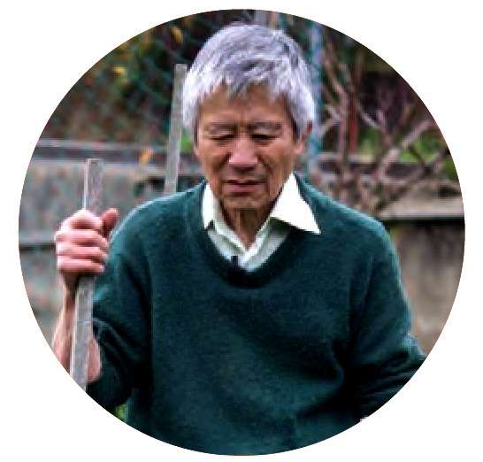
"If it was not for Blind Low Vision NZ,
I would not be where I am now,
still enjoying life and creating many
happy memories and friends."

Page 40

In Gratitude
We are extremely grateful to all our generous supporters. Your kindness helps empower New Zealanders who are blind, deafblind, or have low vision to live the life they choose. Thank you so much for the difference you have made.
From our street collection volunteers to the avid readers who make our Great Kiwi Bookathon so successful, to our puppy sponsors and all our wonderful supporters, we could not do it without you. We would like to say a special thank you to some of our key supporters in financial year 2022.

Major Donors
Air Rescue Services Ltd
Alan D Harvey Estate
Beatrice Georgeson Trust
Bruce Russell
Brynden Butler in memory of
Muriel & Eric Thatcher
Carlene Jones
Central Lakes Trust
Challenge Fuel Ltd
Chenery Memorial Trust
Community Trust South
D. Geisler
Danesmead Charitable Trust
Dorothy Cutts
Douglas Bates
Dulcie Taylor
E J Price Charitable Trust
Estate of Ernest Hyam Davis and Ted & Mollie Carr Endowment Trust
Four Winds Foundation
Frances Skeet Charitable Trust
Freeman Endowment Fund (Nikau Foundation)
G A Waddel Charitable Trust
Graham Still
Grumitt Sisters Charitable Trust
ILT Foundation
In memory of Mary Haynes
In memory of Robert Stuart
Invercargill Licensing Trust
Kiwi Gaming Foundation
Lake Taupo Rotary
Leigh Pearson
Marion and Neville Handcock
Marriott Trust
Masfen Foundation
Maurice Paykel Charitable Trust
N H Taylor Charitable Trust
N R Thomson Charitable Trust
New Plymouth District Council
Norah Hamblin Memorial Trust
NZCT
One Foundation
Otago Community Trust
Owen & John Whitfield Charitable Trust No 1
Oxford Sports Trust
P H Vickery Charitable Trust
Pageo Charitable Trust
Pelorus Trust
Perpetual Guardian
Peter Baird
Public Trust
Ray Watts Charitable Trust
Roger Kan
Room-Simmonds Charitable Trust
Royston Health Trust Board
Silk Route Limited
"I G Macarthy Trust
"I M Hosking Charitable Trust
Taumarunui Opportunity Shop
The David Ellison Charitable Trust
The Hukanui Charitable Trust
The Lake Memorial Charitable Trust
The Lion Foundation
The Reed Charitable Trust
The Trusts Community Foundation
Timaru District Council
Trillian Trust Ltd
Trust House Foundation
Una and John Kennedy Trust
Waitemata Local Board—Auckland Council
Whanganui Community Foundation
Zelda Roberts Charitable Trust

Page 41

Gifts in Wills
Gifts in Wills support 1 in 3 services at Blind Low Vision NZ. A gift in a Will of as little as 5% makes a tremendous difference. Last year, many of our services would not have been possible without the kind support of the following people who left a gift in their Will.

Legacies
Estate of Alfred Allen Sadd
Estate of Annie Gweneth Ross
Estate of Anthony Howard Bretherton
Estate of Arthur Henry Wall
Estate of Betty Evelyn Boswell
Estate of Bruce John Hood
Estate of Carol-Ann Stuart James
Estate of Clement Douglas HaigWolfe
Estate of Colin Arthur Willshaw
Estate of Cornelius Houtwipper
Estate of Daniel Roulstone Elliott
Estate of David Swallow
Estate of Dawn Lupton
Estate of Donald Banks Laxon
Estate of Dorothy Frisken
Estate of Dulcie Josephine Bindon
Estate of Edith Irene Adamson
Estate of Edmund Alfred Bonner
Estate of Elvaretta Orr
Estate of Fay J Peters
Estate of George Henry Dear
Estate of Gilbert Anthony Hay
Estate of Graham Rowles
Estate of Helen Lorraine Alexander
Estate of Jack Hart
Estate of Janice Anne Kimberley
Estate of Jean Elizabeth Frazer
Estate of Jean-Clare Harper
Estate of Jennifer Louise Hart
Estate of Jillian Clare Pitu
Estate of Joy Ann Foster
Estate of L Hogg
Estate of Lawrence Bernard Grove
Estate of Leo John McAteer
Estate of Lillian Ellen Christophersen
Estate of Lindsay Robert McLean
Estate of Lionel Evert Meredith
Estate of Marcella Veronica Richardson
Estate of Margaret Cleo Remedios
Estate of Margaret E F Suthrell
Estate of Margaret Joy Crawford
Estate of Margaret Knowles Gebbie
Estate of Margaret Lillian Waller
Estate of Margaret Mary Hancock
Estate of Marie Joyce Turner
Estate of Mavis Bertha Elston
Estate of Michael John Allen
Estate of Miriam Frances Wright
Estate of Molly Reynolds
Estate of Monica Mary Richards
Estate of Morris Harrison Benton
Estate of Neil Francis Jenkins
Estate of Ngaire Patricia Rickard
Estate of Ngarita Johnstone
Estate of Nigel Michael David Osborne
Estate of Norman Peter Summers
Estate of Patricia Joy Edbrooke
Estate of Patricia Marion Morgan
Estate of Patrick Malcolm Reynolds
Estate of Penelope Joan Williams
Estate of Raymond Di Mento
Estate of Raynor Elizabeth Stevens
Estate of Raynor Joyce Black
Estate of Rita Yvonne Van der Meer
Estate of Robert Sydney Cretney
Estate of Ron Gilbertson
Estate of Ronald & Dawn Sare
Estate of S M Wells
Estate of Valma Rhoda Barnhill
Estate of Voldemar Greivulis
Estate of Winifred Plummer
Page 42

Pūrongo Pūtea

Financials
TN: See diagrams on the next two pages.

Where our income comes from:
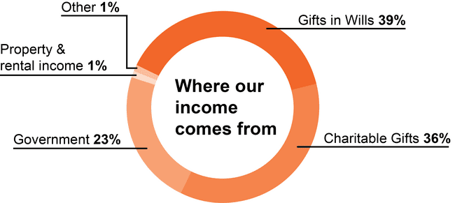

Where our income goes:
TN: Continues on next page.

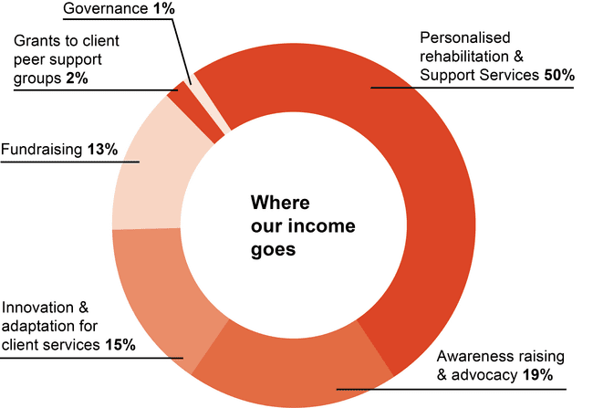

Page 43
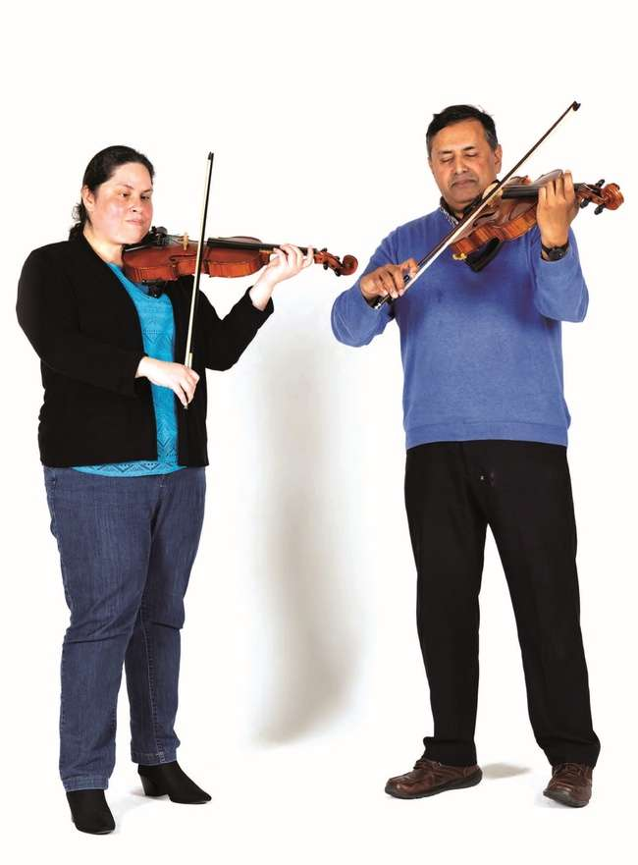

Page 44

Te Poari Kaitiaki

The Board
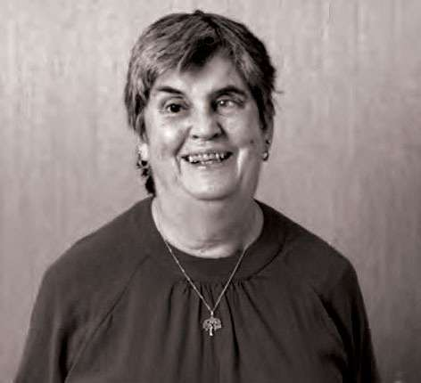  Judy Small | 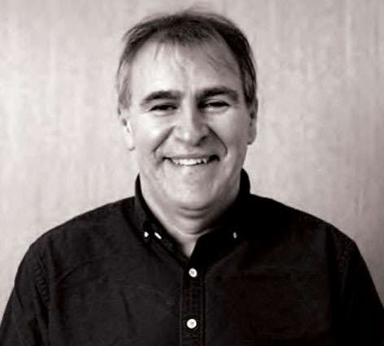  Fraser Alexander
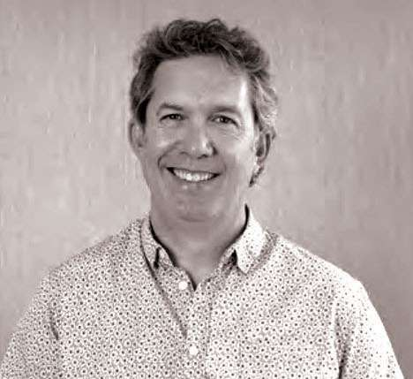  Richard Patete | 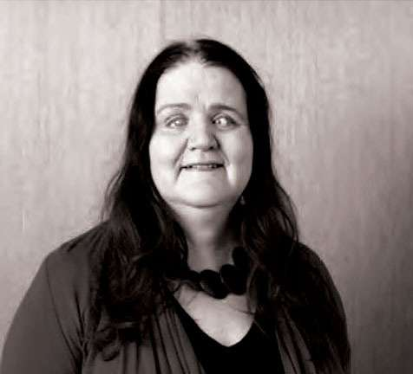  Martine Abel-Williamson
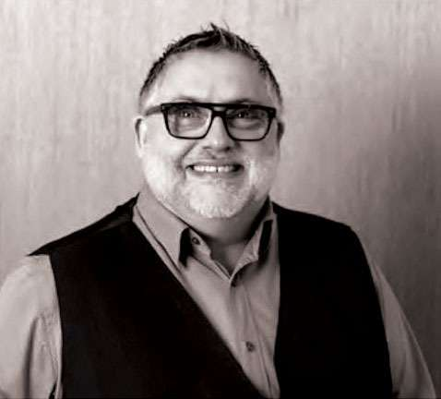  John Billings | 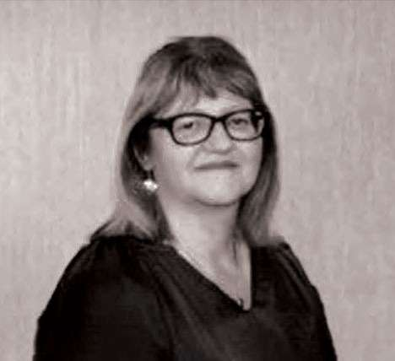  Anne-Marie Taggart
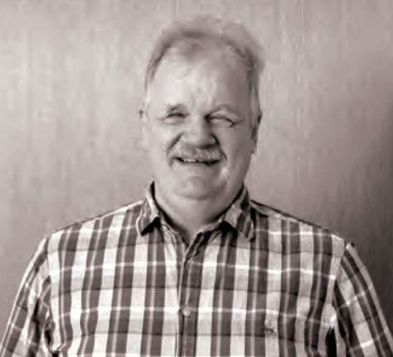  Clive Lansink | 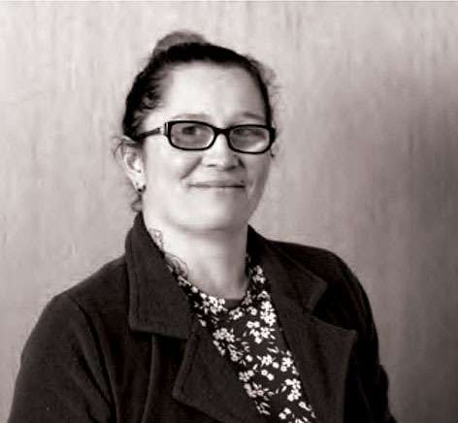  Donna McCaskill
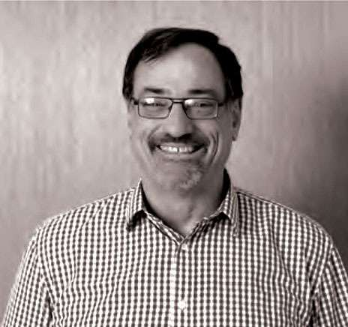
Ronald (Ron) Scott
Page 45

Judy Small—Chair
Judy has been a client of Blind Low Vision NZ since she was four years old. Judy graduated in 1999 with a Masters of Social Science (Hons). She worked as a Policy Analyst for 11½ years in social policy in the Office for Disability Issues and has also served on the Blind Citizens New Zealand National Executive.

Fraser Alexander—Deputy Chair
Fraser holds an Undergraduate degree in biosciences and a Postgraduate honours degree in business. He has spent 22 years in not-for-profit marketing including nine years with us. Fraser is also a past President of Retina NZ.

Richard Patete
Richard has been involved with Blind Low Vision NZ for over 20 years as his eldest daughter, Renee, was born blind. Raising Renee has given him a strong understanding of the needs and challenges of the blind and low vision community. He brings with him an extensive range of experience working in the not-for-profit sector.

Martine Abel-Williamson
Martine has been living in New Zealand for the past 22 years since emigrating from South Africa. Her qualifications are in the areas of vision rehabilitation, education and social policy and previously worked at Blind Low Vision NZ in the fields of blindness awareness training and service co-ordination. Martine is also President of the World Blind Union.

John Billings
John has been practising his profession as a Dispensing Optician for 35 years. He has always had a strong interest in providing Low Vision Aids and services to the partially sighted in order to help them continue with as good a quality of life as possible. As well as the Low Vision community, he also has experience with the Deaf community.

Anne-Marie Taggart
Anne-Marie is an experienced senior leader within the NZ public sector. She began her career as an HR professional but in recent years has branched out and has led both corporate and operational functions. Recently Anne-Marie has joined Te Kawa Mataaho (Public Service Commission) as the Executive Coach in the Leadership Development Centre.

Clive Lansink
Blind since birth, Clive has spent much of his personal life working on behalf of people who are blind, deafblind or have low vision and was President of Blind Citizens New Zealand for a total of thirteen years. He has an engineering degree as well as a law degree.

Donna McCaskill
Donna worked for almost 20 years with Blind Low Vision NZ before standing for the Board. She currently works within the disability sector for a pan disability social enterprise as a direct line manager and advocate for a team of people with sensory, physical, cognitive and intellectual disabilities.

Ronald (Ron) Scott
Ron lives in Tauranga where he is a Board Member of the Bay of Plenty District Health Board (DHB) and chairs the DHB Audit Finance and Risk Management Committee. He is also Chair of SILC, a charity which supports 200 people with disabilities and long term illnesses and is a member of the AA Bay of Plenty Council.
Page 46

Te Ranga Manahautū

Executive Leadership Team
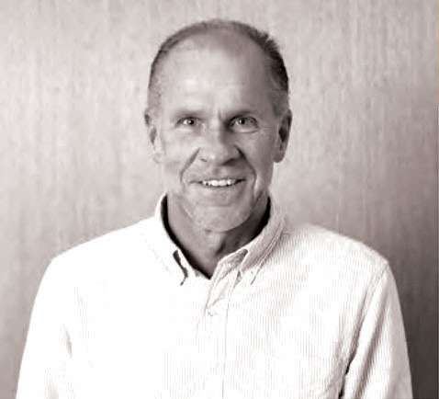  John Mulka | 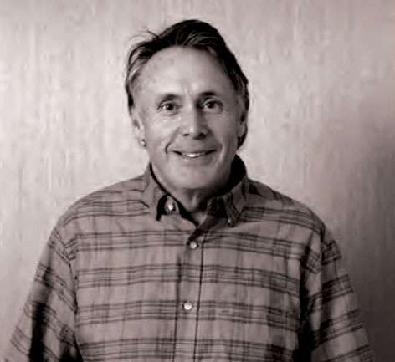  Greg Hurn
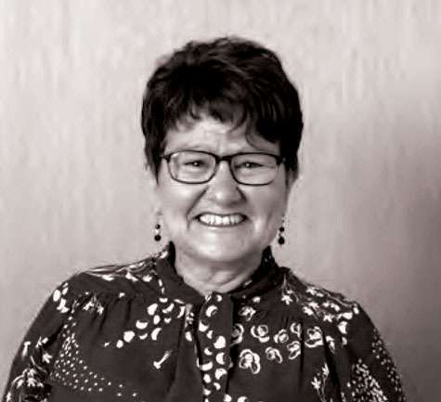  Liz Ansell | 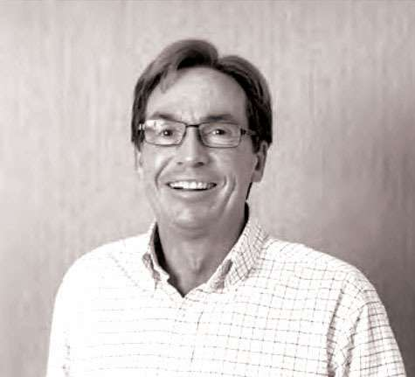  Mark Dickinson
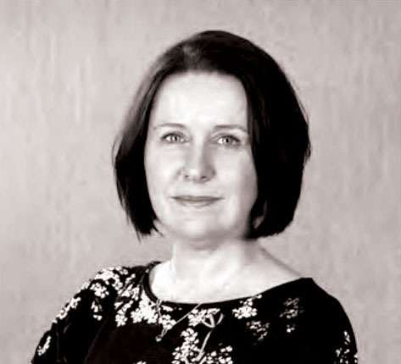  Gwen Green | 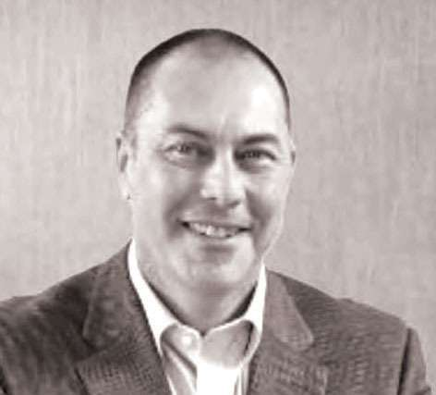  Nico Jansen
Page 47

John Mulka,
Chief Executive
Before joining Blind Low Vision NZ in September 2019, John spent his then 28-year professional working career in the not-for-profit and charitable sector with national organisations in his native country of Canada. Over his
11-year career with the CNIB (Canadian National Institute for the Blind), his responsibilities grew progressively, culminating with him being appointed as the Vice President, Western Canada in 2015 which he held until accepting the Chief Executive role with Blind Low Vision NZ.

Greg Hurn,
Chief Financial Officer
Greg has a wealth of experience in finance, customer services, production, service delivery and administration. He has worked in the manufacturing, banking and telecommunications industries. Greg's aim is to ensure we are financially sound and sustainable over the long term horizon. He looks after our finances, contracts, strategy and planning, performance, governance and business development initiatives.

Liz Ansell,
General Manager Client Services
Liz is a seasoned leader with experience across both public and private sectors including FMCG, banking, media and security. Following extensive experience in HR and managing change, she is thrilled to bring her skills into managing and growing a team of people passionate about providing first-class service in the not-for-profit sector.

Mark Dickinson,
General Manager Business Services
Joining Blind Low Vision NZ in 2018, Mark has extensive New Zealand and International operational and senior leadership experience.
Mark's focus in leading the Business Services portfolio is to enable the development and implementation of creative business solutions to support our entire organisation as we strive to achieve best in class performance, delivering superior service outcomes for our members and clients.

Gwen Green,
General Manager, Fundraising
Gwen has over 20 years' fundraising, marketing, and communications experience both in New Zealand and
the UK.
Gwen has a passion for developing donor-focused fundraising, creating new income opportunities, and
re-visioning existing fundraising strategies to maximise income generation in ways that are flexible to our ever changing world.

Nico Jansen,
General Manager, People & Performance
Nico is a collaborative Senior People & Culture Specialist with over 25 years' experience within multi-national organisations across the FMCG, Manufacturing, Services and Engineering sectors.
Nico's biggest fulfilment is to work with organisations to improve their bottom line by focusing on leadership effectiveness, organisational culture, employee engagement and workforce capability.
Page 48

Amsler Grid

How to test your eyes with the Amsler Grid
Tear this page out and keep it somewhere you will remember so that you can test your eyes regularly
- Wear glasses that you normally wear for reading
- Hold the grid about 35−40cm away from your face
- Cover one eye at a time
- Stare at the dot in the middle
- Contact your eye care doctor immediately if any of the straight lines appear wavy or bent, any of the boxes differ in size or shape from the others, or any of the lines are missing, blurry or discoloured
Here is what an abnormal reaction to the amsler grid might look like. If you start to notice this, please consult your doctor.
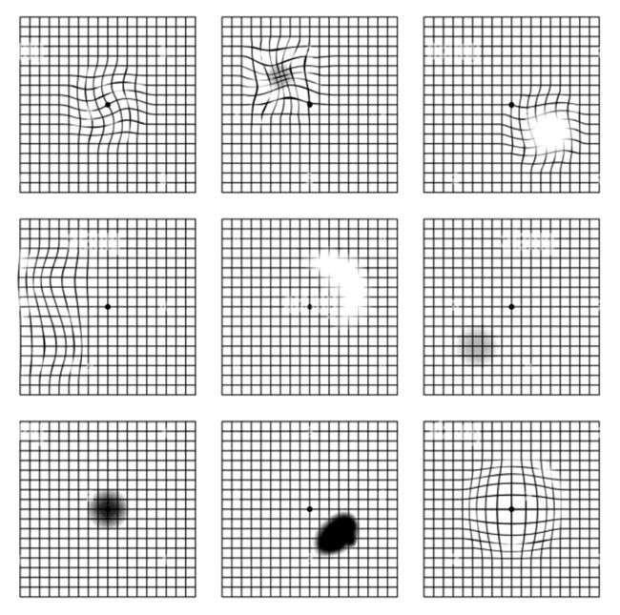
Page 49

Eye Test
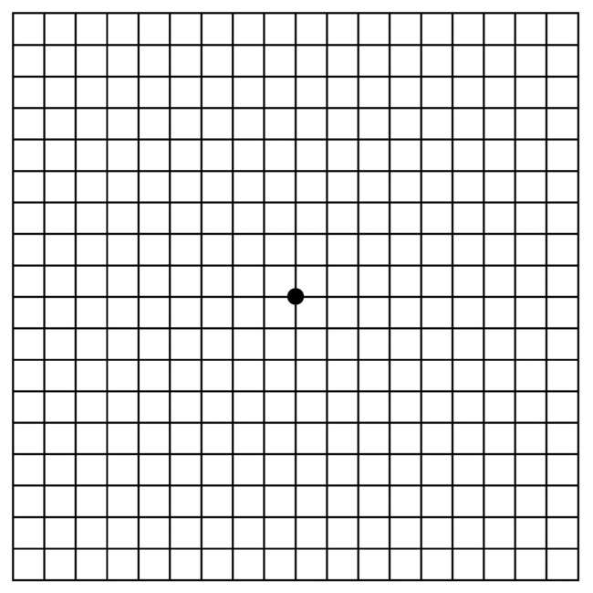
Pages 50–51

Kāpō Matarehu Aotearoa puta noa i te motu

Blind Low Vision NZ around the country
TN: Key to map of NZ that follows the next two pages:
A: Whangarei  277 Kamo Road, Kamo, Whangarei 0112 | E: South Auckland  20 McVilly Road, Manurewa,  Auckland 2102
B: Albany  3 William Laurie Place, Albany, Auckland 0632 | F: Fale Kotuku  20 McVilly Road, Manurewa,  Auckland 2102
C: West Auckland  Unit C (upper level),  197 Universal Drive, Henderson, Auckland 0610 | G: Guide Dog Services  30 McVilly Road, Manurewa,  Auckland 2102
D: Parnell, Auckland  541 Parnell Road, Parnell, Auckland 1052 | H: Hamilton  15 Liverpool Street, Hamilton 3204
I: Tauranga  160 Seventeenth Avenue, Tauranga South,  Tauranga 3112 | O: Kāpiti Coast  6 Tongariro Street, Paraparaumu 5032
J: Gisborne  39 Grey Street,  Gisborne 4010 | P: Wellington  121 Adelaide Road, Newtown, Wellington 6021
K: New Plymouth  129–131 Vivian Street,  New Plymouth 4310 | Q: Nelson and Marlborough  530 Main Road, Stoke, Nelson 7011
L: Napier  65 Thackeray Street, Napier 4110 | R: Christchurch  96 Bristol Street,  St. Albans,  Christchurch 8014
M: Wanganui  102 Peat Street,  Wanganui 4500 | S: Dunedin  Corner of Hillside Road & Law Street,  Dunedin 9012
N: Palmerston North  49 Walding Street, Palmerston North 4410 | T: Invercargill  172 Queens Drive, Richmond, Invercargill 9810

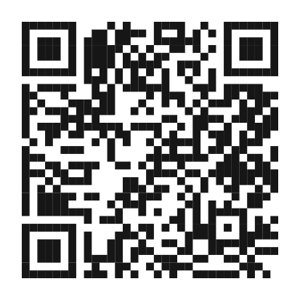
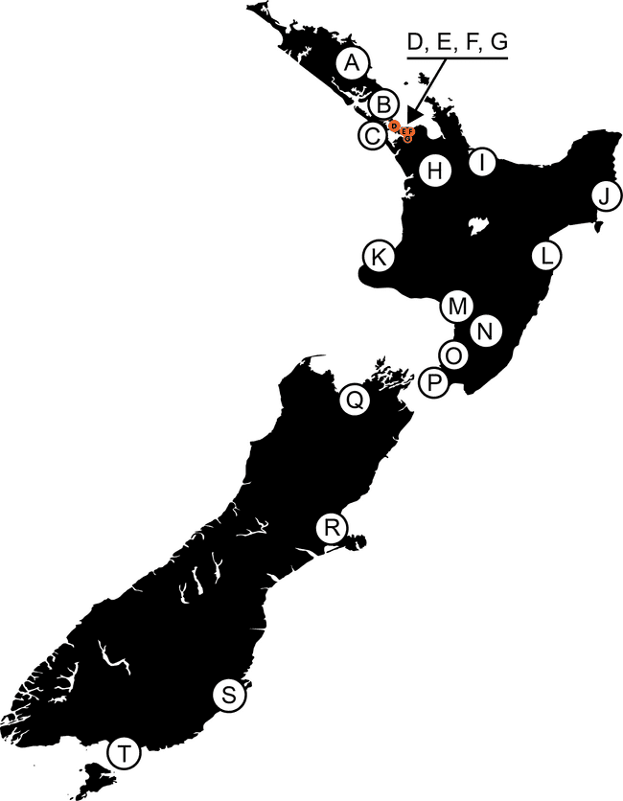
For more information and
opening hours scan the QR code
or visit our website.
Pages 52–53

Pukapuka tuhi

Notebook

Page 54
Ngā mihi nui for your support!
From the team at
Blind Low Vision NZ
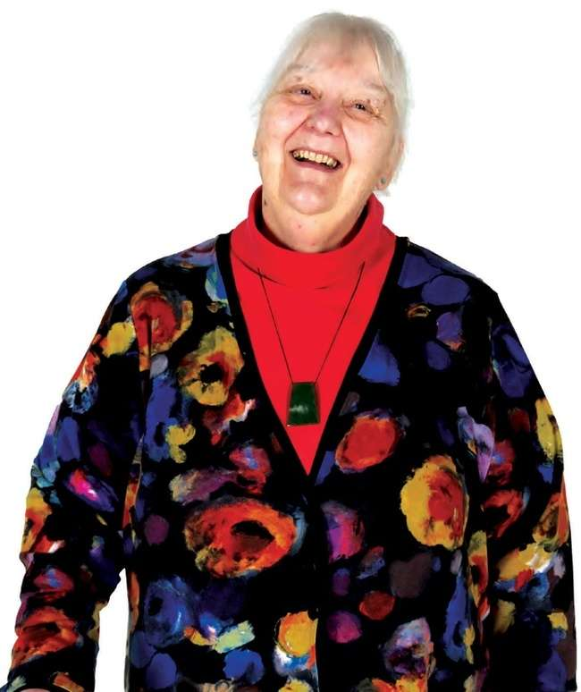
blindlowvision.org.nz
0800 24 33 33
PO Box: Private Bag 99910, Newmarket, Auckland 1149
Facebook: BlindLowVisionNZ
Instagram: blindlowVisionnz
Twitter: BlindLowVision

