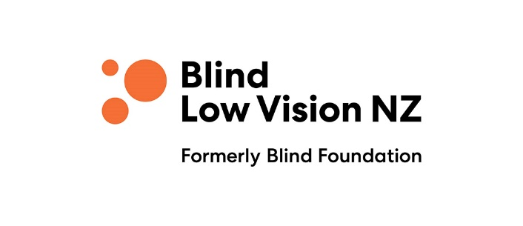

Forsyth Fund: Grant Application Form - Individual (Form 2)
For items of equipment costing $200 or less (excluding GST)
Purpose:
- To offer financial assistance for the enhancement of potential and independence of clients of Blind Low Vision NZ.

Criteria for an Individual:
- Registered client of Blind Low Vision NZ who lives within the boundaries of the Waikato Regional Council or the Waikato District Health Board.

Applications will be accepted at any time and will be considered on receipt.

Amount applied for:
Provide details of the equipment:

Name of Individual:
Client number:
Address:
Phone number:
Email:
Delivery Address, if different from above:
Contact Person/Referrer (name and relationship/position held):

As applicant, I (insert name)
- Certify that the information supplied is true and correct.
- Agree that any grant will be used for the purposes specified only, unless otherwise agreed by the Waikato Regional Committee.

Signature or electronic signature:
Date:
Send in Word format, as an email attachment, to forsythfund@blindlowvision.org.nz
or post the signed hard copy to Waikato Regional Committee, Blind Low Vision NZ,
PO Box 854, Waikato Mail Centre, Hamilton 3240.

Office use only:
Application number: Date received: Verify client number:
Verify client’s address is within Forsyth Fund Area: Decision:

