Full Guide – Includes all sections

Copyright
Blind Low Vision NZ hopes that by sharing this resource, the built and digital environment will become more accessible for people who are blind, deafblind or have low vision. When referring to, or sharing this resource, please use the following reference:
Blind Low Vision NZ “Clearing Our Way” Guide. Published July 2021. Available to download from the Blind Low Vision NZ website.
Copyright Blind Low Vision NZ 2021 ©

1. About
In 2020, the Canadian National Institute for the Blind (CNIB) Foundation gave permission for Blind Low Vision NZ (BLVNZ) to adapt their “Clearing Our Path” resource for the New Zealand context. Our hope is that by sharing this expertise, the built environment and digital spaces will become more accessible for people who are blind, deafblind or have low vision.
The purpose of this resource is to encourage people involved in design to think before they proceed with plans because it is far more cost-effective to build in accessibility in the planning stage.
While this document is based on best practice, it is important to remember that everyone is an individual. As such, this is a living document, and Blind Low Vision NZ will endeavour to keep this resource updated.
We’d love to hear what you think. Let us know by calling BLVNZ on 0800 24 33 33 or emailing communications@blindlowvision.org.nz.
BLVNZ is committed to advocating for accessible environments for people who are blind, deafblind or have low vision. Equal rights for all disabled New Zealanders are enshrined in the New Zealand Human Rights Act 1993, the New Zealand Bill of Rights Act 1990, and echoed in the United Nations Charter on the Rights of Persons with Disabilities (UNCRPD). Governments, both in New Zealand and around the world, are passing ground-breaking accessibility and disability rights legislation. Additionally, we are reaching new levels of societal awareness. We believe that public services and digital spaces that are not accessible to people with disabilities cannot be accurately described as “public”.
Architectural design should incorporate elements that facilitate the safe and independent use of the built environment. There are many simple and inexpensive ways to deliver accessible environments for people who are blind, deafblind or have low vision. These solutions can be designed to be aesthetically pleasing as well as to make environments accessible, and more usable. Implementing these solutions mainly requires the application of simple techniques to make information about an environment available in an accessible way. To read more about the seven principles behind universal design, please visit the University of North Carolina’s Centre for Universal Design.
Equally important is the accessibility of digital information. Virtually all types of information and services are now provided digitally. As with any other user groups, it is important for people with disabilities, including people who are blind, deafblind or have low vision to be able to access and use digital information.
The design recommendations presented in this resource focus primarily on the needs of people who are blind, deafblind or have low vision. People who are deafblind experience even greater barriers to travelling independently and accessing built environments and information. There is great diversity within the deafblind population. Some people are born deaf and later become blind, and vice versa. There are very few people who are totally deafblind, and often there is some sensory ability in one or both of the senses.
While some technical requirements also address various design needs of people with other disabilities, it is important to note that “Clearing Our Way” guide is not intended as a resource to comprehensively address the accessibility needs of all disabled people.
It is also important to note that individual local councils and regional councils may have by-laws that address some of the same technical requirements presented within this resource. Where such by-laws exist, architects and other designers are encouraged to choose the design requirements that maximise accessibility for people who are blind, deafblind or have low vision. Design requirements should always at least meet central government legislated requirements of the local territorial authorities.

2. Acknowledgements
Blind Low Vision NZ gratefully acknowledges the advice and assistance of many individuals who have generously contributed their time and expertise to this resource.
- Jelena Zidov, Senior Policy Analyst, Blind Low Vision NZ
- Chris Orr, Access and Awareness Advisor, Blind Low Vision NZ
- Kate Kerr, Rehabilitation Instructor, Visionary Rehabilitation Services
- Rhonda Comins, Lived experience advisor
- Ari Kerrsen, Lived experience advisor
- Thomas Coysh, Lived experience advisor
- Access Advisors
- Ian Wilson, Photographer

3. Design Needs
The technical requirements within this section are derived from a number of sources listed below:
- New Zealand Building Act 2004
- New Zealand Building Code
- Access Standard NZS 4121:2001
- Waka Kotahi – New Zealand Transport Agency (Waka Kotahi) Pedestrian planning and design guide
- Waka Kotahi Requirements for urban buses in New Zealand (the 'RUB')
- The Accessibility Charter: A commitment to accessible information, New Zealand Government Digital Standards & Guidance
- Web Content Accessibility Guidelines (WCAG)
- Auckland Transport (AT) Transport Design Manual
- Waka Kotahi RTS 14 - Guidelines for facilities for blind and vision impaired pedestrians
- Auckland Council – Auckland Design Manual, and in particular the Universal Design Guide and Auckland Council Universal Design Tool
Please refer to these documents for more complete technical requirements.

3.1 Design basics
Designers should consider five fundamental elements, when creating built environments to meet the needs of people who are blind, deafblind or have low vision:

3.1.1 Layout
People who are blind, deafblind or have low vision can more easily memorise and become familiar with a space when it is logically planned and defined. This is especially important in public spaces (e.g., street networks, transport hubs and interchanges, bus/rail stations and shopping precincts, including individual shops). Use a consistent, logical and straightforward layout for both the exterior and interior of any designed environment. Design should include a continuous accessible path of travel along the building line. The main entrance should be directly accessible from the principal routes of travel from footpaths, transport interchanges, carparks, etc. Ensure that paths of travel are safe, accessible and have distinct tactile qualities where pedestrian traffic crosses through large open areas (e.g., carparks). Distinct colour contrast should be used between paths of travel and adjacent ground surfaces.
Reception areas should be located close to the main entrance of a building. For example, the front door should be where the staffed reception is located.
Large open areas (e.g., reception halls, courtyards and airport terminals) can be difficult for people who are blind, deafblind or have low vision to traverse without losing their orientation. Within such areas, use tactile ground surface indicators (TGSIs) or a continuous strip of material that is texturally different as well as colour contrasted to the surrounding surface in order to define a safe, detectable and direct route across open areas.
Further information on tactile guidance surfaces is provided in the section on Tactile Ground Surface Indicators.
A well-defined space uses straight lines and consistent right angles in its layout, thereby allowing people who are blind, deafblind or have low vision to maintain their orientation.
Hallways and pathways should be straight and turns should ideally be close or equal to 90 degrees. The layout of floors should be identical or as close as possible to identical. Consider the following strategies when planning building/floor layouts:
- Halls, toilets and changing facilities should be in the same location on each floor so the information someone learns on one floor can be applied to another;
- Essential features, such as toilets, lifts and stairs, should be grouped, wherever possible, in one area of the building;
- Stairs and lifts should be located close to each other;
- All toilets should be close to each other and, if possible, accessed from the main area;
- Toilets should be available without having to go up or down a set of stairs.
Changing the layout of a public space can present a problem for regular visitors to a public space who are blind, deafblind or have low vision, and should be avoided wherever possible. For example, the frequent repositioning of tables and shop fixtures in grocery and department stores is frustrating and at times dangerous for people who are blind, deafblind or have low vision.

3.1.2 Lighting
For most people who are blind, deafblind or have low vision, good lighting is the most important tool in the built environment because it helps reveal most of the key areas in a space (e.g., stairs and signage). Lighting is also one of the most complex elements of architectural design.
As people age, their eyes require additional light to function effectively. An adult in their middle to senior years will need more additional light to see well compared to a younger person. An eye condition can also affect a person’s lighting needs. The same level of light may be fine for a fully sighted person, excessive for someone with glaucoma and too low for someone with macular degeneration. These variations mean that there is no standard set of guidelines that will meet everyone’s needs but here are some general concepts to keep in mind when designing lighting for a built environment.
In this section:
- Minimum Lighting Requirements
- Types of Lighting
- Lighting Styles
- Placement of Light Fixtures

3.1.2.1 Minimum Lighting Requirements
Existing legislation and standards outline minimum lighting requirements for people who are sighted but do not provide definitive lighting levels for people who are blind, deafblind or have low vision. In general, provide illumination that is 25 to 50 percent higher than the standard illumination levels specified for rooms and spaces by the Building Code handbook.
In addition, use the following lighting levels (in Lux) required by specific locations:
Location | Lighting Level (in Lux)
Halls | 200
Inquiry/reception stations | 500
Circulation areas: corridors, lifts, stairs | 200
Lounges | 200 to 300
Kitchen and food preparation areas | 200 to 300
Offices, general lighting | 500
Computer workstations | 300 to 500

Note that some people will find enhanced illumination levels overly bright and may experience some vision loss due to the brightness. Lighting designers should allow users to control lighting intensity wherever possible.

3.1.2.2 Types of Lighting
This section introduces the benefits and potential pitfalls of various planning strategies, as well as the importance of design consistency. Lighting types, styles and placement have been reviewed along with concepts for using lighting as a means to support wayfinding and orientation. Colour contrast and brightness is introduced as a critical concept in making environments safer and more usable for everyone, which has a significant impact on many elements within a built environment. The section concludes with the importance of acoustics for people who are blind, deafblind or have low vision, and how the acoustic environment affects usability.
There are five common types of lighting:
- Natural Daylight
- Incandescent Lighting
- Fluorescent Lighting
- Tungsten-Halogen Lighting
- Light-Emitting Diode (LED) lighting

3.1.2.2.1 Natural Daylight
Natural daylight is one of the greatest causes of glare and shadow in building interiors. Inside a building, daylight should be diffused and even, without causing glare or shadowing. Glare and shadowing can be problematic for people who are blind, deafblind or have low vision. Effective methods to control glare and shadow include tinted window glass, translucent wall panel systems and exterior awnings and canopies. Special films that reduce solar and visible radiation can be installed on existing windows and glazing. People who are blind, deafblind or have low vision experience difficulty moving between areas where there is a great contrast in light levels. It is important to moderate light levels, especially near entrances.
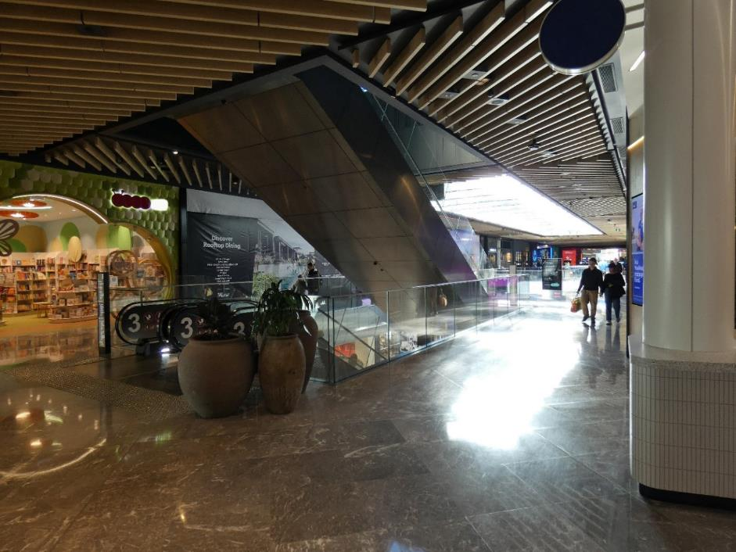
A photo demonstrating how natural light can cause glare. Natural light is streaming into the building through a water feature on the rooftop. There is a large white glare on the brown tiled floor. Photo: Ian Wilson.
Interior and exterior light levels should be as close to equal as possible. Consider the effects of natural lighting and shadowing when deciding where to place items such as entrance canopies and stairs. Entrance canopies can be effective in reducing glare from natural light sources, but they can also hide the entrance from the view of a person who is blind, deafblind or has low vision. At the design stage, the location of stairs at the outside of the building should be in clear view at all times and never shadowed by canopies or other objects. For buildings, there are many ways to mitigate both glare and solar heat gain.
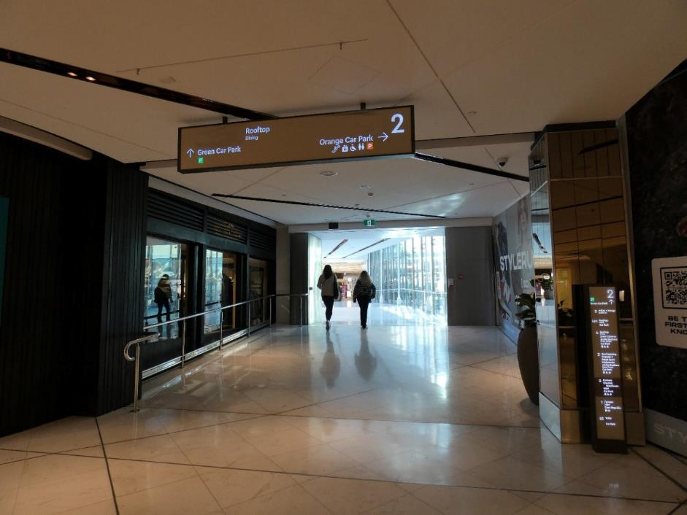
A photo demonstrating how a footbridge encased with glass creates glare and transitioning problems. Two people are walking from a dark, artificially lit environment, towards the bright, naturally lit footbridge. The other side of the footbridge is also a dark artificially lit environment. Photo: Ian Wilson.
Exterior sunshades protect the exterior skin from direct exposure and eliminate glare. Interior window coverings can be automated to respond to glare conditions. Computerized control systems allow the glare condition to be defined to suit users of the occupied spaces and can be easily modified if the use changes.

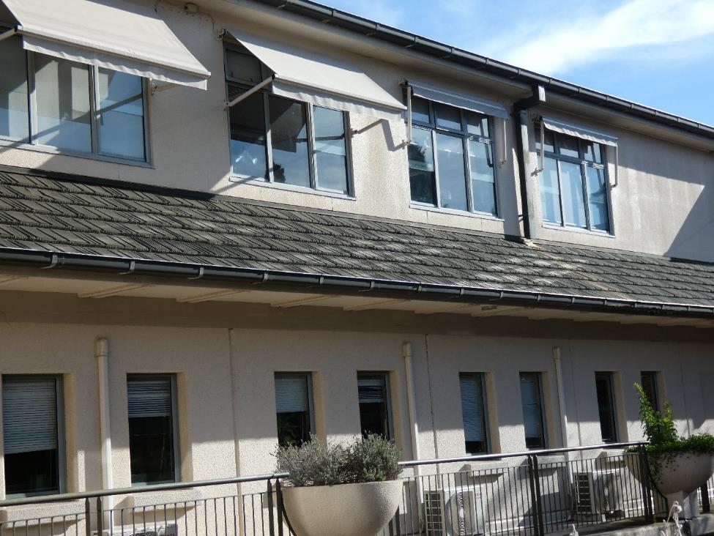
A photo demonstrating four exterior sunshades, which are retractable. Two of the sunshades are retracted, and two are in use. Photo: Ian Wilson.
Natural lighting can be enhanced with the use of light shelves, which are horizontal planes or a series of parabolic louvres that bounce indirect light off the ceiling and deeper into the building. Using these in tandem with automated artificial lighting controls (i.e., that turn off light fixtures when there is enough natural light) is effective in creating more indirect light that is free of glare. It also saves energy. Skylights and other sources of natural light should be positioned so that sunlight does not shine directly into an interior space. If this is not possible, use tinted glazing or incorporate a shading device.

3.1.2.2.2 Incandescent Lighting
Incandescent lighting is produced by light bulbs that give off both heat and light and is a good alternative to natural light. As its colour spectrum is closer to natural light than many other light sources, it was traditionally the preferred source for general-purpose illumination. However, incandescent bulbs are energy inefficient and are being replaced by devices such as fluorescent lamps and LEDs, which give more visible light for the same amount of electrical energy input.

3.1.2.2.3 Fluorescent Lighting
Fluorescent lighting consumes less electricity, lasts longer and does not radiate as much heat as incandescent bulbs. It can come in the form of tubes that create a line of light, which is the traditional lighting environment in large buildings and offices. A fluorescent tube is a more diffuse and physically larger light source than an incandescent lamp. In suitably designed lamps, fluorescent light can be more evenly distributed without a point source of glare as produced by an incandescent filament.
Fluorescent lighting has a major disadvantage in the slight flicker it produces. There are several ways to counteract this effect. You can use proper lenses or shield the light source to provide even, indirect lighting or use two tubes operating in phase opposition. These fixtures produce a substantially reduced flicker when used as an indirect light source or combined with prismatic diffusion covers, lattices, translucent shades or cover panels.
Fluorescent lighting now comes in a range of shades in the light spectrum. The cool “blue” tones of the past were not a good match for natural or incandescent light. Today’s better formulations of phosphor inside the tubes provide warmer tones. The best “soft” or “warm” white fluorescent bulbs available now are similar in colour to standard incandescent lighting. Dimmable fluorescent lighting fixtures, which use electronic ballasts working at a high frequency, will reduce both the flicker of light and energy consumption. Reduced flickering is less tiring and distracting for older adults and people who are blind, deafblind or have low vision – particularly those who rely on peripheral vision. If using a linear arrangement of fluorescent lighting in corridors, designers can take advantage of their directional attribute by installing the tubes in one of two ways:
- Centre: Placing the light fixture in the middle of the corridor provides a visual cue for orientation by helping to define the right and left sides of the corridor. This can be achieved by either indirect or direct lighting. In the case where indirect lighting is used, the centre of the corridor ceiling appears as a dark line with even, diffused, indirect and glare-free light on the ceiling.
- Sides: Placing light fixtures at the two sides of the corridor where walls meet the ceiling provides a similar visual cue that defines the width of the passageway and facilitates navigation. In this case, the lighting is indirect - the fluorescent tubes are tucked into valances or light coves along the sides. The bulbs are not visible and the cove system produces an acceptable “soft” light effect.
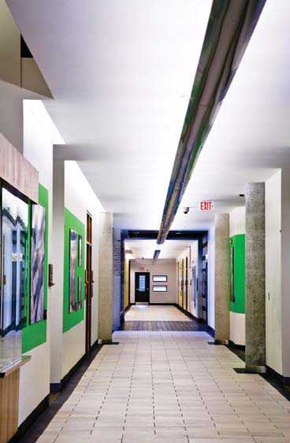
A photo demonstrating use of linear overhead lighting along the centre of a corridor. There is high contrast paint at the edge of the floor and the base of the walls. Photo sourced from Types of Lighting section of the CNIB Foundation’s Clearing our Path Manual.

3.1.2.2.4 Tungsten-Halogen lighting
Tungsten-halogen lighting is a type of incandescent lighting where a bulb’s filament is surrounded by inert gas and a small amount of halogen, which makes the bulb more efficient and increases its lifespan.
Halogen lighting produces a bright white light and provides more light per watt than regular incandescent bulbs, making it a good source of task lighting. As halogen lights are so bright, the positioning of light bulbs needs to be considered to reduce glare and shadow.
Halogen lights also give off a great deal of heat, which is an important safety consideration in any built environment. Avoid positioning halogen lights in an area beneath which someone who is blind, deafblind or has low vision might inadvertently sit or stand and be at risk of injury from the heat. If sight is required to notice the danger, either the lights should be moved out of the way or a barrier (e.g., a railing) should be used to prevent injury.

3.1.2.2.5 Light-Emitting Diode (LED) lighting
LED lighting emits an energy-efficient source of light when electricity is applied to a simple circuit. LED bulbs produce light that is very similar to daylight, making these bulbs practical.
They are frequently used as a directional light source, to focus light on an object or a building element such as a sign or reception desk. LEDs can also be configured in arrays within bulbs, providing multi-directional illumination similar to that produced by incandescent bulbs.
LED bulbs produce no ultraviolet (UV) radiation and little heat, making them ideal for illuminating objects that are sensitive to UV light, such as works of art.
Traditionally used as indicator lights on electronic devices, LED bulbs are now used in wider applications including signage, streetlamps and architectural detail lighting. LED lighting is also used as task or spot lighting and movable so the person with vision loss can get the best use of the light (e.g., under kitchen cabinets to illuminate countertops or to back light a sign).
LED Sources:
- Light up instantly;
- Can be easily dimmed;
- Operate silently;
- Require only a low-voltage power supply (which increases safety);
- Are increasingly more common and affordable.

3.1.2.3 Lighting Styles
There are many lighting styles, each with different considerations for people who are blind, deafblind or have low vision.
Spotlighting casts a strong light on a small area. In normal circulation routes or work areas, it is not usually recommended because it can create strong contrasts that cause eye adaptation problems for people with certain kinds of vision loss. Spotlighting is best used to supplement general illumination by highlighting specific features or as task lighting for a specific work location.
Many hotel reception desks and bank counters use overhead spotlights directly above the counter area to aid with reading and writing. This benefits many people who are blind, deafblind or have low vision who still have some usable vision. Please note that these lights need to be positioned so that users do not create shadows on their own work surfaces.
For example, an office area with a general lighting level of about 500 lux would benefit from task lighting from adjustable desk lamps providing illumination levels from 1,000 to 1,500 lux. However, the same desk lamps used in an area with a lower general illumination level of 50 lux will create eye adaptation problems, because the light contrast between the general light level and the workstation is too great.
Where task lighting is provided close to the user, fluorescent lighting is a safe option that does not generate heat, unlike incandescent or halogen illumination.
Up lighting and indirect lighting reflect light onto a ceiling or wall, which then indirectly illuminates a space. This is often effective in providing lighting without strong shadows or glare.
Up lighting or indirect lighting can be accomplished with different lighting designs or lamp types. The three most common types are suspended indirect fixtures, freestanding up lights and wall sconces.
Reflecting light off a ceiling mitigates glare on items such as computer screens and signage, especially when compared to traditional ceiling-mounted lighting.
Freestanding up lights are recommended in small spaces because they can be moved to suit the activity. To counteract the reduced brightness that results when light reflects off a ceiling, increase the wattage of the bulbs or use more powerful fixtures.
Wall sconces with an upward component reflect light off a ceiling as well as the wall on which they are mounted. By positioning them at regular intervals, they can be used to create a visual rhythm that can help people find their way through spaces such as public corridors. They can also be positioned to focus on specific features, such as doorways.

3.1.2.4 Placement of Light Fixtures
Exterior and interior lighting should be directed to avoid glare and reflection and to maintain a consistent pattern and level of light. The type and placement of lighting should never cause the shadowing of building elements that need to be visible.
Consistent use of different types of lighting can provide useful directional cues and help people who are blind, deafblind or have low vision differentiate between areas in a space. For example, one type of light could be used to light pathways and another type could be used for carparks.
Here is a checklist for good lighting placement:
- Avoid glare. Glare and reflection, often caused by shiny or glossy surfaces, can cause visual confusion. Check light fixtures from all angles at their proposed mounting height to identify glare-producing surfaces, and then make any necessary adjustments to the lighting or the surfaces.
- Place light sources to avoid creating problem shadows. Shadows, whether caused by natural or artificial light, can hide important features and create optical illusions. For instance, a shadow can appear to be the edge of a table or part of a building, or it might hide an obstruction from view.
- Distribute light levels evenly at working and walking surfaces.
- Include task and spotlighting to augment the overall lighting system. This is an economical way to provide extra light for certain areas without having to light the entire space brightly. Task lighting benefits everyone and is essential for people who are blind, deafblind or have low vision who require extra light for detailed tasks such as reading and writing.
- Use dimmer switches and high-wattage light bulbs whenever possible and appropriate so that lighting levels can be adjusted to suit the needs of different users of the space.

3.1.3 Colour Contrast and Brightness
Colour contrast is the degree of difference between one colour and another on the colour wheel: the more visually different the colours, the greater the contrast.
Brightness contrast (also known as luminance contrast) is the difference in brightness between one object or surface and another: the greater the difference in brightness levels, the greater the contrast.
In the built environment, colour contrast and brightness can be utilised for many purposes. It can be used to identify a door opening, to draw attention to signage, to define a route of travel or for orientation. For example, a building designer may opt to use different colours for different sections or floors in a building. However, consistency and simplicity are also important. Providing colour contrast and brightness at every turn or change in architectural detail can be confusing.
To benefit someone who is blind, deafblind or has low vision, all parts of a built environment must be taken into consideration when it comes to colour contrast and brightness. For example, a light-coloured door against a light-coloured wall would be easier to identify if the doorframe and door were a dark colour, such as brown. A sign is much easier to locate when its colour contrasts and brightness is different to the surrounding wall surface.
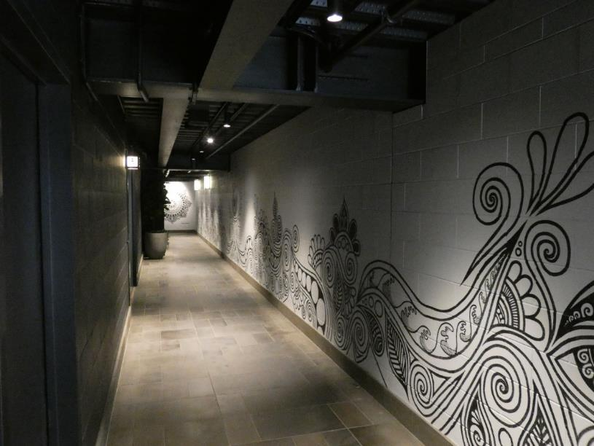
A photo demonstrating lack of colour contrast in a hallway leading to public bathrooms. Has a mural on the wall, which could be visually confusing. Photo: Ian Wilson.
Follow these guidelines to produce colour contrast and brightness for exterior spaces, interior spaces and signs:
- Use noticeably different colours side by side to distinguish different key building elements. Some good combinations are:
  - Black/white
  - Yellow/black
  - Chocolate brown/white
  - Dark blue/white
  - Dark purple/white
  - Orange/black
- Avoid these colour combinations, which have poor contrast:
  - Yellow/grey
  - Yellow/white
  - Black/violet
  - Red/black
  - Grey/white
  - Light blue/white
- Avoid these colour combinations, which have poor contrast and are particularly difficult for people with colour blindness:
  - Red/green
  - Blue/green
- White lettering on a dark background is easier to read for people who are blind, deafblind or have low vision than dark letters on a white background. Further information is provided in the Signage section.
- Keep colour schemes simple to avoid confusion in your design. Too many colours and busy patterns create confusion.
- Be consistent in the use of colours to convey specific information. For example, use one colour for all entrances to women's toilets in a building and a contrasting colour for all entrances to men's toilets.
- When it is impossible to adjust the colour or contrast of an item, consider other options. For example, when the colours in a corporate logo cannot be changed, and the logo includes colours with poor contrast, place a contrasting border around logo signage.

3.1.4 Acoustics
Sounds can give a person useful information about a space. People who are blind, deafblind or have low vision may snap their fingers, tap a long cane or make another noise to listen for a reflected sound, a process known as “echolocation”.
Echolocation may help to detect the size of a room, presence of corridors or proximity of structural barriers (e.g., walls and poles). Within a built space, specific sounds can provide information about the location of specific features, such as elevators. However, the space must be designed to allow all of these sounds to be heard.
Inappropriately high levels of reflected and ambient sound (sound glare) within an environment will result in sound masking. Sound glare interferes with the process of locating an auditory cue and can confuse and tire a listener. Crowds of people, construction or maintenance noise, a jet plane flying overhead or background music in lobbies and elevators can drown out useful auditory information. Layouts that feature large rooms with high, open ceilings result in excessive noise, making navigation or orientation extremely difficult for someone with vision loss. If possible, avoid this kind of layout to ensure all guests and patrons have the best possible experience.
A solid object located between a sound source and a listener can create a sound shadow. Sound shadows can provide useful information, but they can also cause disorientation for a person who relies on specific sound cues for mobility. For example, a temporary display, scaffolds used for building maintenance and repairs or decorative items that are positioned after building construction can distort or block critical sounds.
While a building designer cannot control every occurrence of sound glare or shadowing, there are a few steps that should be considered when planning the acoustic design of a space:
- Well-defined, acoustically alive spaces are easier for people who are blind, deafblind or have low vision to traverse safely. Position elements such as water fountains, elevators or escalators to create useful sounds. For example, a water fountain could be positioned to indicate a garden or reception hall. An escalator would be a good indicator of a central location that’s an important part of the building’s design.
- Carpets, acoustic ceiling tiles and upholstered furniture absorb sound and dampen reflected sound. Create a good balance of sound absorption and sound reflective materials so that people can “hear” the space (i.e., get information about the space through sound).
- Sound sources may mask other sounds intended to provide important directional cues. Consider the noise produced by elements such as ventilation ducts or air conditioning units. These sounds can be useful but they should not obscure other important audio cues, such as the sounds from an elevator’s arrival or a public address system.
- Glass can be an effective sound buffer. Use a double-glazed glass that has an established sound-reduction capacity.
Reflected sounds that enable a person to use echolocation are frequently a good source of auditory cues. Consider how the structure and texture of planned circulation routes might interact with user-created sounds (e.g., the tapping of a cane) before building or retrofitting a space.

3.1.5 Complexity
Keep things as simple as possible with no clutter. The priority should be about the traveler. Facilities should consistently consider the safety and efficiency of the traveler.

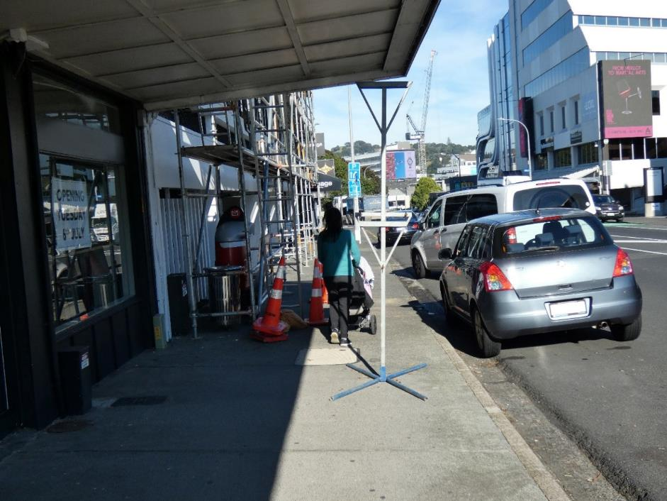
A photo demonstrating a cluttered and narrowed footpath due to construction, and a member of the public pushing a pram through a narrow walking space. Scaffolding takes up half the width of the footpath. A warning sign stand is on the footpath before the scaffolding, but there is no warning sign on the stand. Photo: Ian Wilson.

3.2 Exteriors and Interiors — Common Design Elements
This section provides details for design elements that are commonly used in both interior and exterior environments.
Design requirements for accessible paths of travel are introduced, including stairs, ramps and platform edges, with a focus on the elements that impact safety and usability for people who are blind, deafblind or have low vision. Guidance on how to use warning and guidance tactile ground surface indicators (TGSIs) are provided.
This section also presents the importance of signage for people who are blind, deafblind or have low vision, along with guidance on sign size, configuration and location. It concludes with the technical requirements for information and communication systems that are usable by people who are blind, deafblind or have low vision, including information desks, public address systems and building directories.
For more information, refer to the sections on Exterior Design Elements, Interior Design Elements, and Signage.
The technical requirements within this section are derived from a number of sources including the sources listed below. Please refer to these documents for more complete technical requirements. We also note that local councils may have their own standards and regulations.
- New Zealand Building Act 2004
- New Zealand Building Code
- Access Standard NZS 4121:2001
- Waka Kotahi – New Zealand Transport Agency (Waka Kotahi) Pedestrian planning and design guide
- Waka Kotahi Requirements for urban buses in New Zealand (the 'RUB')
- Auckland Transport (AT) Transport Design Manual, Waka Kotahi RTS 14 - Guidelines for facilities for blind and vision impaired pedestrians
- Auckland Council – Auckland Design Manual, and in particular the Universal Design Guide
The Auckland Council Universal Design Tool takes people through a Universal Design approach to development for commercial buildings. The tool provides practical design solutions illustrated with diagrams, real-life examples and checklists.

3.2.1 Continuous Accessible Path of Travel
A path of travel is any space in a public facility where people might reasonably be expected to move from one point to another. It is essential to pay attention to the design of paths of travel when considering people who are blind, deafblind or have low vision.
The continuous accessible path of travel defines the area where the pedestrian route is safe and convenient for everyone, especially people with impaired mobility, and people who are blind or have low vision. It has even surfaces, gentle slopes and is free of permanent and temporary obstacles at all times. The preferred width is 1.8 metres (minimum width 1.5 metres), but wider is beneficial on busy footpaths, refer to the Waka Kotahi Pedestrian Planning and Design Guide 14.2 for specific details on footpath widths.
A continuous accessible path of travel should ideally be straight, with turns as equal to 90 degrees as possible. Ensure the path’s surfaces are firm, stable, slip-resistant and free of glare. Avoid using busy and heavily patterned surfaces, which can result in visual confusion and disorientation.
Pedestrian paths of travel should be designed to intersect as close to a right angle as possible, and the intersecting paths should continue in straight lines.
Obstacles such as advertising and regulatory signs, seating, rubbish bins, utility poles, post boxes and bus shelters should be kept clear of the continuous accessible path of travel at all times. Advertising signs on the footpath should be avoided if possible. Where advertising is permitted, signs shall be located away from the continuous accessible path of travel, i.e., on the kerb edge, and always placed consistently in the same location.
This summary information has been adapted from Section 4.3 in RTS 14. Refer to the full document for further guidance and best practice demonstrative photos.
Section D3.2 in Access Standard NZS 4121:2001 addresses design issues for people with vision loss. For example, people with vision loss using mobility aids need a clear width of up to 1.2m when moving through spaces.
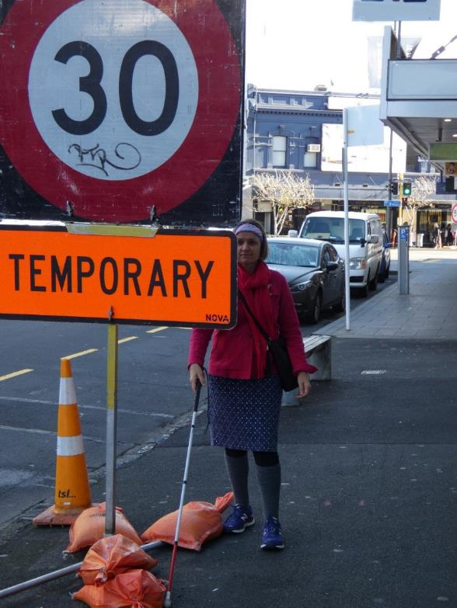
A photo demonstrating a white cane user missing an obstacle due to overhanging signage on the footpath at head height. Photo: Ian Wilson
Dimensional criteria for ensuring that protruding objects and other obstacles are cane detectable.
Avoid placing objects or signs that will protrude into the continuous accessible path of travel (also referred to as a through route). They are potentially hazardous to people who are blind, deafblind or have low vision unless they are located within the detection range of a long cane.
A protrusion is an object projecting into the footpath from the side. Very minor protrusions are acceptable, as long as they are not within the pedestrian through route and comply with the dimensions in Table 14.6 of the Waka Kotahi Pedestrian Planning and Design Guide. Every item protruding into the footpath needs to have an element (which can include any mounting post) within 150 mm of the ground, so that white cane users can detect it.

3.2.2 Tactile Ground Surface Indicators
TGSIs, also known as detectable warning indicators or directional indicators, are there to provide pedestrians with visual and sensory information.
Chapter 5 in RTS 14 includes further guidance on where and how TGSI should be installed and used in different environments. Importantly, it also includes guidance on TGSI maintenance. This chapter also points to relevant sections in the Waka Kotahi – New Zealand Transport Agency (Waka Kotahi) Pedestrian planning and design guide.
TGSIs should be made from any material that complies with AS/NZS 1428.4.1: 2009, – Section 2.3.1 and 3.2.1. When selecting a material, consideration should be given to the performance characteristics of the material, such as:
- Visual contrast;
- Slip resistance in wet and dry conditions;
- Resistance to impact, i.e. chipping or cracking;
- Shall exhibit weathering and UV stability for maintaining high visual colour contrast;
- Wear resistance;
- Adhesion/bond strength - particularly if immersed in water.
This summary is copied from section 5.2.3 in RTS 14. Please refer to the full document for more detailed guidance and information.

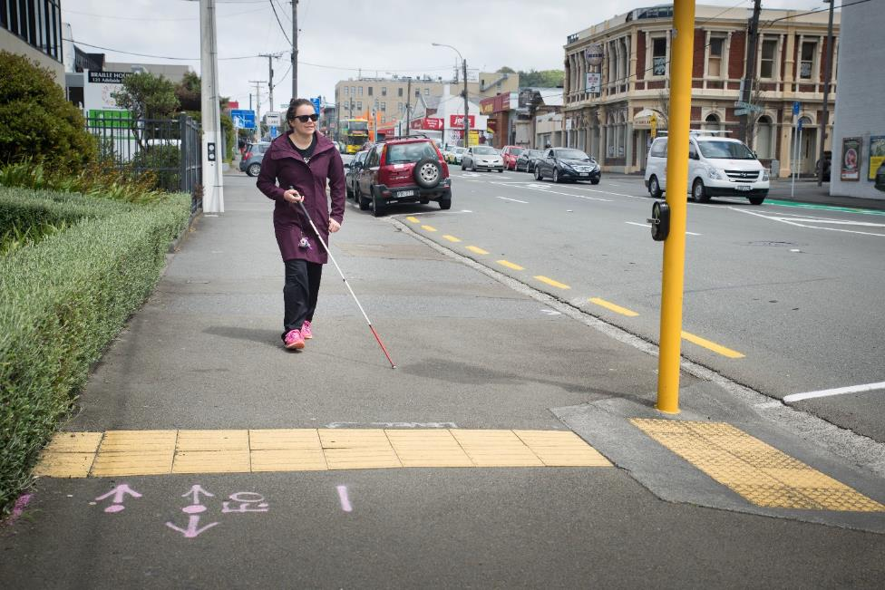
A photo demonstrating good use of direction and warning TGSIs. Mary Fisher, pictured here using a cane, is walking along the footpath approaching a yellow tactile strip on Adelaide Road, Wellington. The tactile strip, indicating a traffic light controlled crossing, spans the entire width of the footpath, ensuring easy detection. Sourced from the Access Matters Barriers Photo Library. Photograph taken November 16, 2018, by Victor Komarovsky | For Purpose. Copyright: Attribution-NonCommercial-ShareAlike.
There are two types of TGSIs:
- Warning TGSIs - Warning indicators alert people who are blind or have low vision, to pending obstacles or hazards on the continuous accessible path that could not reasonably be expected or anticipated using other tactile and environmental cues.
- Directional TGSIs - A directional indicator is a textured surface feature consisting of directional grooves built into or bars applied to walking surfaces to give directional orientation to people who are blind or have low vision. As with any facility, directional indicators should be used appropriately and not overused. If overused, it can lead to pedestrians who are blind or have low vision being unable to tell the difference between indicators intended for different purposes.

3.2.2.1 - Warning Tactile Ground Surface Indicators
Warning indicators are intended to function much like a stop sign. They alert pedestrians who are blind or have low vision to hazards in their line of travel, indicating that they should stop to determine the nature of the hazard before proceeding further.
Warning indicators are installed to inform people who are blind or have low vision of:
- Life-threatening hazards where serious falls may occur, such as at railway platforms or wharves;
- All pedestrian kerb crossing points (both formal and informal), paths cut through medians, and other places where the footpath is not separated from the roadway by an abrupt change of grade of at least 12.5% (or 1:8) or with a vertical kerb more than 70mm high;
- Approaches to stairways, ramps, escalators and moving walkways (Section 5.13);
- The presence of level railway crossings (Section 5.7.5);
- Overhead impediments or hazards other than doorways (e.g., wall-mounted objects and archway structures), with a clearance of less than 2m from ground level, in an accessible open public space with no clearly defined continuous accessible path of travel;
- Location of bus boarding positions.
Warning indicators may also be installed to inform people who are blind or have low vision- of:
- Vehicle hazards at busy vehicle crossing points such as at shopping centres, bus stations and large public car parks, where other design solutions are not appropriate (Section 4.12)
- Street furniture inappropriately located in the continuous accessible path of travel and not detectable by a person who is blind or has low vision using the aid of a white cane.
This summary is copied from section 5.2.1 and 5.2.2 from RTS 14. Refer to the ful, document for detailed information and demonstrative photos.

3.2.2.2 Directional Tactile Ground Surface Indicators
Directional indicators should only be used where other tactile and environmental cues, such as the property line or kerb edge, are either absent or give insufficient guidance. They:
- Give directional orientation in open spaces;
- Designate the continuous accessible route to be taken to avoid hazards;
- Give directional orientation to a person who must deviate from the continuous accessible path to gain access to a crossing point, public transport access point, or point of entry to a significant public facility e.g., public toilet, information centre.
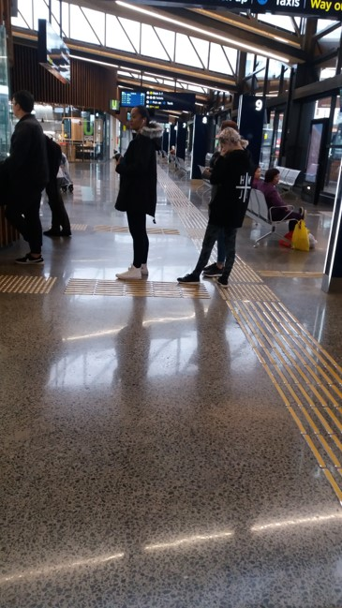
A photo demonstrating good use of directional TGSIs leading to a payment station. Photo: Blind Low Vision NZ

3.2.3 Visual contrast
The visual contrast between the walking surface and surrounding environment is critical for people who have low vision. They are using their limited residual vision for orientation, distinguishing the limits of the footpath, recognising hazards and gathering information. Contrast is especially important in the provision of TGSI to warn pedestrians of hazards. TGSI should provide high visual contrast to the adjoining walking surface.
“Safety Yellow” is the recommended standard colour for TGSI. Provided that contrast requirements are met, other colours may be used. User views should be sought from Blind Low Vision NZ.
High visual contrast must be maintained throughout the product’s useable life. Visual contrast exists in three dimensions – brightness, hue and saturation.
Brightness refers to the amount of light reflected by a surface – perceived as light or dark. Differences in brightness provide the main contrast available to a person with poor colour discrimination. Minimum luminance contrast values are specified in Section 2.2 of AS/NZS 1428.4.1: 2009 which also details techniques for laboratory and on-site measurement of differences in Light Reflectance Value or luminance contrast. AS/NZS 1428.4 requires the following minimum luminance contrast to the immediately adjoining surface
- For tiles of uniform colour: 30%
- For individual domes of uniform colour used in warning TGSIs: 45%
- For individual domes with different characteristics on the sides and top of the domes: 60%
Hue refers to the basic colour reflected by the surface, and can simply be described by the elementary colour names such as red green yellow blue. It is most easily understood by reference to the colour wheels used in paint charts
Saturation refers to the purity of colour. Highly saturated colours are pure and vivid whereas colours with low saturation are pastel or dull.
This summary is copied from section 5.3 in RTS 14. Please refer to the full document for more detailed guidance and information.

3.2.4 Stairs
Refer to section 8 of Access Standard NZS 4121:2001 for detailed guidance, dimensions and photos that demonstrate best practice.
The Auckland Council – Auckland Design Manual-Universal Design Guide Stair Checklist is a good guide as well.
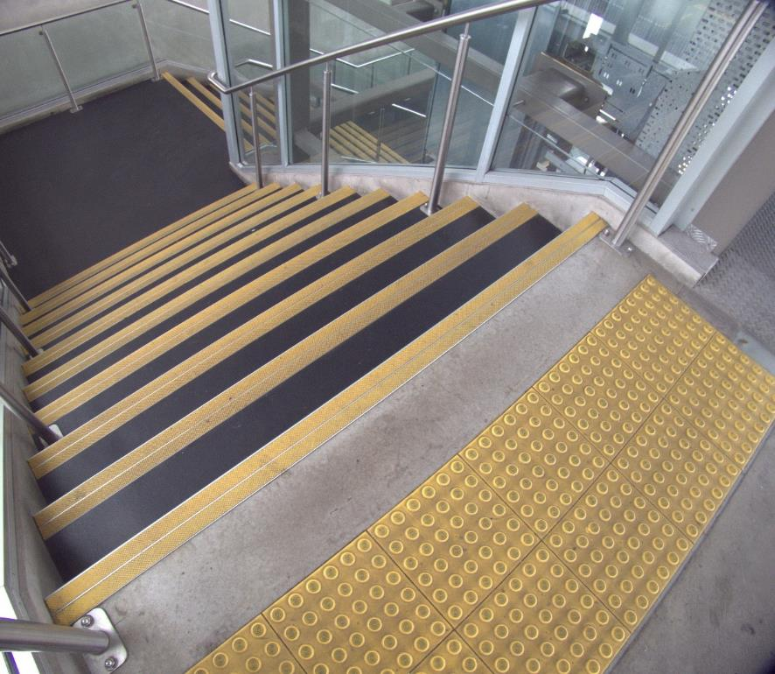
A photo demonstrating good use of warning tiles to indicate the start of stairs, and good colour contrast on stair nosing. Photo: Ian Wilson

3.2.4.1 Location
Stairways need to be clearly marked and easy to find without posing an unnecessary danger. Place stairways near main circulation routes so that they are accessible. They should also be offset from the direct route of travel to reduce hazards.
Stairs can be particularly hazardous for people who are blind or have low vision, given the serious fall or trip that could occur if a pedestrian were to inadvertently step off, or onto, a flight of stairs. At the top of the stairs, a fall could be particularly serious, while the bottom stair presents a trip hazard, and indicates the commencement of the landing.
At stairs, warning indicators should be installed
- The full width of the path of travel;
- 300mm back from the top and bottom steps;
- At least 600mm deep at the top and bottom of a flight of stairs.
See section 5.14 of RTS14 for best practice information on how to use TGSIs at stairs and escalators. This section refers to AS/NZS 1428.1: 2009 Section 2.4, provides examples of stairways and escalators and prescribes the requirements for installing TGSI in these situations.
In a building with more than one level, stairways should be placed consistently in relation to other repeated building elements. Stairs should not be installed in unexpected locations, which could easily disorient a visitor who is blind, deafblind or has low vision.

3.2.4.2 Treads and Risers
Stairways that require the user to step unevenly (e.g., two steps forward followed by one step up) can be confusing and sometimes dangerous for people who are blind, deafblind or have low vision. Treads and risers on stairs should be arranged so that users can maintain a consistent climbing rhythm.
Follow these guidelines for treads and risers:
- A flight of stairs should have uniform riser heights and tread depths;
- Risers should be closed, not open;
- Treads should be covered with, or made from, a slip-resistant textured surface extending the full width of the tread. This surface should cover at least half the depth of the tread starting at the nosing;
- Carpeting with bold patterns should not be used. Bold patterns can cause perceptual problems and obscure the edges of the treads.
A photo demonstrating a carpet with a visually complex pattern. The carpet inside one of New Zealand's major domestic airports has a highly complex, visually stimulating pattern. This can create confusion for people with low vision, and may be overstimulating for those with sensory sensitivity, such as people with autism. Sourced from the Access Matters Barriers Photo Library. Photograph taken November 17, 2018, by Victor Komarovsky. Copyright: Attribution-NonCommercial-ShareAlike.

3.2.4.3 Nosing
A nosing can improve the visibility of each tread, clearly defining where it ends and giving users the confidence to walk up and down.

3.2.4.4 Handrails
Handrails along the sides of staircases prevent accidents by providing support and serve as visual and tactile guides for people who are blind, deafblind or have low vision. Where possible, use handrails continuously throughout a stair system, along both sides of a staircase and continuing along the sides of all adjoining landings.
The ends of handrails should meet the wall or floor, or a post, to avoid hazards for pedestrians.
Handrails should have continuous gripping surfaces that aren’t interrupted by construction elements (such as newel posts) or obstructions that can break a hand hold.
Handrails should be free of any sharp or abrasive elements.
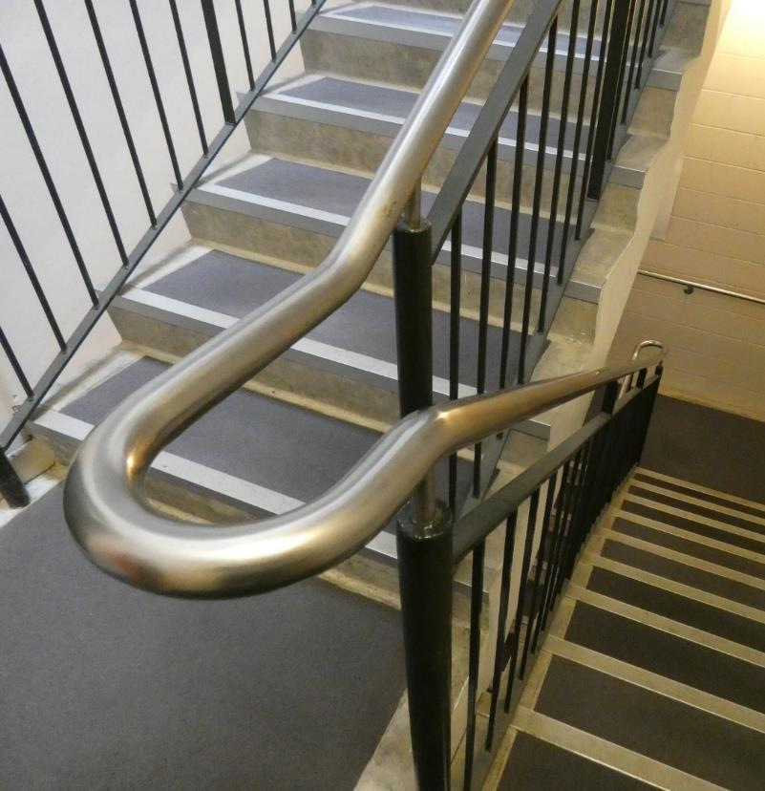
A photo demonstrating a continuous handrail on stairs and landing. Please note on the landing the handrail is level. Photo: Ian Wilson

3.2.4.5 Underside of Stairs
If a route of travel exists underneath a staircase, you must ensure that a person cannot accidentally bump into the underside of the stairs.
Space underneath the stairs should be at least 2200mm high from the finished walking surface. If this is not possible, consider installing architectural detailing, plants or guardrails that can be detected by people who use long canes or guide dogs. This will help prevent accidental access to the underside of the stairs.

3.2.4.6 Lighting
Adequate lighting is a very important measure for increasing safety on stairs.
Make sure all step edges are easy to see across various lighting conditions by using visual highlights or tonal contrasts.
Lighting systems for stairs should be positioned so that they do not produce shadows or glare across the steps. You should also avoid lighting that casts shadows from outdoor objects (e.g., canopies) across the stairs.

3.2.5 Ramps
Ramps should be avoided where it is possible to design level access instead. Use ramps to provide access to different elevations of public areas of the built environment if other accessible options, such as elevators, are not available.
The maximum gradient of a ramp (other than a kerb or step ramp) is 1 in 12.
Refer to section 6.4 of Access Standard NZS 4121:2001 for detailed guidance, dimensions and photos that demonstrate best practice. The Auckland Council – Auckland Design Manual-Universal Design Guide Ramp Checklist is a good guide as well.
In this section:
- Width and Landings
- Handrails

3.2.5.1 Width and Landings
Ramps require level landings at the top and bottom, wherever there is a change in direction, wherever doors open off them and at intervals not exceeding 9000mm.
Landings should be level and should be provided at all changes of direction. Include a landing at the top and bottom of each ramp run. These landings should have a minimum dimension of 1200mm. Landings served by doorways should have a minimum surface area to allow people enough space to change direction safely and without obstruction.
Refer to section 6.5 of Access Standard NZS 4121:2001 for detailed guidance, dimensions and photos that demonstrate best practice on landings at ramps. The Auckland Council – Auckland Design Manual-Universal Design Guide Ramp Checklist is a good guide as well.

3.2.5.2 Handrails
Ramp landings need to have handrails at a height of 840 - 900mm on all open sides.
Refer to section F of Access Standard NZS 4121:2001 for detailed guidance, dimensions and photos that demonstrate best practice on handrail design.

3.2.6 Platform edges
Pedestrians who are blind or have low vision rely heavily on public transport and therefore need to identify areas of access to public transport. TGSI alone will not distinguish public transport access points from road crossing points. Other environmental cues such as a person’s environmental perception, orientation and awareness will help to determine between particular crossing points and other features, such as areas of access to public transport. For example, most bus stops will not have kerb ramps, but do have bus stop information signage.
TGSI to identify access to public transport should be installed as follows:
- Warning indicators 600mm deep and installed 600mm from the edge when used at train platforms and ferry wharves (see Photo 5.4 in the Waka Kotahi – New Zealand Transport Agency (Waka Kotahi) Pedestrian planning and design guide for an example);
- Directional indicators 600mm deep, installed where the warning indicators are not located in the direct line of the continuous accessible path of travel, forming a continuous path to the warning indicators.
Parts of this summary are copied from section 5.5 in RTS 14. Refer to the full document for further guidance on where and how TGSI should be installed and used around platform edges. Importantly, it also includes guidance on TGSI maintenance. This chapter also points to relevant sections in the Waka Kotahi – New Zealand Transport Agency (Waka Kotahi) Pedestrian planning and design guide.

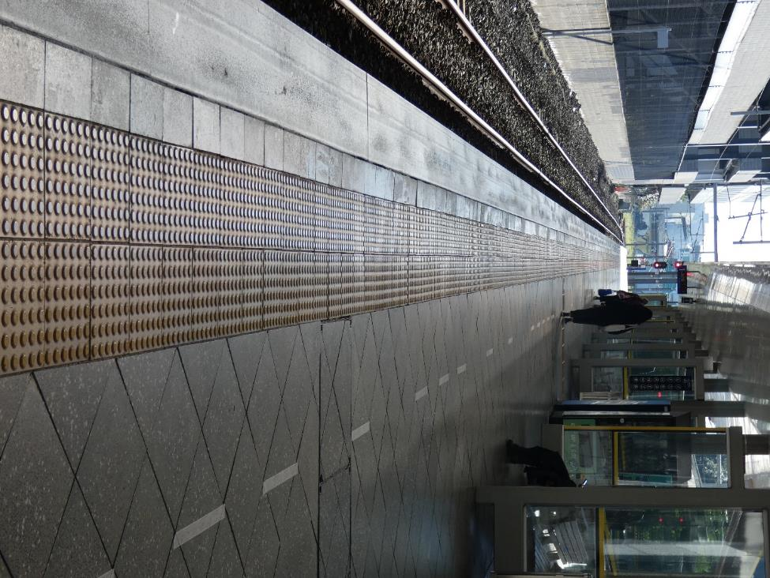
A photo demonstrating the use of warning tactiles at a train platform. Photo: Ian Wilson.

3.2.7 Signage
Accessible signs should be provided for any features of a building that would normally be given a print sign. Signs have three functions:
a) Informative—Advising about availability of facility or service;
b) Directional—Directing to a specific facility;
c) Locational—Identifying the place where the facility is provided.
Installing accessible signage which complies with these guidelines will help with compliance with section F8 of the New Zealand Building Code Handbook and section 5.3 of the Access Standard NZS 4121:2001. This also aligns with the New Zealand Disability Strategy 2016-2026 Outcome 5 – Accessibility, which states: "We access all places, services and information with ease and dignity".
New Zealand Standard 4121: 2001 (NZS4121) provides guidance but is not detailed, particularly for tactile signage (braille, embossed print and tactile pictograms). Braille standards have been developed and adopted by the Braille Authority of New Zealand Aotearoa Trust (BANZAT) and reflect the way braille is used in New Zealand. This includes the use of Unified English Braille (UEB) and Te Reo Māori.
Signage that is truly accessible can be read and understood by every customer, whether they read by sight or touch.
General guidance is provided in this section; please see the full Blind Low Vision NZ Accessible Signage Guidelines: Braille, Tactile and Clear Print Fifth Edition (2018).
We recommend that braille, high contrast tactile print and large print signage b provided in all publicly accessed buildings and spaces. These include, but are not limited to:
- Toilets and showers—both general and specifically accessible facilities;
- Elevators—controls and floor indicators;
- Numbers on stair landing hand rails to allow identification of floors;
- Office and hotel room name/number plates;
- Emergency doors, routes and exits;
- Emergency evacuation instructions;
- Cautionary signage;
- Floor and building directories;
- Door controls on public transportation vehicles—emergency and standard;
- Free telephones in shopping malls;
- Bus stop, interchanges and train platform numbers;
- Signage in marae and places of worship;
- Operating instructions e.g., for vending machines or toilets;
- Offices and meeting rooms;
- Libraries;
- Shopping malls;
- Reception areas;
- Entrances to buildings.
Signs provide essential information to everyone. To accommodate the needs of the general public, including people who are blind, deafblind or have low vision, follow these basic guidelines:
- Keep sign information short and simple. Signs that are easy to understand generate confidence;
- Be consistent in the placement of signs. For example, place signs at decision-making points along routes of travel, including entrances and exits, and mount signs at the same height throughout a building;
- Mounting heights should be appropriate for the primary occupants of a building. Lower signs may be suitable in facilities intended primarily for the use of children;
- Where lower signage is used, ensure safety-related signs are provided at both lower and standard mounting heights;
- Use typefaces, colours and graphics logically and consistently.
See the BLVNZ signage guidelines for technical requirements and guidance on signage.

3.2.7.1 General
Signs should be accessible to all users of the building or facility, including people who are blind, have low vision and those with additional learning or cognitive impairments.
The most accessible sign contains braille, large print, embossed (raised) print and embossed pictograms. Always accompany any pictogram with print and braille text. Some readers will not know what the pictogram means without accompanying text.
Where possible, braille, print and pictograms should be included on the same sign. Having multiple formats on one sign helps some readers clarify or confirm the meaning and strengthens the sign’s message.
The braille should convey the same information as the print.
Do not convey information solely through colour or images. Provide information in raised print and braille as well. NZSL Video could also be used or made available for use on mobile devices.
Make signs clear and unambiguous. Keep text short and simple.

3.2.7.2 Placement
Place signs at a consistent height and location throughout a building or facility.
Place tactile signage where it can be reached easily without obstruction.
Place signs logically and as close as possible to the object or destination they are indicating. (e.g., Place "push" near the door opening for easy location).
Place signs at the entry point to corridors.
In general, where a single sign contains print, embossed print and braille, keep the braille at optimum reading height for most people, especially where sign plates extend below the braille.
Always place separate braille sign plates in a consistent location relative to the print sign.
For playgrounds, primary schools, or other facilities where the main population is likely to be children, place the signs at an appropriate height. It is important to remember that signage also needs to be accessible for adults employed or visiting the facility.
Avoid suspended signs as they are very difficult to locate and too high to be read by a person with low vision.
Avoid protruding signs or sandwich boards as they are a health and safety hazard.
If doors are generally left open (e.g., office doors), place the sign on the wall or glass on the latch-side. If there is insufficient room, the sign can be placed on the hinge side as near to the door as possible. Choose whichever side would be more logical and usable, and be consistent throughout the building.
If doors are generally left closed (e.g., hotel room or toilet doors), place the sign on the door itself. Braille should be placed directly underneath pictograms or print numbers if they exist. Always include braille and print text as well as the pictogram. A pictogram alone is not enough.
For elevator controls, place braille and embossed characters to the immediate left of the buttons (as per NZS4121).
Place tactile elevator floor indicators on the leading edge of an entrance door or landing architrave.
For handrails, place braille and tactile print parallel to the longitudinal direction of the rail. Place the braille on the area where it can most easily and safely be read by touch. Determine the best place for braille and tactile print based on the handrail’s shape, thickness, surroundings and the method by which the handrail is fixed.
Only place braille on hand rails if the floor surface is flat to allow for safe standing while reading. This means handrails on stairs should have extensions where braille and tactile print can be placed.
Most importantly, be consistent around your entire facility to ensure all users can easily locate your signage.
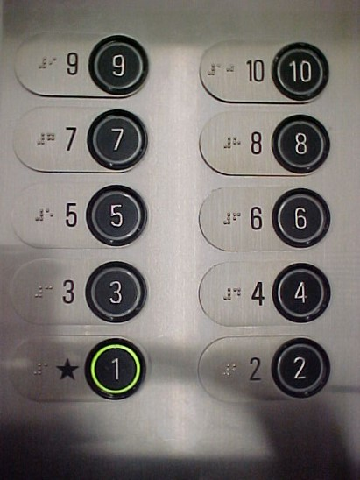
A photo demonstrating good use of braille and contrast in a lift on the call buttons. LED lighting creates colour contrast. The braille is to the left of the call buttons, and not on the call buttons themselves. This way a blind person doesn't accidentally press all the floor buttons until they find the floor they want to go to. Photo: Blind Low Vision NZ.

3.2.7.3 Contrast
Ensure that the sign visually contrasts with its background so that it can be located more easily by people with low vision. For example, on a light-coloured wall, use a sign with a dark background and light coloured print. If a sign must be placed on a similar coloured wall, use a thick border of contrasting colour to assist with the location.
Embossed and large print should have a minimum 30% luminance contrast to their sign background. This should be measured in all lighting conditions. The sign itself should contrast 30% with the surface on which it is placed.
For signs placed on glass, ensure that there is enough colour contrast between the sign and its background. A thick border of contrasting colour surrounding the sign may be helpful.
Avoid placing signs on backgrounds that contain a lot of visual clutter—this can include general information such as posters, pictures and pamphlets which do not communicate orientation information.
Ensure the sign is in an area with good lighting. Avoid creating shadows on areas of the sign. Task lighting can assist with location of the sign in poorly lit areas.
Reflective glare will make the sign more difficult to read. Use non-reflective surfaces and ensure that lighting does not create glare on the sign.
The table below shows several effective combinations for signs when choosing colours for a surrounding surface, sign background (signboard) and lettering:
Background surface | Sign background | Lettering colour
Light brick or light stone | Dark (black preferred) | White or yellow
Whitewashed wall | Dark (black preferred) | White or yellow
Red brick or dark stone | White | Black, dark green or dark blue

3.2.7.4 Layout
All text and braille on a sign should be left-aligned and set horizontally.
Where embossed print and braille appear on the same sign plate, place braille a minimum of 10 mm below the corresponding print.
Use simple, consistent and logical layout.
Avoid complicated images. Keep the design simple with a plain background. Avoid too much information on one sign.

3.2.7.5 Durability and Maintenance
As most signage is intended to have a long lifespan, choose durable materials, which can be cleaned easily. The material should also be able to withstand heat and sunlight.
Cardboard or adhesive braille label are only suitable for temporary signage, which may need to be moved frequently, for example, office name plates. These materials can easily be pulled off or fade with time and use.
If tactile elements of your signs have degraded over time, they should be replaced so that the sign remains readable.

3.2.7.6 Braille Signage
A tactile sign is any sign that can be read by touch. Braille, raised print and raised symbols or pictograms are examples of tactile elements used on signs. Doors and openings that lead to public spaces should be identified by tactile signage.
Technical Specifications
Braille dots should have a domed or rounded shape—make sure they are not pointed or flat. Braille dots must be raised from the surface of the sign plate. Engraved braille is impossible to read. Empty space between braille cells or words should be preserved or braille will be unreadable.
The standard for braille in New Zealand is Unified English Braille. For braille signs of 10 words or less, use uncontracted braille. For floor directories, use uncontracted braille.
For signs of greater than 10 words, use contracted braille only if the sign consists of sentences such as emergency evacuation instructions. Ensure contracted braille follows Unified English Braille rules.
Generally, do not use capital letters in braille signs, except for emergency instructions which comprise sentences.
If text is multi-lined, print and braille should appear in separate blocks. Do not interline the print and braille. Place all the braille a minimum of 10 mm below the entire raised print text.
Where a sign contains a single letter (for example Platform B), a letter sign should not be used in braille.

3.2.7.7 Print Signage
Clear Print: Readability by sight
The size, type and layout of lettering on signs must be clearly legible.
Use a clear, simple sans serif typeface with uniform stroke width, wide horizontal proportions and distinct letterforms including prominent ascenders and descenders and open counter forms. Some examples of suitable typefaces are Arial, Gill Sans, Clearview ADA, Agro Sans, Frutiger and Helvetica.
Avoid using italics, stylised print, and underlining and block capitals.
The initial letter of each word should be in upper case. The whole word should not be capitalised. Initial capitals help with letter and word recognition. Example: Female Shower
Always ensure the sign background contrasts with the print. Clear colour combinations include black text on a white background, white on black, yellow on black or black on yellow.
Do not print information over pictures or patterns.
Characters and their background should be non-reflective.
For non-tactile print, the size of the text should be related to the distance at which the information is to be viewed.
Raised or Embossed Print: Readability by Touch
Raised letters should have rounded edges.
Embossed characters should be integral to the sign.
Tactile text should be left-justified, except for single words that may be centre aligned.

3.2.7.8 Pictograms
When using pictograms for features like exits or male/female toilets, use internationally recognised symbols (refer to Access Standard NZS 4121:2001 and ISO 7001).
Make sure pictograms are accompanied by raised print and braille. The pictogram is not sufficient on its own—some people will not know what the picture means.
If using the International Symbol of Access, make sure it conforms to that shown in Appendix E of NZS4121.
Raised arrows can be used to indicate direction. These should appear either at the beginning of a line of text or directly after the text label. Avoid large spaces between arrows and their labels. Where braille is on a separate sign plate, a small raised arrow should be horizontally aligned with the braille, either directly before or after the braille text.
Always ensure the sign background contrasts with the pictogram. Clear colour combinations include black text on a white background, white on black, yellow on black or black on yellow.
Raised pictograms should have soft-shouldered edges, and should be raised from the surface of the sign plate.

3.2.7.9 Te Reo Māori
Te Reo Māori uses the same alphabet as English braille. We encourage the use of Māori braille on signage alongside English braille. Use uncontracted braille in all instances except for ‘wh’. If a macron is shown on the print sign, then the macron should be shown on the braille sign also. Please follow all other guidelines regarding placement, spacing and capitalisation.
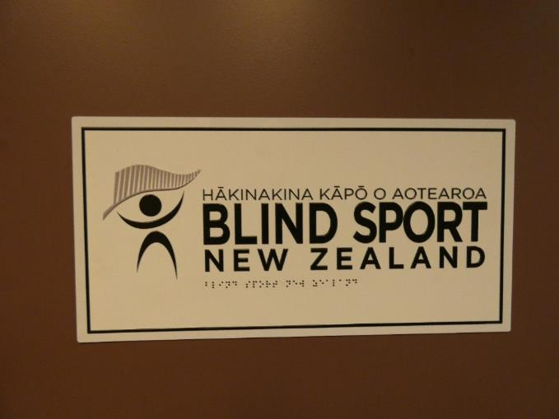
A photo of the Blind Sport New Zealand logo. The photo is demonstrating how contrast, braille and Te Reo Māori are effectively used on signage. There is also good contrast between the dark door, and white background, and black lettering and braille. Photo: Ian Wilson.

3.2.7.10 Audible Signs
Audible signs are signs that use speech technology to supplement the information typically found on print signs. Do not use audible signs exclusively, as they don’t provide an accessible solution for individuals with hearing loss.
More and more, audible signs are becoming part of the built environment for the benefit of most users, not just users who are blind, deafblind or have low vision. They are commonly used in elevators to direct passengers to the correct floor. They are being used increasingly by public transit systems to automate the announcement of upcoming stops and the destination of arriving transit.
Audible signs should be simple and intuitive to use. They should be audible only when required (i.e., to the user only, not to all passing people) and silent when necessary.
Audible signs can be manually activated by a button or other control, or automatically activated using technologies such as radio-frequency identification (RFID) or Bluetooth. New technologies are evolving rapidly. Automatic activation is preferred, as buttons/controls can be difficult to locate by people who are blind, deafblind or have low vision.
Applications for RFIDs are expanding. They are being used on footpath pavements to orient people to their surroundings.
Information Audio and vibration is also helpful. The use of simply plain English is preferred.
Refer to section 6.2.5 in RTS14 for further guidance on what constitutes an audible volume. Audible signals should have a volume control that is automatically responsive to the ambient (background) noise level as specified in AS 2353: 2018.

3.2.7.11 Electronic Signs
Dynamic signage is being used increasingly within built environments, replacing traditional signs with liquid crystal display (LCD) monitors and LED displays. Refreshable digital screens are being used for many types of signs, including building directories, elevator call systems, room identification/information signs and stop identification signs within transport vehicles.
The dynamic nature of the information provided by digital signs presents many challenges for people who are blind, deafblind or have low vision. As with any sign system, the information presented visually should also be made available in an alternative format such as audio or tactile information.
The design requirements for electronic signs are no different from those of traditional signs that are read through sight. The technical requirements presented throughout the signage section are equally applicable to electronic signs.

3.2.8 Information and Communications Systems
While it’s important to review the characteristics and common features of the built environment that support independence, it’s also important to proactively provide information to people who are blind, deafblind or have low vision about building services and safety. This information can be provided in a variety of formats (i.e., visual, audible or tactile) and in a variety of ways.

3.2.8.1 Reception Desks and Information Desks
Many buildings have information desks staffed by an attendant. It is often easier for a person who is blind, deafblind or has low vision to ask an attendant for directions than to find information from a directory.
Attendants should receive specific customer service training on how to provide good information to people with disabilities. This includes teaching attendants to communicate effectively with people who are blind, deafblind or have low vision and use appropriate devices such as assistive listening systems (which augment sound for people with hearing aids) to communicate with people who are Deafblind. In addition, training for reception desk attendants should include appropriate guiding and etiquette techniques for assisting customers or visitors who are blind.
A reception desk should be strategically located in relation to the main entrance of a building so that it’s easy to find and quickly accessed (e.g., placed in front of or at right angles to the main entrance). It could be highlighted using colour contrast and brightness in both the design of the desk and the path leading towards it. Consider using directional TGSIs or textural contrasts in floor materials, detectable by a long cane and underfoot, to lead individuals directly from the main entrance to the information desk.
Refer to the Building Code advice on reception areas for more information.
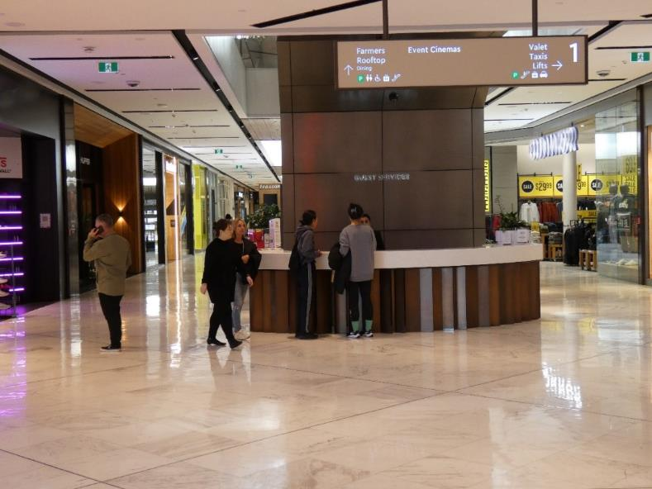
A photograph demonstrating a manned information desk. The receptionist is assisting two members of the public. However, this area may be difficult to locate as it is not located directly in front of the main entrance when you walk in. This particular location also has multiple entry points, and it would be difficult to know which one to use. Photo: Ian Wilson.

3.2.8.2 Information Telephones
If there is no information desk, consider placing an information telephone near the entrance, accompanied by instructions on the purpose of the phone and how to use it. Present instructions visually and in braille.
Employees answering information phones should be trained to assist people who are blind, deafblind or have low vision. The phones should include a system for people with hearing loss, as pre-recorded messages are not sufficient.
Use colour contrast to easily distinguish information phones from their surroundings. See the section on colour contrast for good colour combinations. Use directional TGSIs or textural contrasts in floor materials (detectable by a long cane and underfoot) to lead individuals directly from the main entrance to the information phone.
Listing customer assistance phones is also helpful for people with vision loss. For example, see the Wellington Airport list of locations on their website.

3.2.8.3 Information Directories and Desks
Directories that provide information about a building’s layout and services should be easy to use and locate. Place them near all entrances in logical locations. If a building requires a number of different directories for different areas, place them in a consistent location on each floor (e.g., beside the elevators).
Directories should include raised print as well as print lettering. They should also include braille as appropriate.
Ideally, directories will incorporate a tactile map that is readable by sight and touch. This should illustrate the layout of the floor on which the directory is located, as well as the principal paths of travel to features and services on the floor.
Use directional TGSIs or textural contrasts in floor materials, detectable by a long cane and underfoot, to lead individuals directly from the main entrance to the building directory. In multi-storey buildings, they should be used from the elevator to the floor directories.
If using a tactile map, careful planning is necessary. Like braille, tactile diagrams require additional space. Information presented on tactile maps will likely need to be condensed. Blind Low Vision NZ can assist with the design or production of appropriate tactile maps.
Audio and vibration are also helpful. The use of simple plain English is preferred. NZSL Video could also be used or made available for use on mobile devices.
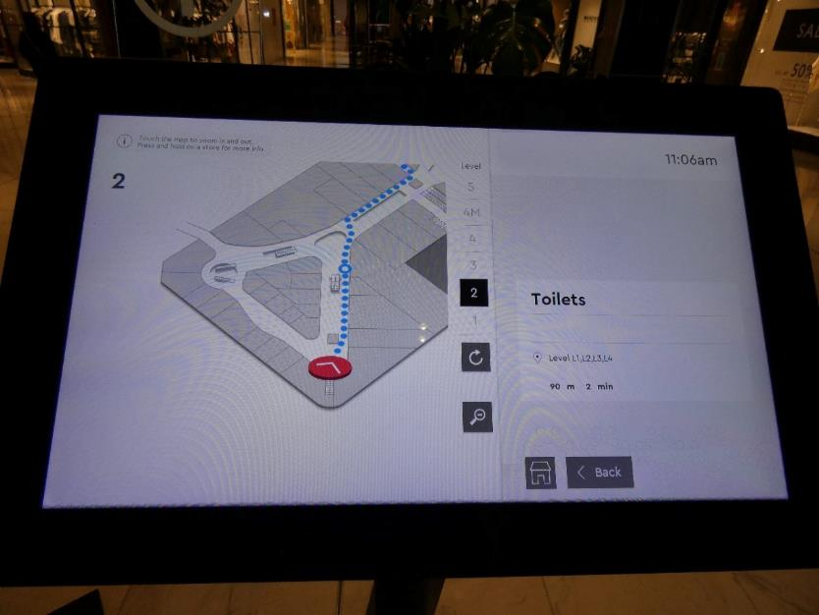
The photo demonstrating a shopping centre information directory screen. It is inaccessible because there is no obvious audible or tactile information. Photo: Ian Wilson.
Some spaces have stand-alone interactive information centres. Such centres may consist of a video display unit with a touch screen, tactile keypad and auditory information. It is important to note that providing visual information alone is not enough!
Information directories are more helpful when they are accessible. The first step is making sure that someone who is blind, deafblind or has low vision can determine the location. More information on audible signs is provided in the Signage section. Further information can be found in the section on guidance TGSIs.
If using touch-screen systems for user input, keyboard or keypad input should be available. Systems should also provide speech output.
Another option is to provide layout information like maps on websites, in a digitally accessible and alternative format, so people with vision loss can study the layout ahead of time.

3.2.8.4 Public Address Systems
Audible communication is an important source of information for people who are blind, deafblind or have low vision. A properly installed public address system can efficiently provide location and emergency or event-related facts.
When audio public address systems are used, equivalent information should be given through visual display units to accommodate people who are Deafblind. Text message alert systems are rapidly evolving and have great potential to provide real-time information in accessible formats directly to an individual’s smartphone. However, they should not be the only means of providing alerts, since not all individuals will have the technology to receive the alerts.
Refer to section 6.2.5 in RTS14 for further guidance on what constitutes an audible volume. Audible signals should have a volume control that is automatically responsive to the ambient (background) noise level as specified in AS 2353: 2018.

3.2.8.5 Tactile Maps and Pre-Recorded Instructions
Tactile maps or pre-recorded instructions can help people who are blind, deafblind or have low vision find their way independently in complex buildings or groups of buildings.
Tactile maps or pre-recorded instructions should be available at a building’s main entrance or reception area. They could also be sent to visitors upon request prior to their arrival. Having a manned reception desk will assist people who are blind, deafblind or have low vision to independently locate specific areas. However, receptionists need to be trained on how to provide directions.
Another strategy to assist people who are blind, deafblind or have low vision to better understand the layout of a facility is to make maps and route descriptions available on a company website. This allows individuals to print the map in advance and enhance the map’s accessibility as required (e.g., magnification and other screen-reading technologies). A route description should accompany any downloadable maps and the instructions should be formatted using BLVNZ’s Accessible documents guide and accessible signage guide. Maps can be downloaded in advance and used to navigate the building on site using a printout or a text-to-speech application on a smartphone.

3.2.9 Card, Keypad and Other Security Systems
The Building Code advises that the use of proximity card devices is preferred to card-swipe devices as they require less dexterity to operate. As long as the card is within the detectable range of the door lock, the card will function. It also advises that where used, building designers should ensure card swipe devices are orientated vertically as this direction is easiest for most people.
Security card access locks for a building should be placed by the door handle at an appropriate height. They should be colour contrasted with the surrounding area, and the slot should be illuminated or colour contrasted from the mounting plate. Refer to the colour contrast section for good colour combinations.
The security card itself should be a distinctive colour or texture.
A person who is blind, deafblind or has low vision using a security card should be able to feel how the card is to be inserted into the lock to open it. For instance, cutting the left corner of the card at a 45-degree angle or punching a hole at the corner tells the cardholder which way is up.
In addition to clear visual indications that a card has successfully triggered, audible indications should be provided.
Keypad door locks should have the same layout as a typical telephone keypad with, at minimum, a tactile indicator located on the number five. Avoid heat-sensitive touch pads, which can be difficult to use for people who are blind, deafblind or have low vision.

3.2.10 Guide Dog Relief Areas
At airports, rail or ferry terminals where secured areas exist, travellers with guide dogs should have access to safe, well-maintained spaces to relieve their guide dog. These areas should be equipped with rubbish bins, hand washing facilities, and a means by which surfaces can be easily cleaned.
Relieving areas should be large enough for a full-size guide dog to turn about inside a designated area.
Guide dog relieving areas should be easily accessible to a barrier-free entrance following a straight path of travel.
Refer to section D3.2.6 in Access Standard NZS 4121:2001 for guidance on dog run layout.
For additional information call 0800 24 33 33.

3.3 Exterior Design Elements
This section provides details for design elements that are commonly found in exterior environments.
It includes design requirements for the continuous accessible path of travel in the exterior environment e.g., footpaths, kerb ramps and pedestrian crossings) and guidance for the maintenance of exterior pedestrian circulation systems. Design considerations for landscaping are also addressed within this section.
Specifications to enhance the accessibility and safety of transport interchanges for individuals who are blind, deafblind or have low vision are presented, including design requirements for platforms, bus stops, and transport interchanges.
Building entrance systems are a key component of exterior paths of travel. Design requirements for the accessibility and usability of entrances is included, along with technical criteria for various types of doors and entrance glazing systems.
The section concludes by exploring the specific needs of people who are blind, deafblind or have low vision in recreational facilities, including playgrounds, parks, nature trails and shared spaces.
Further information on elements that are common to both exterior and interior environments is provided in the Exteriors and Interiors section.
The technical requirements within this section are derived from a number of sources including the sources listed below. Please refer to these documents for more complete technical requirements. We also note that local councils may have their own standards and regulations.
- New Zealand Building Act 2004
- New Zealand Building Code
- Access Standard NZS 4121:2001
- Waka Kotahi – New Zealand Transport Agency (Waka Kotahi) Pedestrian planning and design guide
- Waka Kotahi Requirements for urban buses in New Zealand (the 'RUB')
- Auckland Transport (AT) Transport Design Manual, Waka Kotahi RTS 14 - Guidelines for facilities for blind and vision impaired pedestrians
- Auckland Council – Auckland Design Manual, and in particular the Universal Design Guide
The Auckland Council Universal Design Tool takes people through a Universal Design approach to development for commercial buildings. The tool provides practical design solutions illustrated with diagrams, real-life examples and checklists.
In this section:
- Exterior Paths of Travel
- Pedestrian Crossings
- Transport Interchanges and nodes
- Landscaping and Street Furniture
- Regular Maintenance
- Construction Sites
- Entrances, Corridors, Doorways and Doors
- Recreational Facilities

3.3.1 Exterior Paths of Travel
Additional information can be found in the section Exteriors and Interiors – Common Design Elements (see “Continuous Accessible Path of Travel”).
In this section:
- Location
- Slope
- Obstructions
- Footpaths and Bike Lanes
- Parking Spaces

3.3.1.1 Location
In order to negotiate the road system, people who are blind or have low vision need to be able to find their way along footpaths and across roads. They do so with the help of a variety of environmental cues. Environmental cues include, the property line, the edge of the sealed path, the kerb, and consistently placed street furniture e.g., parking meters. Those people that rely on their residual sight use visual contrast cues for their orientation. People who are blind or have low vision will move around either independently or with the aid of another person who will act as a guide. Those who move around independently will do so making the most of their residual sight and any mobility aids.
The above orientation notes have been copied from section 3.2.2 of RTS14. Please refer to the full document for more detailed orientation and walking environment information.
A continuous accessible path of travel should lead from all transport nodes and interchanges, vehicle drop-off and pick-up locations and public footpaths leading to the main entrance of a building. Additionally, pedestrian footpaths and pathways within a property should be designed to be accessible to everyone, including people who are blind, deafblind or have low vision. Accessible parking spaces should be located adjacent to a walkway leading to an accessible building entrance.
To ensure pedestrian safety, external paths of travel should be distinctly marked and separated physically from traffic. They should not require pedestrians to navigate large open expanses where vehicles are in motion.
Pedestrians should not have to pass behind vehicles that may be backing out, unloading goods or dropping off/picking up passengers. If a pedestrian path of travel is next to such an area, place a fence or landscaped barrier between the walkway and the loading or drop-off area.
TGSIs or textural contrasts in ground materials, detectable by a long cane and underfoot, should be considered to guide individuals along safe pedestrian routes. Further information can be found in the Tactile Ground Surface Indicators section.

3.3.1.2 Slope
Walkways should not be too steep. Refer to the following resources for technical advice on gradients and changes in level:
- Section 14.4 in the Waka Kotahi – New Zealand Transport Agency (Waka Kotahi) Pedestrian planning and design guide
- Sections 5.6, 6.6.2, C12.3.1.2, 13.4.3.1, D1.3.3 – 1.3.5 in Access Standard NZS 4121:2001.
- Auckland Council – Auckland Design Manual-Universal Design Guide Ramp Checklist

3.3.1.3 Obstructions
A continuous accessible path of travel should be wide enough to allow an individual with a guide dog to pass a person using a wheelchair who is travelling in the opposite direction.
The preferred width is 1.8 metres (minimum width 1.5 metres), but wider is beneficial on busy footpaths, refer to the Waka Kotahi Pedestrian Planning and Design Guide 14.2 for specific details on footpath widths.
Place benches, rubbish bins, planters, signs, bus stop shelters and other streetscape elements outside the path of travel – ideally in an activity zone that is clearly differentiated from the continuous accessible path of travel.
Sandwich boards or temporary signs should be avoided wherever possible. These can create major obstacles for people who are blind, deafblind or have low vision, making independent travel unnecessarily difficult. If deemed necessary, they should be placed in the activity zone, outside of the continuous accessible path of travel.
Where outdoor restaurant furniture is located, there should be a physical barrier that is cane detectable. This will prevent outdoor furniture from being inadvertently moved into path of travel.
Refer to section 4.3.1 of Access Standard NZS 4121:2001 for detailed guidance and best practice photos.
Access Standard NZS 4121:2001 sections 13.2 and 13.5 outlines the need for an accessible path clear of hazards and obstructions. Design standards are also included in section 14.9 of the Pedestrian Planning and Design Guide which provides more detailed guidance. Both require all obstacles to have a design element within 150mm of the ground so that they can be detected by use of a long cane.

3.3.1.4 Footpaths and bike lanes
A lot of useful information can be integrated into a footpath’s infrastructure. Wayfinding cues can be incorporated into the surface to assist pedestrians with wayfinding.
Information can be communicated through the use of textural and/or colour changes in the footpath’s infrastructure. Nodes can indicate to pedestrians that multiple routes of travel are in the area.
Wherever possible, bike lanes should be located on the road to discourage cyclists from using footpaths. Wider dedicated cycling lanes that are well demarcated will further increase the likelihood of their use. Protected bike lanes (i.e., where the bike lane is separated from traffic by vertical posts, medians or a well-marked buffer zone) are not only more likely to be used but also more visible to pedestrians.
Refer to the following resources for technical advice on footpaths and bike lanes:
- 5.15.2 in RTS14
- Chapter 14 in the Pedestrian planning and design guide
- Section 6, and in particular 6.2 in NZS4121
It may also be useful to refer to the sections on TGSI, Continuous Accessible Path of Travel and Shared Paths.

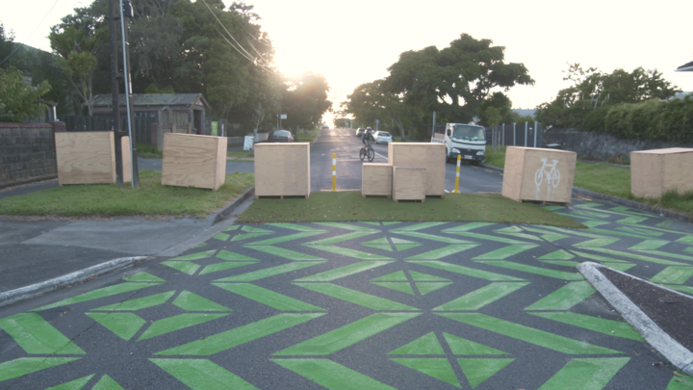
A photo demonstrating a roadway with coloured artwork. Photo sourced from 30 March 2021 RNZ article “Onehunga low traffic trial sees quiet streets but some loud critics”. Photo credit: RNZ / Nick Monro

3.3.1.5 Parking spaces
To accommodate people with a varying range of abilities (including vision loss), designated parking spaces and passenger pick-up/drop-off zones for people with disabilities should be located close to the main building entrance.
Where a parking lot serves several buildings, designated parking spaces should be located next to the shortest pedestrian continuous accessible path of travel that leads to these buildings.
Paths of travel should be physically separated from vehicular traffic. They should not require pedestrians to navigate along vehicular roadways or behind parked cars.
Spatial requirements of accessible parking spaces are also important. Wider parking spaces make exiting and entering vehicles easier for some people with guide dogs or those using other mobility devices.
When installed at vehicle entrances, warning indicators should have a depth of 600mm and extend across the full width of the footpath. They should also be setback at least 300mm from the expected travel path of a large vehicle turning to enter or leave the vehicle crossing point. See photo 5.23 in RTS14 for an example.
Warning indicators should also be used to inform people with vision loss about vehicle hazards at busy vehicle crossing points including, but not limited to: shopping centres, bus stations and large car parks.
When parking lots are situated next to walkways, concrete wheel stops should be used to prevent car bumpers from protruding onto or obstructing the continuous accessible path of travel. Wheel stops should be painted bright yellow or another colour that contrasts with their immediate surroundings. The wheel stops should be positioned so that the front ends of vehicles don’t protrude onto an adjacent footpath. If this isn’t possible, consider placing bollards to prevent vehicles from impeding the continuous accessible path of travel.
Pedestrian lighting should be specifically assessed and additional lighting provided where pedestrians are likely to congregate at night, such as at bus stops, car parks and leisure activity locations.
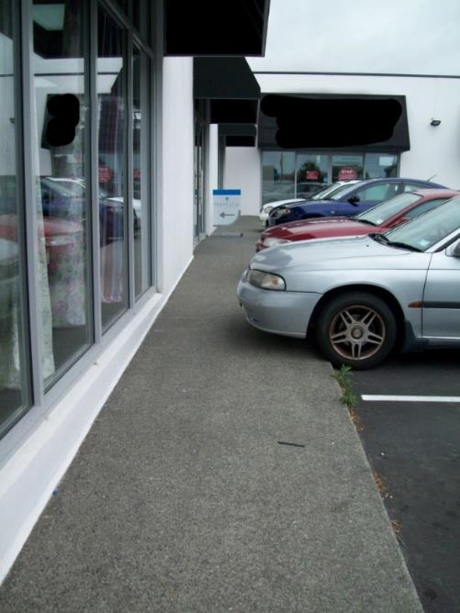
A photo demonstrating several cars parked in an identified parking area, however, the car bonnets are overhanging onto the footpath. The car bonnets are blocking half of an already narrow walkway. Photo: Blind Low Vision NZ.
Refer to the following resources for technical advice on parking spaces
- Section 5 in NZS4121
- Auckland Council – Auckland Design Manual - Universal Design Guide Parking Checklist
- Auckland Council – Universal Design Tool – parking design advice

3.3.2 Pedestrian Crossings
Crossing roads is the most hazardous activity that people who are blind or have low vision perform in the road environment. The most critical safety need is for people who are blind or have low vision to detect reliably where the footpath ends and the road is about to be entered.
When attempting to cross a road a pedestrian who is blind or has low vision needs to:
- Find the crossing point
- Identify when the footpath finishes and the roadway is about to be entered
- Determine the direction to cross
- Determine when it is safe to cross
- Maintain orientation while crossing the road
- Find the opposite kerb crossing point.
The information above is copied verbatim from RTS14 sections 3.2.3 and 3.2.4. Refer to the full documents for further information.
RTS14, and in particular sections 5.6-5.8 and 5.13 provide advice on designing pedestrian crossings. Also refer to chapter 15 in the Pedestrian planning and design guide for technical advice on all aspects of pedestrian crossings.
In this section:
- Selecting the appropriate crossing facility
- Kerb ramps, Blended kerb crossings, and Kerb extensions
- Pedestrian islands, Medians and Pedestrian platforms
- Roundabouts
- Audible Tactile Traffic Signals (ATTS) and Mid-block pedestrian signals

3.3.2.1 Selecting the appropriate crossing facility
The choice of crossing facilities should always be appropriate for the prevailing environment. Section 6.5 of the Pedestrian planning and design guide covers crossing facility selection.
Whatever crossing facility is chosen, the design, installation and maintenance should adhere to requirements laid out in chapter 15 in the Pedestrian planning and design guide, read in conjunction with RTS14. This chapter includes technical requirements, diagrams and photos of best practice. Refer to the required sections as required.

3.3.2.2 Kerb ramps, Blended kerb crossings and kerb extensions
The kerbs that separate pedestrian walkways from vehicular roadways provide critical safety and directional information to individuals who are blind, deafblind or have low vision. Kerbs are a useful orientation cue, as they are detectable by people using a long cane.
Kerb ramps provide a sloped access route from a pedestrian walkway down to a vehicular roadway. Kerb extensions also provide a sloped access route from a pedestrian walkway down to a vehicular roadway, but they are much wider than a kerb ramp, typically running the entire length of an element such as a vehicular drop-off area.
Blended kerb crossings are where the footpath and roadway meet at the same level. This can occur at a number of locations, particularly at pedestrian platforms. The design advice on demarcation and surfacing of pedestrian platforms should be referred to for all blended crossings.
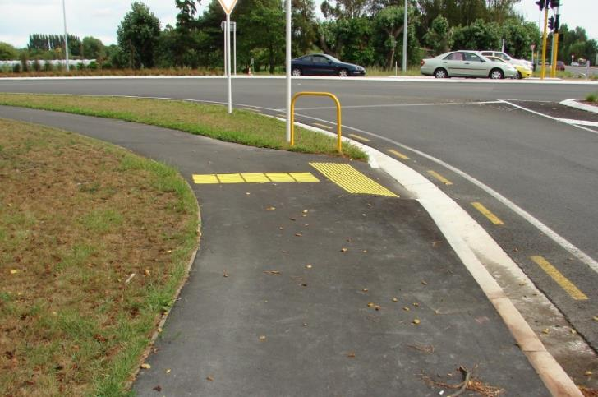
A photo demonstrating good use of TGSI at an identified crossing point. Photo: Blind Low Vision NZ
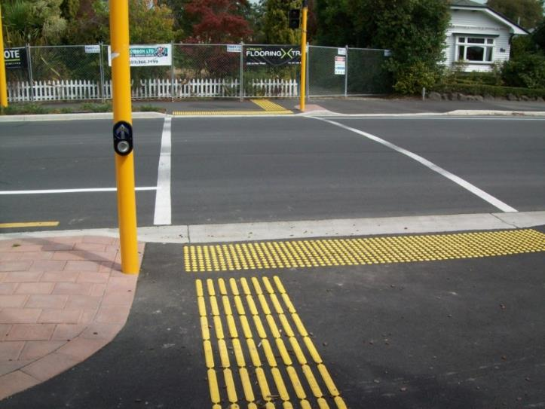
A photo demonstrating good use of TGSI at a traffic light controlled pedestrian crossing.

3.3.2.3 Pedestrian islands, Medians and Pedestrian Platforms
Wherever possible, pedestrian crossings should provide a direct route from one side of the street to another without a raised pedestrian island in the middle. People who are blind, deafblind or have low vision may otherwise assume that they’ve reached the other side of a street when they have in fact reached a pedestrian island.
Medians may be flush or raised. Raised medians are similar to pedestrian islands in many respects. Flush medians enable pedestrians to cross the road in many locations.
Wherever possible, the line of travel through a traffic pedestrian island should be a straight pathway from the original crossing point. Where this is not possible, a channelised configuration should be used to ensure that the entry points on both sides of the pedestrian island align with the original crossing points on each side of the road.
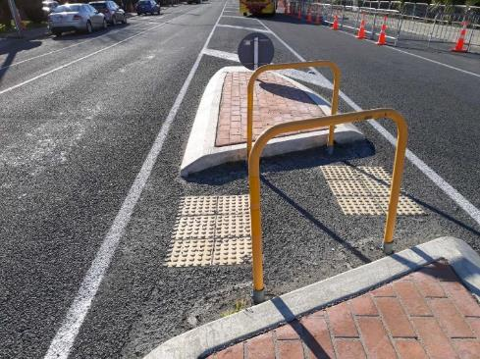
A photo demonstrating the use of warning TGSIs on a pedestrian island. Photo: Blind Low Vision NZ
Pedestrian platforms provide a designated route across vehicular roadways where the pedestrian walking surface is raised above the surface of the roadway. The surface of the pedestrian walkway is at the same level, or close to the same level, as the footpaths that provide access to the pedestrian crossing. As such, pedestrians can cross the roadway without encountering kerb ramps. As vehicles have to “bump over” a pedestrian platform, such crossings can act as traffic calming devices.
Section 15.12 of the Pedestrian planning and design guide provides advice on zebra crossings.

3.3.2.4 Roundabouts
Roundabouts can present significant challenges for people who are blind, deafblind or have low vision. There is confusing audible information from cars approaching and exiting the roundabout. In many cases, people will learn an alternate travel route to avoid encountering a roundabout. This means some pedestrians with vision loss prefer to cross mid-block away from the roundabout.
When providing pedestrian facilities at roundabouts:
- vehicle speeds should be kept low by providing adequate vehicle deflection, and ensuring that on each approach, vehicle intervisibility to the right is not excessive
- splitter islands should be as large as the site allows, with cut-throughs (designed similar to pedestrian islands) one or two car lengths back from the limit lines
- pedestrians must have an adequate sight distance, which may mean banning parking
- street lighting must illuminate the circulating roadway and the approaches
- signs and vegetation must not obscure small children.
Refer to sections 6.7.10 and 15.17 in the Pedestrian planning and design guide for further information.

3.3.2.5 Audible Tactile Traffic Signals (ATTS) and Mid-block pedestrian signals
ATTS provide pedestrians with audible and tactile information at traffic signals. The audible features of ATTS help people who are blind or have low vision locate the pedestrian push button, and inform them when to cross. The tactile features of ATTS also help those who are blind or have low vision with their orientation. ATTS also has benefits for fully sighted pedestrians.
Refer to RTS 14 for guidance on Audible Tactile Traffic Signals (ATTS).
Pedestrian signals are usually installed only where there are enough pedestrians to ensure the signals are activated regularly. If the signals are not activated regularly, drivers can develop the expectation that pedestrians will not be crossing, leading to safety issues. The alternative may be to signalise a nearby intersection.
Kerb ramps on the adjacent footpaths (installed to the standard in section 15.6 of the Pedestrian planning and design guide) provide access to the crossing point. People with vision loss must be made aware of the crossing opportunity and be able to use it safely. This means:
- installing tactile paving in accordance with Guidelines for facilities for pedestrians who are blind, deafblind or have low vision.
- providing audible tactile devices at all new and upgraded installations. When using audible tactile devices, ensure that locations are treated consistently. More details are available in RTS 14.
- If they are being installed at unusual or complex locations, designers should also consult potential users or their representatives (such as the Orientation and Mobility instructors from Blind Low Vision NZ).
Refer to section 15.13 of the Pedestrian planning and design guide for technical requirements, diagrams and photos of best practice on:
- signal timing (see table 15.9)
- detection
- crossing design
All intersections with traffic control signals should be augmented with audio and tactual pedestrian signals to help with accessible and independent travel for people who are blind, deafblind or have low vision. See figure 15.16 in the Pedestrian planning and design guide for pedestrian push-button assembly specifications.
Extending the crossing time universally will enhance walkability for pedestrians who may not walk as quickly as others.
An audio and tactual pedestrian push-button pole should meet these guidelines:
- Located consistently in relation to the continuous accessible path of travel and kerb ramps.
- Placed with the push button facing the direction of travel, except on narrow medians where a single push button can be located with the face parallel to the crosswalk.
- Considered in the middle where pedestrians have to cross more than four lanes of traffic, or where a two-stage pedestrian crossing exists. Care must be taken to avoid confusion between separate phases or sections of a crossing in such circumstances, to ensure pedestrians do not try to cross the full distance when not meant to, or to stop in the median when it is not required.
- Located on traffic pole adjacent to the pedestrian crosswalk.
- Away from obstructions such as raised portions of an island.
Limitations of Accessible Pedestrian Systems
People who are blind, deafblind or have low vision must be able to independently locate the pole and activate the button. This includes thinking about the pole placement.
At best, a traditional audio and tactual pedestrian signal system can provide an audible signal when the walk is on, however, there are other key pieces of information that sighted pedestrians receive that help them cross the street safely. This can include count down timers or general orientation information.
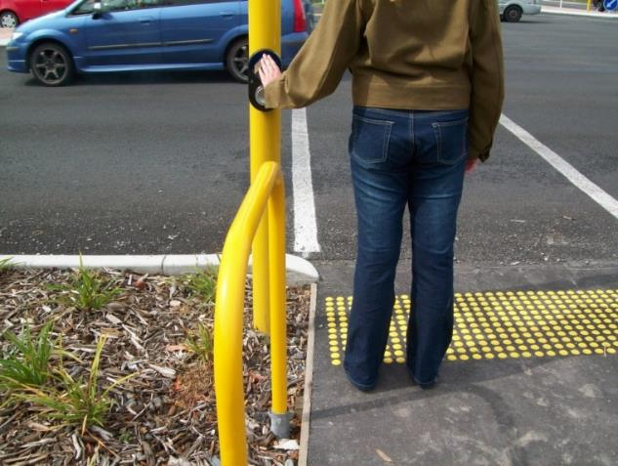
A photo demonstrating a member of the public locating a pedestrian push-button at a mid-block pedestrian signal. Photo Blind Low Vision NZ

3.3.3 Shared paths
Shared paths allow a wide range of transportation methods in urban areas. They support active transportation users of many kinds, including pedestrians, cyclists and people using devices such as scooters, in-line skates and skateboards. Shared footpaths that are not purely recreational may still enable users to travel safely within a community, away from roads. These are most often paved surfaces and should be accessible.
Due to their higher levels of traffic and more diverse usage needs, shared footpaths have additional design considerations over other types of trails, such as nature trails.
There are two primary areas of consideration for visual accessibility of shared footpaths: the design itself and the intersection design (i.e., both where trail routes intersect and where shared footpaths meet roadways).
Larger shared paths may have multiple lanes of travel, which could be one-way or in opposing directions. If present, lanes should be clearly demarcated, preferably by physical separation strips built into the trail. Separation strips should ideally be tactile delineation. Where the provision of physical separation strips is infeasible, a painted centre line should be used, contrasting in colour to the trail surface, with a slip-resistant finish.
Other elements provided along shared footpaths, such as public toilets, rest areas, drinking fountains and emergency telephones, should comply with good accessibility practices as specified elsewhere in this resource.
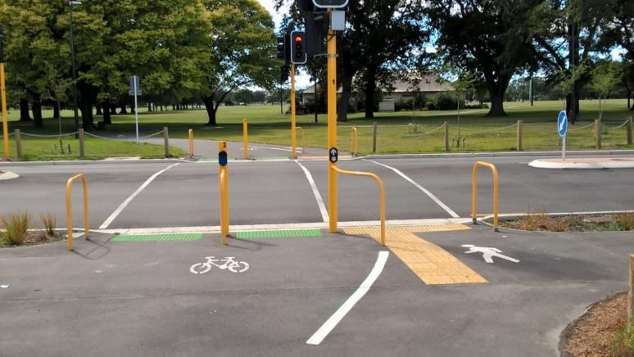
A photo demonstrating a shared footpath, and controlled pedestrian crossing. Photo Blind Low Vision NZ
Refer to the following documents for more information:
- Section 5.10 in Waka Kotahi RTS 14 - Guidelines for facilities for blind and vision impaired pedestrians
- Sections 5.5.3, 6.4.4, 14 (in particular 14.12) in Waka Kotahi – New Zealand Transport Agency (Waka Kotahi) Pedestrian planning and design guide

3.3.4 Transport interchanges and nodes
Pedestrians who are blind, deafblind or have low vision rely heavily on public transport and therefore need to identify areas of access to public transport. TGSI alone will not distinguish public transport access points from road crossing points. Other environmental cues such as a person’s environmental perception, orientation and awareness will help to determine between particular crossing points and other features, such as areas of access to public transport.
Some regional transport authorities have their own specifications for transport infrastructure, like Auckland Transport’s Transport Design Manual, which includes various guidelines for public transport interchanges, and bus and rail ferry infrastructure.

3.3.4.1 Locating public Transport pick-up and drop-off points
Whenever possible, public drop off points should be situated on access ways and be as close as practicable to accessible routes and to the main entrances of buildings of major public importance (Section 13.1.2 in Access Standard NZS 4121:2001 )
Bus stops should be located on an accessible route and have a marker pole that is identifiable, visually and tactilely, from other facilities and elements along the route. Stops should be identified with visual and tactile signage. Refer to table 14.9 in the Pedestrian planning and design guide for guidance on typical characteristics of bus stop shelters, public transport signs and other street furniture.
Pedestrians who are blind, deafblind or have low vision should be able to identify a “bus stop” sign by touch or colour. Further information on accessible signs is provided in the Signage section. Stop identification numbers that are posted for real-time transit information should be in large-print, braille and raised numerals, located to be readable and touchable.
Most bus stops will not have kerb ramps, but do have bus stop information signage. TGSI to identify access to public transport should be installed as follows:
- Warning indicators a minimum of 600 mm wide x 600mm deep installed 300mm back from the front of the kerb edge when used adjacent to a bus stop
- Warning indicators 600mm deep and installed 600mm from the edge when used at train platforms and ferry wharves (see Photo 5.4 for an example in RTS14)
- Directional indicators 600mm deep, installed where the warning indicators are not located in the direct line of the continuous accessible path of travel, forming a continuous path to the warning indicators;
- At bus stops, the directional indicators and warning indicators shall be installed in a position that will be close to the bus entry door.
At railway level crossings, warning indicators shall:
- Be located 3.0m from the track centre line (2.5m minimum)
- Cover the full width of the footpath
- Have a minimum depth of 900mm
For more information on provision at railway crossings refer to sections 6.8 and 15.19 in the Pedestrian planning and design guide.
This information is copied from section 5.12 of RTS 14. Please refer to the full document for more information. Obstacles such as advertising and regulatory signs, seating, rubbish bins, utility poles, post boxes and bus shelters should be kept clear of the continuous accessible path of travel at all times.

3.3.4.2 Bus stops and shelter
Well-designed public transport stops and their interface with the pedestrian network are essential to a usable system. Refer to section 14.13 of the Pedestrian planning and design guide for technical guidance and best practice photos on public transport interfaces.
Shelters at bus stops are recommended to provide weather protection for commuters. Where seating is provided within transit shelters, the seats should be colour contrasted to be identifiable for people who are blind, deafblind or have low vision.

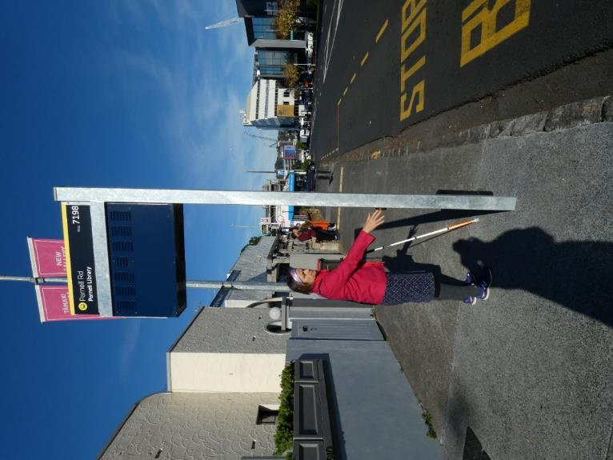
A photo demonstrating a person with low vision using the audible bus information button on the bus stop location pole. Three members of the public are in the background standing about a metre away at the boarding area. Photo: Ian Wilson
Preferably, bus shelters would be mostly transparent, with good contrast, to allow bus drivers to see passengers inside them. As with glass doors and panels in other contexts, the edges of all panels should be marked with a colour-contrasting strip and have contrasting stripes at eye level. Glass panels should extend as close to the ground as possible so that panels are cane detectable. Additionally, panels should be consistent in width from top to bottom to prevent overhead or tripping hazards.
Electronic signage at stops and stations, if not executed correctly, can present a challenge for individuals who are blind, deafblind or have low vision. Red LED signs are difficult to read, as are dynamic signs where text scrolls across a screen. If scrolling messages are necessary, they should move slowly enough to be read comfortably. Refer to the signage section for further guidance.
Transport station design incorporates many of the same concepts as for bus stops. Visual information should always be presented in other accessible formats such as audio, braille and tactile characters, where appropriate. For example, audible signs would not be helpful when several buses pull up to a stop at the same time. This would make it difficult for anyone to hear the audible announcements, given the collective noise of the buses. It would also be difficult to identify where the bus being announced has parked. Audible signs can only be helpful in settings where there is no excessive ambient noise and they can be clearly heard.
Video demonstrating how ambient noises affect audible signs. For example, when the cars are passing, it’s significantly harder to hear the audio.
Navigating many stations is complex. Elements incorporated into transport stations (e.g., pedestrian routes, stairs, ramps, washrooms, emergency systems, furniture and lighting) should comply with good accessibility practices as specified throughout this resource.
If a station is unstaffed and primarily relies upon ticketing machines, the machines should incorporate clear signage, tactile elements and be in an accessible location. Ticketing machines should be accessible. Refer to the Digital Accessibility section for more information.
Platforms in train stations should always be clearly defined with both visual and tactile indicators. Attention TGSIs must be installed in a continuous line along the platform edge, extending the entire length of the platform.
Obstacles such as furniture, guards and rubbish bins should be cane detectable and colour contrasted to their surroundings. Any columns or posts should also be colour contrasted to their surroundings. If this isn’t possible, use a colour-contrasting band at eye level to mark them as a hazard. Additional lower bands are also recommended.

3.3.5 Coloured artwork on footpaths and roadways
The use of coloured artwork on footpaths and roadways is an increasing trend in Aotearoa New Zealand. Waka Kotahi - The New Zealand Transport Agency released its Draft Handbook for Tactical Urbanism in Aotearoa – Guidance: Roadway Art in September 2020. This guidance forms part of the Waka Kotahi Innovating Streets Project, which includes a number of “pilots” funded by Waka Kotahi and the local territorial authorities.
Coloured artwork on footpaths and roadways is a subset of street art. It is not considered a “traffic control device”. However, Waka Kotahi seems to be using coloured artwork on footpaths and roadways as a traffic calming tactic. For individuals who are blind, deafblind or have low vision coloured artwork on footpaths and roadways is an additional barrier and hazard to safely and independently navigating the streetscape.
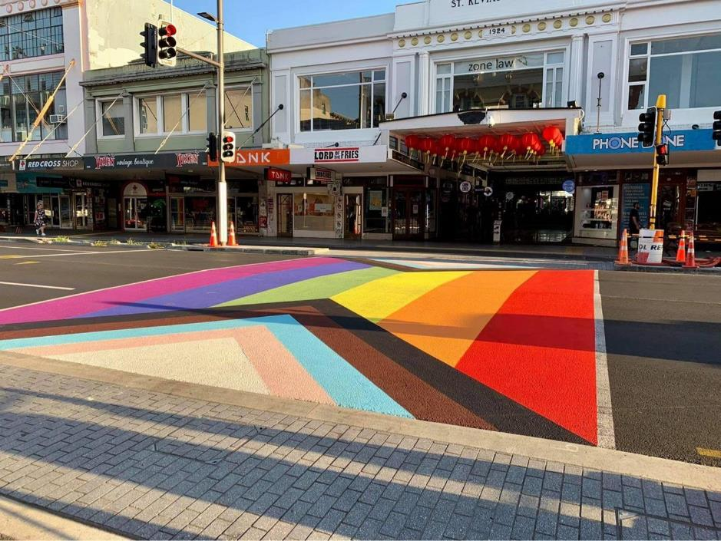
A photo demonstrating a rainbow-coloured area in a controlled pedestrian crossing. The use of colour is potentially confusing and disorientating. Photo sourced from 18 February 2021 NZ Herald article “Pride 2021: Auckland's Karangahape Rd gets its first 'Progress Pride' rainbow crossing”. Photo credit: John Nottage
Blind Low Vision NZ does not support the use of coloured footpath and roadway art as it can potentially create confusion and or disorientation for travellers with vision loss. This is an added barrier for this group of people in travelling safety and independently. A number eye conditions result in the loss of colour vision especially the ability to see red and green colours. Coloured footpath and roadway art is another barrier to the low vision traveller in their path of travel. We fully support Waka Kotahi’s position of not permitting coloured art on zebra crossings. We strongly advocate that there be no coloured art on pedestrian crossings. The continuous accessible path of travel must be kept completely clear of coloured art works at all times.
Best practice design around coloured footpath and roadway art for people with vision loss should ensure:
- No coloured footpath and roadway art is used in the Continuous Accessible Path of Travel (CAPT). Note that the Waka Kotahi preferred CAPT width is 1.8m.
- No coloured footpath and roadway art is used near pedestrian crossings or intersections.
- No reflective paint is used in coloured footpath and roadway art.
People with vision loss should be consulted at the design stage of coloured footpath and roadway art projects.

3.3.6 Landscaping and Street Furniture
Landscaping can be used effectively to help people who are blind, deafblind or have low vision find their way. For example, bushes planted on either side of a building’s main doors can help provide tactile and olfactory (fragrance) indicators of the building’s entrance.
Landscaping can also negatively impact the usability of pathways if permitted to encroach into walking routes and cast shadows that reduce visibility. Ongoing maintenance along accessible routes is important.
Planters and other landscaping elements should be located out of primary paths of travel. The edges of planting beds that are close to accessible routes should be clearly defined using kerbs or changes in paving materials that incorporate colour and texture contrast. Potential obstacles such as tree gratings should be cane detectable.
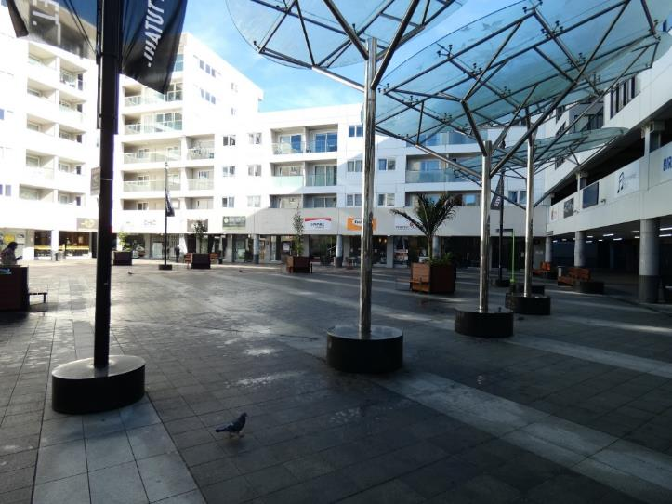
A photo demonstrating wide open space in a shopping area. Several planter boxes and sculptural pieces are scattered around the wide-open space causing hazards and obstacles. No colour contrast has been used. Photo: Ian Wilson.
Avoid planting thorny plants, poisonous plants, plants with large seed pods or fruit-bearing trees in or near public spaces. Their branches may grow and interfere with the clear and accessible path of travel, or they might drop leaves, berries or other matter that could cause slips and falls.
To accommodate guide dogs and other service animals, provide a grassy area or an area with a permeable surface as a relief area, as well as an easily located garbage can for the disposal of waste.
Use low landscaping to disguise necessary amenity elements that could potentially impede pedestrian routes.
Refer to the following documents for more information, guidance and best practice photos on street furniture and landscaping:
- sections 14.8 and 14.9 in the Waka Kotahi Pedestrian planning and design guide
- section 13.5 in Access Standard NZS 4121:2001

3.3.7 Regular Maintenance
Check paths of travel frequently for uneven surfaces and damage. Unit pavers such as paving stones can provide effective textural contrast, but they must be checked regularly, as they often shift through the effects of settlement or movements of the earth. This can cause a tripping hazard. Ideally, unit paving should be installed over a concrete substructure to prevent movement.
Repair problems immediately, preferably at a time of low pedestrian traffic.
When a path of travel requires repair or becomes unusable because of nearby construction, an alternate clear and accessible path of travel should be provided.
Whenever possible, provide notification of proposed maintenance activities in advance, so that pedestrians can plan an alternate accessible route.
Temporary pathways should be laid out logically, following a right-angled design if possible. If the temporary pathways will be used for an extended period of time, they should incorporate directional cues, such as:
- Textural changes on the ground surface
- Colour contrast
- Guidance TGSIs
- Auditory/tactile information to supplement signage and other wayfinding systems
Where temporary pathways direct pedestrians along a vehicular roadway, a physical barrier should be placed to separate pedestrians and vehicles.
Refer to the following documents for more information, guidance and best practice photos on regular maintenance:
- Section 5.15 in RTS14
- Section 18 in Waka Kotahi Pedestrian planning and design guide
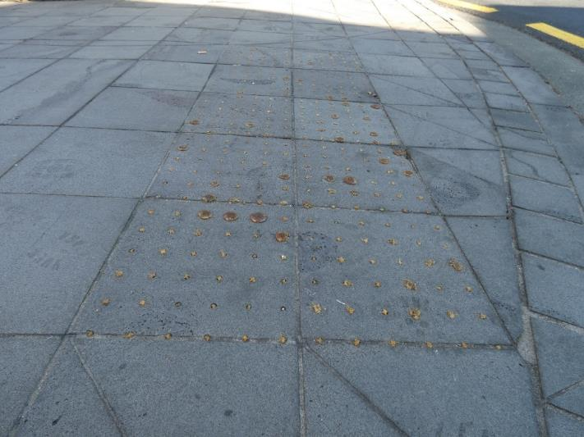
A photo demonstrating worn out warning TGSI, indicating no maintenance has been completed. Photo: Ian Wilson.
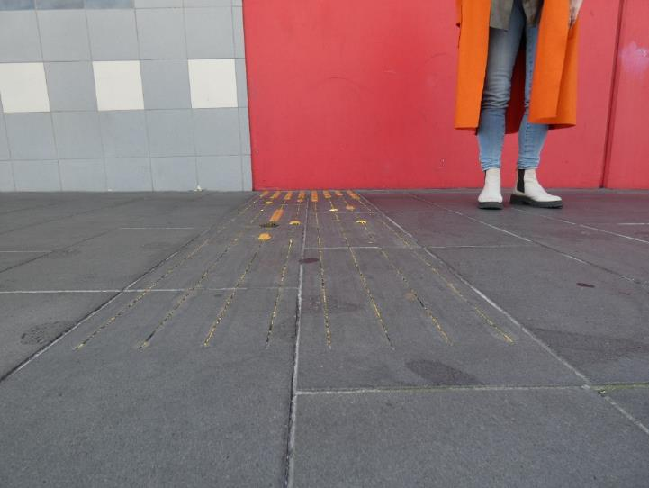
A photo demonstrating worn-out directional TGSI, indicating no maintenance has been completed. Photo: Ian Wilson.

3.3.8 Construction Sites
Construction sites should be completely closed to the public.
Install barricades that are detectable to long cane users in a colour that contrasts with the surroundings. When chain-link fencing is used, construction-grade tarpaulin fabric should be used on the walkway side of the fence, to a height of 500 mm. This will prevent mobility canes from getting stuck in the chain-link fencing.
The temporary path of travel is separated from the construction by a hoarding, which is a non-permanent structure of solid construction, erected around the perimeter of a construction site. The path of travel is separated from traffic by a temporary concrete barrier.
Ensure all construction equipment is safely placed behind the barricades.
Refer to the following documents for more information, guidance and best practice photos on regular maintenance:
- Clause F5 in New Zealand Building Code Handbook
- Section 18.7 in Waka Kotahi Pedestrian planning and design guide
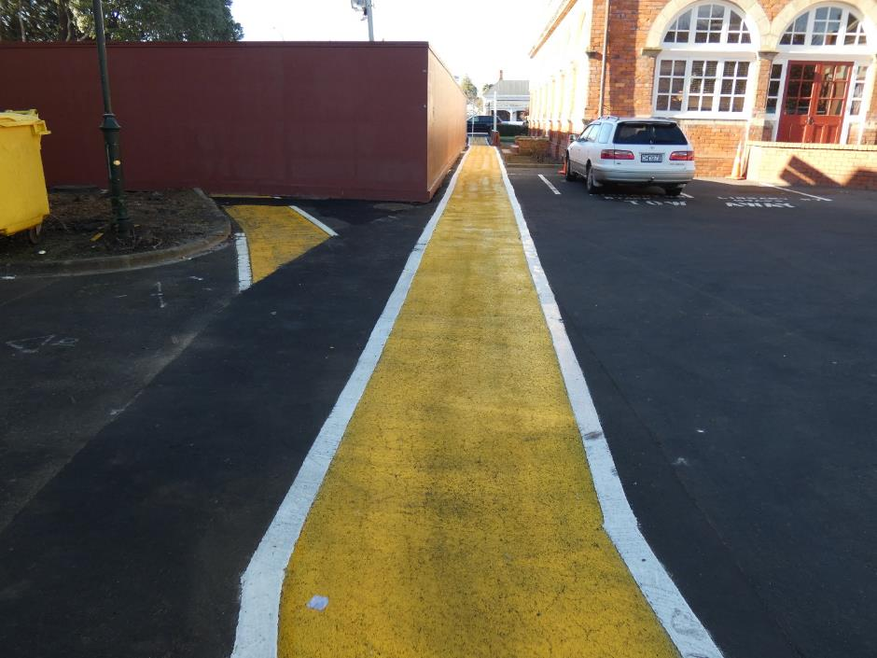
A photo demonstrating a detectable barricade around a construction site, and a clearly identified safe walking area. Photo: Ian Wilson.
The erection of scaffolding or hoarding on pavements and public rights of way can narrow the walking space and can, unless properly protected, increase the risk of collision with protruding objects.
The provision of a continuous handrail will assist pedestrians who are blind in finding a safe route through scaffolding and to locate any public entrance.
If it is not practical to provide a safe route through the scaffolding, an alternative route should be provided.
Erect a barrier between pedestrian paths of travel and vehicular traffic. The barrier should be colour contrasted to the ground surface, ideally being yellow and black.
When temporary paths of travel are erected to mitigate risks from construction sites, ensure that TGSIs are installed at the entry point; otherwise, pedestrians who are blind will have no means by which to detect a clear and accessible path of travel. This could potentially result in their walking into unprotected areas such as adjacent lanes of traffic or where heavy equipment is being operated.

3.3.9 Entrances, Corridors, Doorways and Doors
Entrances to public buildings must be easy for people to identify. A variety of elements can be used to help people who are blind, deafblind or have low vision quickly identify an exterior entrance:
Signs: The sign should comply with the design requirements for signage. For larger buildings, large signs should be incorporated into the landscaping leading to the main entrance.
Entry doors should have a visual colour contrasted wide band to signify that it’s the entry door. This will help people with low vision to detect the door.
Door frames: All door frames should be colour contrasted to the walls or surfaces around them.
Landmarks: Planters and columns can draw attention to the main entrance. Plants can be positioned to guide the direction of travel towards the entrance.
Recessed entrances: A recessed entrance is easier for a long cane user to detect. It can also create an acoustically different space, making the entrance easier to locate for people who are blind, deafblind or have low vision.
Change in surface texture: The approach to a building entrance can be marked with a different ground surface. For example, paving stone can intersect with a concrete footpath to mark the place to make a 90-degree turn to reach the entrance. The paving stone should be detectable with a cane and underfoot.
Audible cues: Audible signs and other audible cues, such as music, can be used to draw attention to a building’s entrance.
Where there is a row of doors to individual businesses that blend with the surrounding wall along a building line, it is important to clearly identify each door. For example, use colour-contrasting doors, doormats outside each door, leading up to each door. Signage that incorporates visual and tactile information should also be provided at each door.
Turnstiles and revolving doors can be difficult for guide dog users to walk through since the clear width is often inadequate. Where turnstiles and revolving doors do exist, an adjacent gate or door should be available.
Doors should not swing into a clear and accessible path of travel. If power doors do swing into the path of travel, install guardrails perpendicular to the walls that contain the doors and ensure these guardrails are detectable by a long cane user at the ground or floor level.
Refer to the following documents for more information, guidance and best practice photos on entrances, corridors, doorways and doors:
- Section 7 in Access Standard NZS 4121:2001.
- Entrances and Exits section in the Auckland Council Universal Design Tool.
- Guidance from Lifemark on universal design, including door handles.

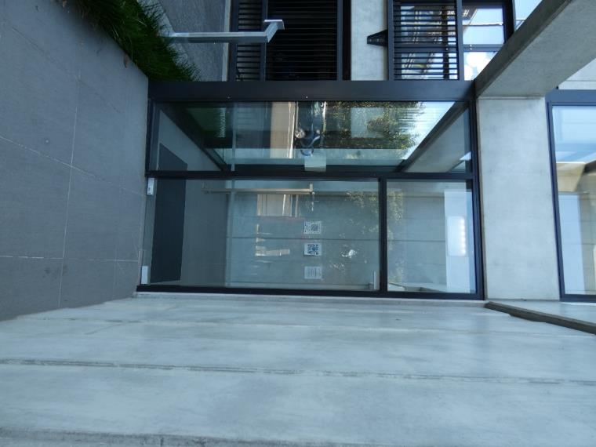
A photo demonstrating entrance way with a glass door and narrow strip of low contrast, at a low level. Photo: Ian Wilson.
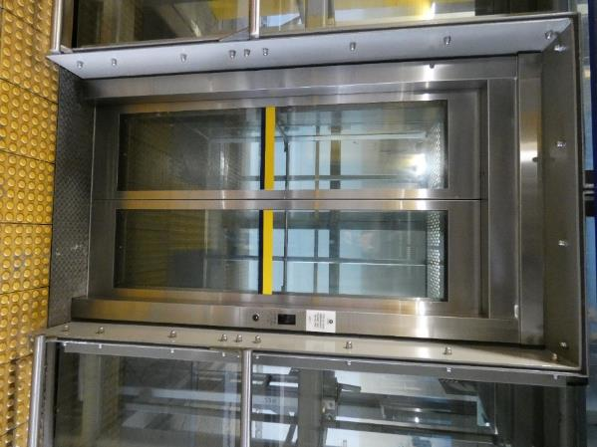
A photo demonstrating a high contrast strip on glass lift doors. Also uses warning TGSIs. Photo: Ian Wilson
Hardware should be placed in approximately the same position on all doors. Hardware should also be colour contrasted to the door’s surface.
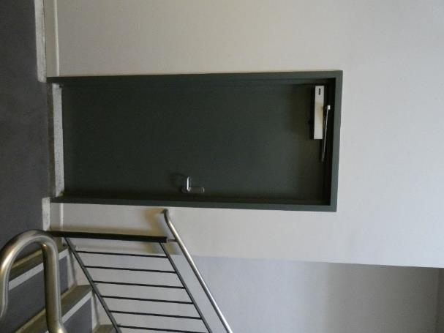
A photo demonstrating good positioning of door handle, and good colour contrast to the door itself. Photo: Ian Wilson.
Avoid steps at public entrances to a building. If steps are unavoidable, install an adjacent ramp leading to the public entrance. Doors should have a clear and level area on both sides. Refer to the Ramps Section for more information.

3.3.9.1 Automatic Sliding Doors
Automatic sliding doors at a building entrance with a colour-contrasted strip on the glass doors.
Where possible for building entrances, use automatic sliding doors activated by a motion detector. These doors also provide an audible cue for people who are blind, deafblind or have low vision to the presence of the entrance.
If push buttons are used for automatic swing-type doors, each button should open only one door. Push buttons should never open both leaves of a pair of doors. A person should be able to open or stop an automatic swing-type door with reasonable force.
Where used, push-button or push-plate activated power door operators should be consistently located at all entrances. They should be colour contrasted to the background environment to enhance visibility for people who are blind, deafblind or have low vision. Position push buttons/plates so that the opening door does not hit the person opening the door or their guide dog.
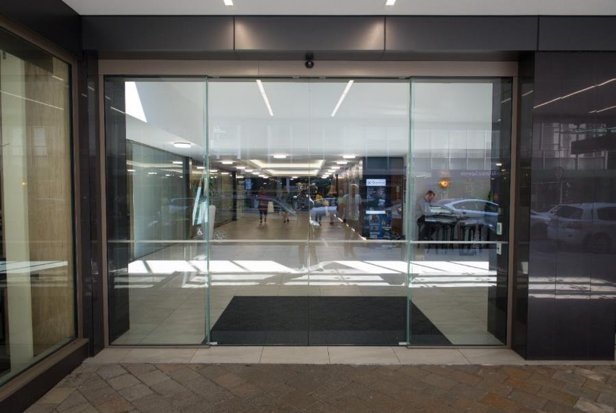
A photo demonstrating a front entrance of a building with wide glass sliding doors leading inside. There is an inch-thick opaque band, about halfway down the glass, which runs along the width of the glass entrance. This glass manifestation is barely visible compared with the reflections in the glass. Sourced from the Access Matters Barriers Photo Library. Photograph taken November 15, 2018, by Victor Komarovsky. Copyright: Attribution-NonCommercial-ShareAlike.

3.3.9.2 Multiple Doors
Some building entrances have several doors in a row, such as theatres and auditoriums. When these doors swing out into the path of travel, they can pose a hazard to people who are blind, deafblind or have low vision. A colour contrasted and cane detectable safety guard should be provided.
Sets of automatic sliding doors are a better alternative to a row of swing-type doors. Another option is to provide one set of sliding automatic doors in the middle of a row of standard doors at a building entrance.

3.3.9.3 Revolving Doors
Blind Low Vision NZ does not recommend the use of standard-sized revolving doors at building entrances because they are not universally accessible.
Wherever revolving doors are used, an accessible entrance door should be provided adjacent to the revolving door.

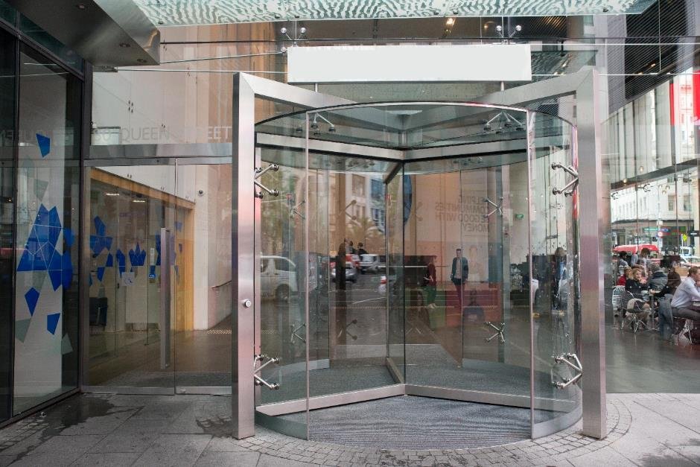
A photo demonstrating the use of both a revolving and side door. However, the glare and lack of contrast are an issue. Revolving main door to a building with an automatic door to the side. A revolving door provides the main entrance way to this building. To the left there is a glass door that can be opened with the push of a button. This door is marked with the International Symbol of Access, but it is a barely visible opaque decal. Signage should be high contrast to allow for easy detection by everyone, and especially by people with low vision. Photo sourced from the Access Matters Photo Barriers Library. Photograph taken October 30, 2018, by Victor Komarovsky. Copyright: Attribution-NonCommercial-ShareAlike.

3.3.9.4 Glass Doors, Glazed Screens and Sidelights
Frameless glass doors, fully glazed doors (with frames), glazed screens and sidelights can be hazardous for people who are blind, deafblind or have low vision if they are not properly designed. The edges of frameless glass doors should also be highlighted with colour-contrasted strips.
Strips of highlighting on doors should be identifiable from both the inside and outside of the building under any lighting conditions. With etched or panelled glass decals, strips of contrasting colour should also be provided. Etched strips within the glass, or decals providing the same effect, don not provide enough colour contrast to be effective.

3.3.10 Recreational Facilities
Public recreational facilities should be accessible to everyone, including people who are blind, deafblind or have low vision.
Refer to the following documents for more information, guidance and best practice photos on entrances, corridors, doorways and doors:
- Section 13 in Access Standard NZS 4121:2001
- Sections 16.3 in Waka Kotahi Pedestrian planning and design guide
- Regional advice like the Auckland Design Manual Parks Hub
- Auckland Council Universal Design Manual case study - The Canadian Museum for Human Rights
In this section:
- Outdoor Picnic Areas
- Benches
- Playgrounds and Parks for Children
- Nature Trails

3.3.10.1 Outdoor Picnic Areas
Outdoor picnic areas should be located adjacent to a clear and accessible path of travel and marked with appropriate signage. They should have a ground surface that is firm, relatively level and slip-resistant. Picnic areas will be easier to distinguish by people who are blind, deafblind or have low vision when the ground surface contrasts in colour and texture to the nearby accessible path.
Picnic tables should be in good repair, without protruding nails, screws or large splinters.
Rubbish bins with open tops are easiest for people who are blind, deafblind or have low vision to use.
A strip of colour-contrasted material should be placed around the top of the rubbish bin to assist people who are blind, deafblind or have low vision.
Barbecues in picnic areas should be placed on a surface that contrasts in tone and texture from the immediate surroundings. They should be detectable by long cane users at the finished grade. For example, a light-coloured concrete pad with a brushed finish is suitable when surrounded by grass.
Place drinking fountains adjacent to the clear and accessible path of travel so that long cane users can detect them.

3.3.10.2 Benches
Install benches on the same level as a walkway, and ensure that benches are cane detectible. Their colour should contrast to their surroundings. A tactile change in the area surrounding the bench can be used to indicate to a pedestrian that a bench is nearby.
To accommodate guide dog handlers, situate benches to provide adequate space for a guide dog to lay next to its handler. Provide adequate space behind or next to a bench for a guide dog to rest. A handler should be able to position the dog so that it does not lie in a public pathway and is safe from bicycles or other pedestrians.
Section 13.5.2 and Figure 50 in the Access Standard NZS 4121:2001 lays out typical park bench seating.

3.3.10.3 Playgrounds and Parks for Children
Playgrounds and parks are intended to be carefree places for children to play and explore. By taking a few simple steps, they can be made enjoyable for children who are blind, deafblind or have low vision too.
Grouping playground components together logically (e.g., by type and intended age group) can make them more accessible to children who are blind, deafblind or have low vision and their families. For example, place all toddler equipment in one area.
Colour is a welcome feature in a playground and contrasting tones can be used to attract children to specific play structures or to indicate items like kerb borders of play areas and edges of raised platforms.
Pathways within a playground should link appropriate play elements. The pathways should be placed and colour contrasted so that children who are blind, deafblind or have low vision can easily locate them. Pathways should also have a different texture from the defined play area. Tactile, colour-contrasting pathways must be created to lead children away from the bottom of slides and other exits of play equipment.
Swings should be placed away from other play equipment to avoid any possible collisions. Avoid putting pathways in front of or behind a swing. The swing area should be delineated by both a change in surface texture and the use of contrasting tones on the equipment and along the perimeter.
In a water park, water-flow controls that are installed for children should contrast in tone from their background. Position them to be easily seen and reached.
Give particular attention to the overhead clearance of play elements within the playground. Children who are blind, deafblind or have low vision may not detect overhanging or freestanding objects, which could result in injury. Provide guards or other features where overhanging or freestanding play equipment is present.
All playgrounds should be inspected regularly. To ensure they are properly maintained, all maintenance staff should be trained on the function of the barrier-free elements that have been incorporated into the playground.
The Auckland Design Manual provides some advice on play spaces. Build in safety by following NZS 5828:2015 Playground Safety Standards.

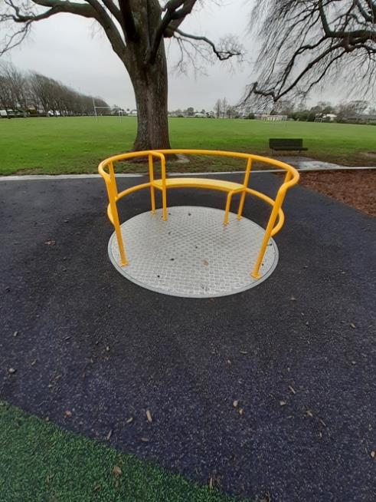
A photo demonstrating use of colour and tactile contrast on playground equipment. Photo: Blind Low Vision NZ.

3.3.10.4 Nature Trails
Nature trails provide recreational opportunities in an outdoor setting. Terrain and other factors may make it difficult to make every nature trail universally accessible, but steps can be taken to ensure people who are blind, deafblind or have low vision can use and enjoy a nature trail. It is important to consider the needs of all users, including those with vision loss.
Trail access points should connect to a local accessible pedestrian route. Please refer to signage guidelines.
Information about nature trails describing their length, degree of difficulty and distinguishing features – especially hazards should be available on websites and other sources. This will provide information about the trail that will allow the user to understand the configuration and assess the level of risk. This will allow them to determine if the degree of challenge matches their abilities. Refer to BLVNZ guidance on accessible information and communications.

3.4 Interior Design Elements
This section provides details for design elements that are commonly found in interior environments.
Design requirements for accessible interior paths of travel are covered, including corridors, hallways, escalators, moving walkways and elevators. Design considerations for entrance lobbies, doors, interior glazing systems, service counters, queuing and public telephones are also included.
The section concludes by exploring the specific needs of people who are blind, deafblind or have low vision in specific types of facilities, including theatres, lecture halls, dining spaces, kitchens, washrooms, change rooms, pools, gyms, libraries and exhibition spaces.
Note that further information on elements that are common to both exterior and interior environments is provided in Exteriors and Interiors.
Refer to the following documents for more information, guidance and best practice photos on interior design elements:
- Access Standard NZS 4121:2001, section 3 in particular
- Auckland Council Universal Design Tool – Advice on “Inside the Building”
In this section:
- Entrance Lobbies
- Amenities
- Floor Finishes, Grilles and Mats
- Receptions and Information Desks
- Queuing Systems
- Interior Circulation
- Escalators and Moving Walkways
- Lifts
- Doors and Entranceways
- Accessible Accommodation
- Specific Interior Rooms and Spaces

3.4.1 Entrance Lobbies
People who are blind, deafblind or have low vision use their remaining senses, in addition to any usable vision they may have, to orient themselves within a space. Acoustic, olfactory (i.e., related to the sense of smell) and tactile elements in a building lobby all convey important information about the organisation of the space and can help with wayfinding. A logically organised, uncluttered space is easiest to navigate.
Entrance lobbies can present particular challenges for people who are blind, deafblind or have low vision in terms of lighting. Give careful attention to the transition in lighting levels between outdoors and indoors. There should be a gentle gradation from the natural light levels outside to the light levels inside. You should also take into account the changes in exterior lighting levels from day to night. Refer to the lighting section for more information.
There are many ways to facilitate independence in public buildings. Provide information and communications systems within the main entrance lobby, as well as tactile guidance systems that allow people who are blind, deafblind or have low vision to find amenities such as reception desks, building directories.
Refer to the Building Code advice on reception areas and to Access Standard NZS 4121:2001 for more information.
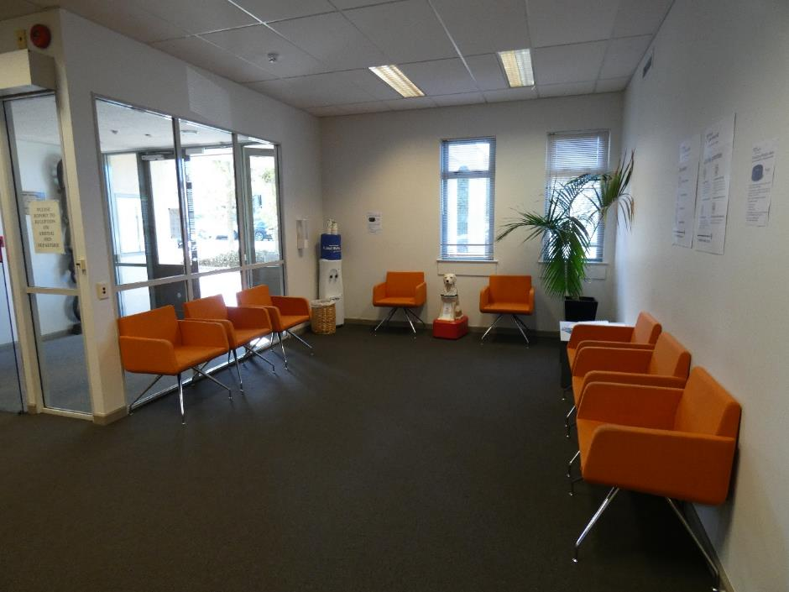
A photo demonstrating a reception area that uses colour contrast to differentiate between the floor, walls and seats. Photo: Ian Wilson.

3.4.2 Amenities
Building amenities, such as seating areas, planters, rubbish bins, signs, displays, vending machines and art (including sculptures), should not be placed in the clear and accessible path of travel. They should be detectable by long cane users at floor level wherever possible. Use colour contrast and brightness to help differentiate amenities from floors and walls.
To help with the identification of amenities, consider locating them in amenity zones that are differentiated from adjacent paths of travel using floor finishes with different colour and tactile characteristics. Amenity zones can help to define and reinforce the intended clear and accessible path of travel through an area.
Fire extinguishers, drinking fountains and public telephones in hallways should be recessed into corridor walls. If this is not possible, these fixtures should be detectable by a long cane user at floor level. They should contrast in colour and brightness to surrounding surfaces.

3.4.3 Floor Finishes, Grilles and Mats
All floor finishes in a building should be slip-resistant and present a matte (non-glare) surface. Avoid heavily patterned floor tiles or carpets with a busy design.
Use colour contrast and brightness to differentiate floor surfaces from walls, or use boundaries between walls and floor surfaces that contrast in colour and brightness.
The colour of the flooring contributes to the overall reflectance factor for light in an interior space. Lighter flooring can help create a brighter space if that is desirable.
Mats can be used to indicate doorways or circulation intersections. Mats that contrast in colour and brightness from the surrounding floor surface provide textural and visual cues for people who are blind, deafblind or have low vision.
Floor finishes should be slip-resistant when dry and should not be highly polished. Most floor surfaces are reasonably slip-resistant when dry. All surfaces except textiles, tend to become slippery when wet or covered in mud. Entrance lobby flooring can especially become slippery in wet weather.
Refer to C4.6.1 in Access Standard NZS 4121:2001 for detailed advice on flooring.

3.4.4 Receptions and Information desks
Reception and information desks and similar amenities should be located adjacent to a main path of travel. Provide enough space so that a person standing at the counter with a guide dog or sighted guide will not be in the path of travel.
Receptions and information desks should contrast in colour and brightness to their immediate surroundings for easy identification. They should be lit at the same level as their surroundings or have brighter lighting when necessary – for instance, when a person may have to sign something or pay at the counter. Counters should be clear of unexpected objects such as plants and pamphlet racks.
The design of the service counter should meet universal design principles.
Receptions and information desks with glass partitions should include a communication system that allows people on each side of the glass divider to communicate clearly with each other. Consider audio loop systems at service counters to help facilitate communication for people who use a hearing aid. Avoid excessive background noise, which can prevent a person who is blind, deafblind or has low vision from being able to hear instructions from a counter attendant. Environments, where large crowds gather (e.g., movie theatres and restaurants), are problematic for people with significant vision loss.
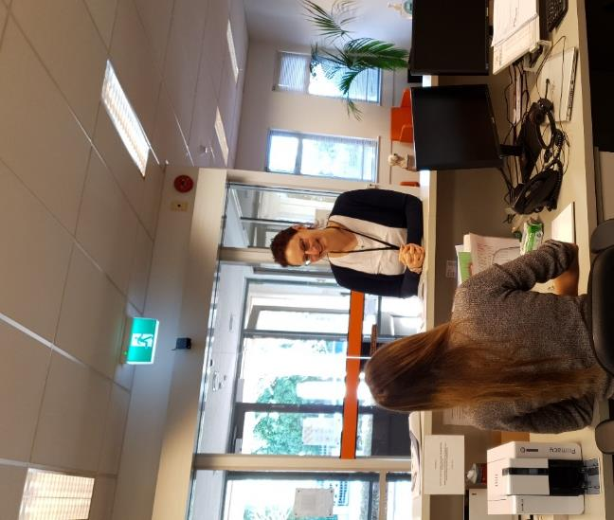
A photo demonstrating a well laid out reception desk. It is straight in front of the main entrance and is manned by a receptionist. Photo shows the receptionist assisting a visitor. Photo: Ian Wilson.

3.4.5 Queuing Systems
Queuing systems that are configured using non-fixed guides (e.g., ropes or retractable bands) are difficult and even hazardous to use for people who are blind, deafblind or have low vision. Such systems present several problems:
- They are often located in the middle of an open area and are difficult to detect with a long cane.
- People who are blind, deafblind or have low vision may have difficulty determining where the line starts within the queuing system.
- People who are blind, deafblind or have low vision may find it hard to know when the line is moving.
- Guide dogs can be easily bumped at travel terminals when people are waiting in line with baggage and carts. Guide dogs may also be tempted to guide the handler under the ribbon.
- People who are blind, deafblind or have low vision may find it hard to know where an available service person is located when they get to the front of the line. This problem is compounded when service personnel cannot see the front of the line from their workstations.
When non-fixed guides must be used, improve the queuing system by moving it away from the building’s main clear and accessible path of travel. The ropes, retractable bands and stands should contrast in colour and brightness to their surroundings and should be detectable using a long cane. Non-fixed queuing guides that incorporate the use of two rigid horizontal guides between stands to afford cane detectability are preferred. Even when rigid horizontal members are not practical, systems are available with retractable bands at two levels for cane detectability and to keep guide dogs from passing under the horizontal barriers.
Queuing systems with fixed guides that contrast in colour and brightness and that are cane detectable are preferred.
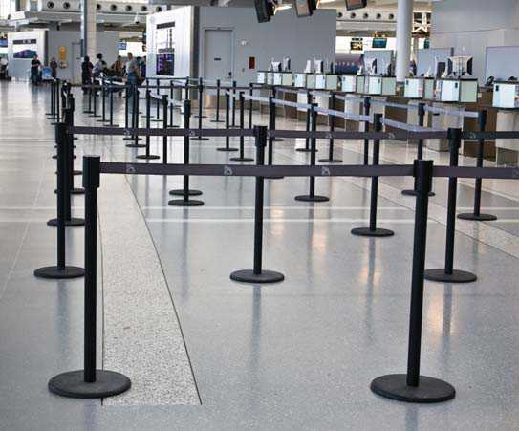
A photo demonstrating a poor queuing system that projects into the space’s main path of travel. However, the system illustrates good colour contrast to the surrounding floor surface. Photo sourced from Queuing Systems section of the CNIB Foundation’s Clearing our Path Manual.
“Pick-a-number” systems are problematic for people who are blind, deafblind or have low vision. Even if the next number to be served is called out, without sighted assistance, people who are blind, deafblind or have low vision may not know what number they have pulled. To mitigate this barrier, businesses using this form of queuing system may wish to install dispensing machines with audible indicators which verbalize the number being pulled. While this may resolve the issue of knowing what number is being served, a customer who is blind will have no way of knowing which agent or service point is available.
If using a pick-a-number system, a dedicated service counter should be incorporated to serve people with disabilities. It should be integrated with the other service counters and located as close as possible to entrances and/or the position where the pick-a-number dispensing machine is installed.

3.4.6 Interior Circulation
People who are blind, deafblind or have low vision find independence easiest where interior layouts are straightforward and logical, and changes in direction are set at right angles. Avoid changes in floor elevation, such as raised platforms placed in the centre of a room. If elevated surfaces are necessary, provide tactile warning indication through the use of a change in flooring.
Similarly, sunken floors, like those used in many restaurants and bars, can create a major hazard. If sunken areas are used, install railings or other barriers to prevent people who are blind, deafblind or have low vision from inadvertently walking into the sunken area.
In this section:
- Corridors and Hallways
- Handrails
- Waiting Areas

3.4.6.1 Corridors and Hallways
Main corridors should be wide enough for two people with guide dogs, or two people travelling with sighted guides walking in opposite directions to pass each other easily. Wider hallways will also make it easier for people using mobility devices to navigate corridors. People with vision loss using mobility aids need a clear width of up to 1.2m. Refer to D3.2 in Access Standard NZS 4121:2001 for more information.
Changes in corridor direction should be at 90-degree angles. This makes it easier for independence and memorising a corridor’s layout. It is more difficult and disorienting for a person who is blind, deafblind or has low vision to navigate corridors that curve or change direction at angles that are greater or less than right angles.
At intersections between primary paths of travel, use textured flooring that differs from the leading clear and accessible path of travel. This will indicate to pedestrians who are blind, deafblind or have low vision that a decision point has been reached with respect to navigating through a building or large open area.
The walls at the ends of corridors should contrast in colour and brightness to the surrounding walls and floor. Avoid using windows at the end of corridors because they produce glare. If windows are already in place, use shades, blinds, glazing or other methods to reduce glare while maintaining appropriate light levels.

3.4.6.2 Waiting Areas
Waiting areas should be located off the main path of travel. Avoid placing them in the centre of large open areas such as hotel lobbies or shopping centres. Signs and design features (e.g., textured flooring that extends across the main path of travel), and colour contrast can be used to highlight the location of a waiting area.
In every waiting area, provide a clear area out of the accessible path of travel to accommodate someone who has a guide dog. Any path of travel through a waiting area should provide enough room for guide dogs and their handlers as well as long cane users. Avoid creating paths of travel that meander around waiting areas. This can cause people who are blind to become disoriented.

3.4.7 Escalators and Moving Walkways
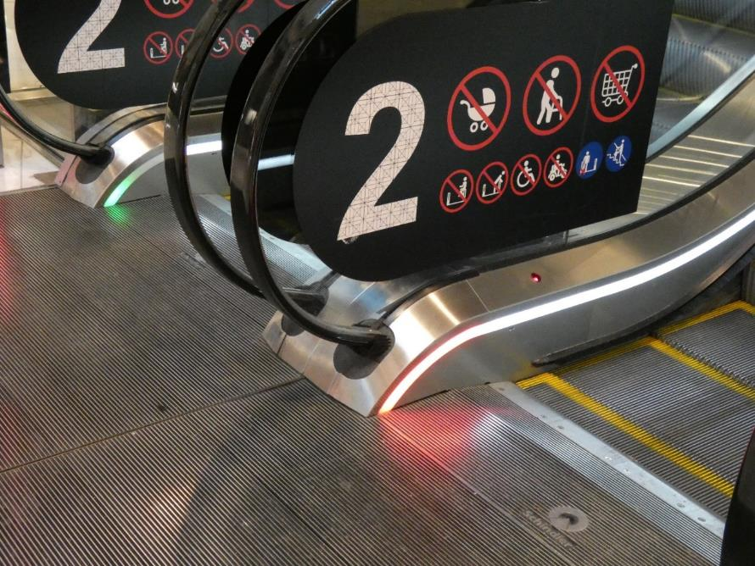
A photo demonstrating use of colour contrast on escalator. The number 2 indicating the flow level has good contrast and is a good size. However, the additional symbols placed on the escalator are too busy and include too much information. Photo: Ian Wilson.
Refer to Australian Standard AS1735: Part 6(Int):1996 Lifts, escalators, and moving walks for guidance in this area.
Section 5.14 in RTS14 provides guidance on escalators.
In this section:
- Surfaces
- Treads and Risers
- Tactile Ground Surface Indicators
- Lighting
- Underside of Escalators and Moving Walkways
- Alternate Access
- Repairs

3.4.7.1 Surfaces
The surfaces of escalators and moving walkways should be made of a slip-resistant, non-reflective material.

3.4.7.2 Treads and Risers
The top nosings (both horizontal and vertical edges) of escalator steps should have colour/brightness-contrasted strips that run the width of the step.

3.4.7.3 Tactile Ground Surface Indicators
Tactile Ground Surface Indicators should be used.
The comb plate (i.e., surface closest to the escalator or the moving walkway, both as you step on and step off) should be marked with a colour/brightness-contrasted strip that runs the width of the step or walkway, is detectible under foot or with a mobility cane.
A low-level warning sound should mark both ends of a moving walkway. A person who is blind should be able to hear the warning approximately a metre before the transition between the moving walkway and the floor. Any audible warning indicators should be adjustable for environmental noise such as crowds.

3.4.7.4 Lighting
It is important to maintain enough lighting in areas that have escalators and moving walkways, especially at their beginning and end.

3.4.7.5 The Underside of Escalators and Moving Walkways
Where there is a route of travel underneath escalators or moving walkways that are on an incline, it is essential to ensure that a person cannot accidentally bump into the underside of these amenities.
The space underneath the escalator or moving walkway should be sufficiently high from the finished walking surface. If this is not possible, install architectural detailing, plants or guardrails that can be detected by people who use long canes or guide dogs. These can prevent accidental access to areas of low headroom.
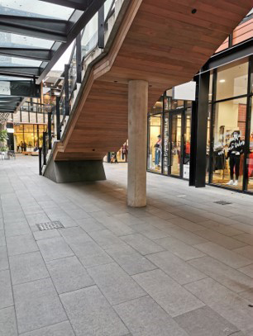
A photo demonstrating an overhead obstruction not detectable by a cane user. This is a safety hazard. Photo: Blind Low Vision NZ.

3.4.7.6 Alternate Access
Provide an alternate access route (e.g., a stairway, ramp or elevator) close to escalators for people who are uncomfortable using escalators or for guide dog handlers whose dogs do not feel comfortable using an escalator.

3.4.7.7 Repairs
Place barriers at the beginning and end of escalators or moving walkways that are out of order or undergoing repairs. Barriers should be detectable by long cane users. Appropriate signage should also indicate that the escalator or moving walkway is out of service.

3.4.8 Lifts
To meet the needs of people who are blind, deafblind or have low vision, refer to previous sections on colour contrast, lighting, audible information, and signage.
In particular, lifts should always give audio announcements that tell people who are blind, deafblind or have low vision which level the lift has arrived at.
Refer to the Auckland Design Manual, Universal Design Guide- Checklist for Lifts.
Section 9 in Access Standard NZS 4121:2001 provides guidance on lifts.
In this section:
- Lift cars
- Lift control panels
- Lift telephones
- Support rails

3.4.8.1 Lift Cars
To enhance the visibility of the door threshold, the lift car should have a yellow colour/brightness strip across the lift car door threshold, where the cab meets the floor.
The lift’s floor and floor perimeter should contrast each other in colour and brightness. Use a light colour on the floor when a dark colour is used to mark its perimeter. If the floor is dark, use a light colour to mark the perimeter and a light-coloured logo/design in the centre of the floor space (a dark floor on its own can be perceived as an empty space by a person who is blind, deafblind or has low vision).
Lifts should be programmed to allow time for someone who is blind, deafblind or has low vision to reach and enter the elevator safely. Lifts should also include a motion sensor that will prevent the door from closing if there are any obstructions between the doors.
Mirrors, large panels of glass, glazed screens and sidelights can present problems for people who are blind, deafblind or have low vision, applicable to mirrors, glazed screens and sidelights found inside a building.
Floor-to-ceiling mirrors inside a building can be confusing for people who are blind, deafblind or have low vision and should be avoided.

3.4.8.2 Lift Control Panels
The control panels inside a lift car should be located to the right of the elevator door when facing the door from inside the car. Where possible, control panels should be on both sides of the door. Avoid using heat-sensitive buttons, as people relying on braille or tactile numbers have no means of knowing when or if a button has been pushed. Additionally, because they use touch to locate buttons, every heat-sensitive button they touch will be activated.
Lift panels should be slightly inclined from vertical to make the buttons easier to read without crouching down. It also makes it easier to read braille and tactile characters.
The call buttons on each floor should be organised in a logical pattern that is consistent within all lifts in a building.
Raised numerals, letters and other symbols should be placed to the left of the elevator’s call buttons on a colour/brightness-contrasted background. Characters should be in an Arial font and not in an italic, oblique, highly decorative or unusual form. The same information indicated for each button through raised characters should also be provided just below them in uncontracted braille.
Use larger, backlit buttons, which are easier to see for people with low vision. Ensure there is good contrast between the background and the buttons.
The floor identification information should contrast in colour and brightness to its surroundings in the elevator.
Lift location floor information should be indicated both audibly and visually. Voice annunciation should be used to identify floors and the direction of travel.

3.4.8.3 Lift Telephones
Telephones in lift cars should be placed to the right of the panel. If there is more than one panel, the telephone can go to the right of the right-hand panel when facing the doors from inside.
The lift telephone or its cabinet, if there is one, should be labelled with the international symbol for telephones. The phone should be equipped with a volume control.

3.4.8.4 Support rails
Support rails need to be provided in lifts. They should be on all walls apart from where there are doors. Refer to NZS 4121 for dimensions and guidance.

3.4.9 Doors and Entranceways
The specifications provided in the section Exterior Doors are equally applicable to doors within a building. This section provides additional specifications for interior doors.
Doors accessible from the path of travel should either be recessed or open into rooms to avoid obstructing the clear and accessible path of travel. Entranceways without doors can also provide access, negating the potential hazard of door swings.
Open doors in halls and corridors are a serious hazard for people who are blind, deafblind or have low vision. Wherever possible, avoid having double doors where only one side opens. Either both doors should be propped open or both doors should be shut. This will prevent people who are blind, deafblind or have low vision from inadvertently encountering a partially open door.
Signs to identify rooms should be located adjacent to the latch side of doors. Further information is provided in the signage section.
Raised thresholds should be avoided wherever possible.

3.4.10 Accessible Accommodation
Section 14 in Access Standard NZS 4121:2001 lays out what accessible accommodation, hotels, motels, hostels and other such premises look like.

3.4.11 Specific Interior Rooms and Spaces
Room designs should incorporate the following elements:
- Proper hallway signage to identify the room, including tactile characters, braille, appropriate colouring and appropriate font.
- Appropriate doors with respect to location, width and hardware.
- A logical arrangement of equipment, fixtures, furniture and services using straight lines and right angles, if possible.
- Colour contrast to identify equipment, facilities and hazards within the room.
- A clear and accessible path of travel.
- Clear space next to seating areas to accommodate guide dogs.
- Light switches and other environmental controls placed close to the room’s entrance at the height of the door handle.
In this section:
- Places of assembly and entertainment
- Places of Recreation
- Cafeterias and Dining Rooms
- Kitchens, Toilets and Shower Stalls
- Change Rooms

3.4.11.1 Places of assembly and entertainment
Seating in a lecture hall or theatre should be oriented so that the occupants sit facing the focal point of the room. Position the room’s furniture and fixtures so that a clear view of the focal point is maintained. Sloping or “raking” the floor so that the back of the room is higher than the front also helps keep the focal point unobstructed.
The path of travel to the seating area should not cross the line of sight to the focal point. For example, in most theatres, the entrances are at the back or sides, out of the patrons’ line of sight to the stage.
If there is a designated seating area for people with accessibility needs, spaces to accommodate guide dogs and seat their handlers should be provided close to the path of travel. They should be clearly marked to keep them reserved for people who need them.
Public address messages should include the location of emergency exits, for example: “There are emergency exits on either side of the stage at the front of the auditorium.” Many people who are blind, deafblind or have low vision regularly attend public events independently, so it is not appropriate to assume that a sighted companion will always be present.
Lighting can be used to accentuate key areas in an assembly or meeting place. For example, a lecture hall may have a combination of lighting levels and lighting patterns that draw attention to the lecturer.
Take care to maintain adequate light levels, and gradually change levels where appropriate. For instance, the difference in lighting between the lobby of a theatre and the seating area should be gradual to accommodate people with difficulties adapting to sudden changes in light levels. One approach is to provide the brightest lighting at the entrance and ticket sales counter and then slightly reduced lighting at the concession stands and restrooms. The inside of the theatre would have the lowest level of lighting. Before the event starts, lights in the room should be dimmed gradually.
Colour contrast on furniture and room fixtures can facilitate better use of a room. For example, in a theatre with dark-coloured seating, a dark-coloured stage set against a light background will direct the audience’s attention to the stage. Colour-coded seating can make it easier to find a specific section (e.g., rows A to D are dark blue, rows E to H are dark yellow, etc.).
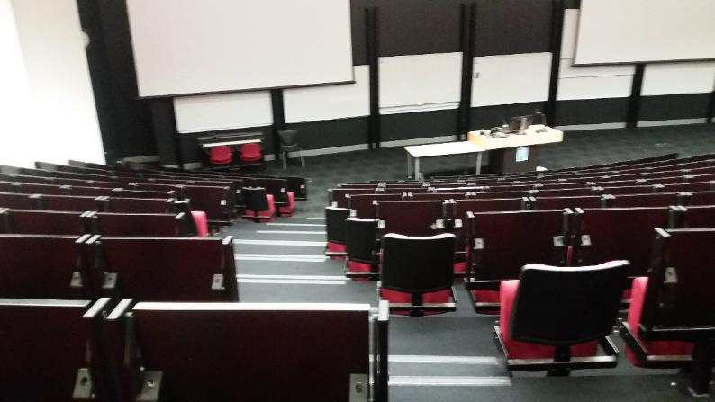
A photo demonstrating a lecture hall using good contrast seating, however, the multi-level walkway is not straight. Photo: Blind Low Vision NZ
Refer to Sections 12 in Access Standard NZS 4121:2001 for more information.
Arrange exhibition halls so that all displays are detectable by people using long canes. Further information is provided in the section on protruding objects.
Low-pile carpeting that contrasts to the surrounding floor surface can be used to indicate the clear and accessible path of travel. The layout of displays and other facilities should be logical and easy to follow. Matte finishes should be used in displays. Care should be taken in the position and type of lighting used for an exhibit. There should be sufficient lighting, but it should not produce glare.
In libraries, the colour contrast and brightness principles outlined in this website should be used for the flooring to help people find their way from open areas to bookshelves. Appropriate signage should be posted at the ends of bookshelves to indicate their contents.
Designers should provide spaces for book carts, chairs, step stools and other objects so that they do not create obstructions in the clear and accessible path of travel. For instance, bookshelves could include a space where footstools can be stored when not in use.

3.4.11.2 Places of Recreation
Refer to Section 12.3 in Access Standard NZS 4121:2001 for more information.
Common safety concerns at public swimming pools for swimmers with vision loss include:
- Finding the edge of the pool
- Safe movement and orientation within the pool
- Confusion or discomfort caused by glare reflected off the water
People who are blind, deafblind or have low vision must be able to detect the edge of the pool safely. This can be achieved by a change in surface.
Handrails for ladders that give access to the pool should extend above the pool deck and contrast in colour and brightness to the surrounding area. Ladders should not project beyond the wall of the pool. They should be recessed into the wall to prevent limbs from being caught behind the ladder’s rails.
Rope-and-float partitions that are colour contrasted to their surroundings will help swimmers orient themselves in the pool.
Indoor swimming pools, use indirect lighting or up lighting to reduce the effects of glare from the water’s surface.
Indirect lighting should also be used in gyms together with matte flooring. Designers should be careful when preparing the floor pattern of a gym. School gyms, in particular, can become cluttered with many sets of coloured lines intended for a wide variety of games. Reduce the use of these lines to benefit gym users with vision loss.
Equipment rooms should be clearly marked. It is best if door systems for equipment rooms open into the equipment room itself and not the gym space. This makes them less of a hazard for everyone, and particularly for people who are blind, deafblind or have low vision.

3.4.11.3 Cafeterias and Dining Rooms
In an eating area, it is important to take into account the provision of safe access to food items, especially hot foods, and predictably located furniture and facilities.
Tables and chairs should be colour contrasted to their surroundings and arranged in a regular, logical pattern that visitors can learn easily. The layout should provide a clear and accessible path of travel. A change in flooring texture and colour/brightness contrast should be used to differentiate the seating area from the main path of travel.
Lighting should be even throughout a cafeteria or dining room. Avoid pools of light or shadow.
In cafeterias, dishes and cutlery should be set out in a logical way.
A continuous tray path is easier to use than separate food service stations. Place physical colour-contrasted stops at the end of the tray counter so that trays cannot be accidentally pushed off.
Hot food serving areas should be designed to minimise the possibility of burns from spills or incidental contact with hot foods or appliances.
Place waste containers and tray return bins outside the path of travel. They should be clearly marked and colour contrasted to their surroundings if appropriate.
Menus and price lists in restaurants and cafeterias should be posted on a wall near the entrance. Hand-held menus should be available in at least 14-point type and in braille. They could also be made available on a portable audio device such as an MP3 player. Update all menus at the same time so that prices and contents of print and braille menus are consistent. Menus should also be provided in an accessible format on the restaurant’s website.
Vending machines should provide information about the food items available and the price of each item, as well as instructions on how to use the machine. These labels should be provided in a minimum of 14-point type and braille.
When vending machines provide a telephone number for service, it should also be available in braille or large-print, located as close as possible to coin slots.
Refer to Figure 53 in Access Standard NZS 4121:2001 for guidance on minimum dimensions for an accessible dining area.

3.4.11.4 Kitchens, Toilets and Shower Stalls
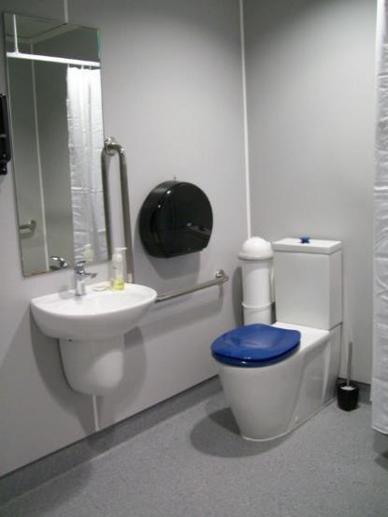
A photo demonstrating good use of colour contrast on a blue toilet seat, and black toilet paper roll holder against white backgrounds. Photo: Blind Low Vision NZ.
Note that while the bathroom in the photo is a good example of colour contrast, it is not NZS4121 compliant. For example, the commercial toilet roll holder prevents the safe use of the support rail, best practice is to have the roil mounted 300mm back from the vertical rail and 300mm up from the horizontal rail. Further, the centre line of the toilet should be 450mm from the nearest side wall to allow a user with limited balance lean against the wall.

Follow the guidance in Access Standard NZS 4121:2001 to design accessible toilets, washrooms and kitchens for everyone, including people who are blind, deafblind or have low vision.
The Auckland Council Universal Design Guide Checklist for Toilets is a useful tool.
Refer to the Auckland Council Universal Design Tool for advice and example photos of accessible:
- workspace kitchens
- residential layout, fixtures and fittings
- toilets, showers and family rooms

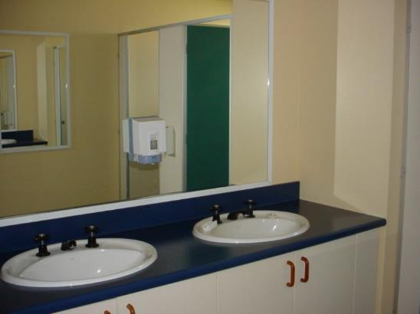
A photo demonstrating good use of colour contrast with white basins against a dark blue counter. Photo: Blind Low Vision NZ

3.4.11.5 Change Rooms
The layout of a change room should be logical and straightforward so that it is easy to memorize. The flooring should have a slip-resistant finish to minimize any hazard from water tracked in from a shower or swimming pool. A matte floor finish makes it easier to see any water that may be on the floor.
Follow colour contrast and brightness principles outlined in this website to highlight all furniture, fixtures and equipment. Proper signage should be placed beside all entrances to pools, sports facilities, saunas and shower areas.

4. Emergency Exits and Safety
Keep in mind that building design and construction are only part of the answer in terms of meeting the needs of people who are blind, deafblind or have low vision in emergency planning. Staff training programs and maintenance schedules also play a critical role.
Further information on elements that are common to both exterior and interior environments is provided in Exteriors and Interiors.
This advice builds on what is prescribed in sections F6 and F7 of the New Zealand Building Code Handbook.
Refer to Access Standard NZS 4121:2001 for further advice on fire safety and other emergency requirements.
In this section:
- Emergency exits
- Emergency alarms
- Meeting points
Emergency procedures

4.1 Emergency Exits
It may take someone who is blind, deafblind or has low vision more time to locate an exit and get there unassisted. Emergency exits should be logically located (e.g., at the ends of corridors) along a simple path of travel. Use tactile, audible, colour and visual design features to attract attention to the location of the exit path.
Everyone should participate in regularly scheduled fire drills, particularly people who are blind, deafblind or have low vision. These exercises provide an opportunity for everyone to become familiar with the location of emergency exits and the procedures to follow if there is an emergency.
In this section:
- Interior Routes
- Exit Doors and Hardware
- Emergency Exit Signage
- Exterior Exit Routes

4.1.1 Interior Routes
There should be an unobstructed clear and accessible path of travel to an emergency exit that provides sufficient space for people who are blind, deafblind or have low vision walking with a sighted guide or guide dog during evacuation procedures.
All interior routes to emergency exits should be properly lit and clearly identified on the life safety plan for a building. These plans should be made available in alternative formats or provided in accessible alternative format documents.

4.1.2 Exit Doors and Hardware
Exit doors on each floor should be clearly labelled with proper signage. The doors should open out in the direction of exit to avoid hitting a person with vision loss. As with any door in a public space, emergency doors should never hinge so that they open into the path of travel.
Thresholds on exit doors should comply with the requirements specified in the section on Exterior Doors. Thresholds should contrast in colour and brightness to their surroundings. Use tactile or textured flooring where possible to mark emergency exits so that the exits can be easily identified.
Double doors that are an emergency exit should not have centre posts, except when centre posts are required by building codes to create and maintain smoke and flame barriers in a building.
Further information on door requirements is provided in the section on Exterior Doors.

4.1.3 Emergency Exit Signage
Illuminated exit signage should be used to assist wayfinding, especially where an exit route changes direction or joins another route. All print and tactile signage used to direct people to exit points should be located at exit route junctions and exit points as needed.
Emergency exit signage should be located on the right-hand side of an exit route.
When emergency signage is placed in proximity to a corner, the signage should be located a consistent distance from the wall junction.

4.1.4 Exterior Exit Routes
The route away from a building should be a clear and accessible path of travel. Exit routes should be configured to ensure that everyone can quickly and safely clear the building. Routes should not require people to pass close to windows or traverse along the immediate perimeter of the building. Where exit routes require travel across landscaped areas, pedestrian paths should be of firm construction, with gradients complying with the requirements for accessible routes. These routes must be maintained clear of obstructions, such as vegetation growth.
Exterior routes from the building should incorporate tactile and colour-contrasted walking surfaces for easier identification. Exterior emergency routes should be clearly identified on the emergency procedure for the building and routinely practiced by all building occupants.

4.2 Emergency Alarms
Refer to NZS 4512:2010 which provides up-to-date specifications for the design, manufacture, installation and maintenance of fire detection and alarm systems.
To ensure that people with vision or hearing loss are alerted to an alarm, both auditory and visual signals should be used in an alarm system, regardless of whether it’s a single-stage or two-stage system. This is particularly important as more people are wearing earbuds and other headphones in buildings.
In residential settings, the installation of vibrating alarm-signalling devices should be implemented where residents who are both deaf and blind reside. Typically, these systems are configured with a bed vibrator that activates if the building alarm system or a smoke alarm system within a dwelling unit is triggered. During waking hours, other warning systems should be provided.

4.3 Meeting Points
As part of emergency procedures, the location of meeting points should be described in public address announcements during an emergency situation.

4.4 Emergency Procedures
Emergency procedures set out how building occupants will be alerted to an emergency situation and evacuated from a building or public space. It is specific to a particular location and it must address the needs of everyone who uses or may use the space or building.
When developing emergency procedures, consider the needs of people who are blind, deafblind or have low vision. All people who are blind, deafblind or have low vision and are working in a new space within a building should be informed about the location of emergency exits and practice identifying them on their first day.
Emergency procedures should be made available in alternative formats such as accessible electronic documents including audio, large-print or braille. These documents should be updated as often as necessary to ensure that documents in alternative formats are current with the print versions of the life safety plan.
For commercial tenants, the alternative format materials should be made available to people who are blind, deafblind or have low vision immediately upon joining an organisation. In residential settings, these documents should be made available with tenant agreements.
Building attendants, security guards, reception staff and event hosts should receive regular training on how best to assist blind people in an emergency.
Instructions about the location of emergency exits should be part of the routine when greeting blind people who are visiting a facility or attending a meeting in it.
Fire wardens in a building should be provided with training on how to inform people who are deafblind of an emergency. Each warden should receive training on how to act as a sighted guide for a blind person.
Emergency procedures for public buildings should include the following documents, which should be available by request in print, braille, audio and electronic text formats:
- A description of emergency procedures, including considerations for people who are blind, deafblind or have low vision who are regularly in the building.
- A description of the responsibilities of building staff and other occupants of the building in an emergency situation, including specific instructions on how to assist people who are blind, deafblind or have low vision.
- A copy of applicable fire safety regulations.
Emergency procedures should be supported by these activities:
- Distribution of relevant parts of the life safety plan to all occupants of the building in alternative formats.
- Training of fire wardens on how to assist in the evacuation of the building and how to act as a sighted guide for building occupants who are blind, deafblind or have low vision.
- Posting of evacuation procedure signage on each floor in print, tactile and braille formats.
- Regular checking and maintenance of emergency systems, including alarm systems, emergency lighting, emergency communications systems and obstruction-free evacuation routes.
- Regular review of emergency procedures through the use of practice drills.
- Provision of orientation and mobility training around emergency exits for building occupants who are blind, deafblind or have low vision on a routine basis.
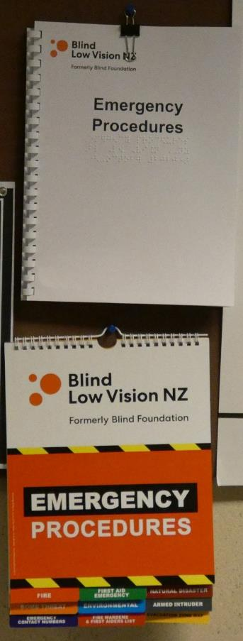
A photo demonstrating emergency procedures available in print, large print and braille. Photo: Blind Low Vision NZ.

5. Digital Accessibility
In this section, you will learn what digital accessibility truly means. You will understand why it is important to make digital information accessible. We will introduce you to the specific groups of people who benefit from accessible content. You will also learn the basics of how to make your digital information accessible to these groups. Finally, we will discuss the next steps you can take to make your digital content accessible.
In this section:
- What is digital accessibility?
- Reasons for making your digital content accessible
- Business benefits of accessibility
- Who benefits from digital accessibility
- Making digital content accessible
- Next steps

5.1 What is Digital Accessibility?
Digital accessibility is making digital content accessible to people with disabilities. Digital content refers to information, products, and services provided in digital format. Common examples include websites, mobile apps, and various types of software. Digital accessibility involves principles, guidelines, and techniques. You need to perform a series of steps to ensure that your digital content is accessible.
Digital accessibility is the degree to which people with disabilities can perceive, use, and understand your content. If your digital content has high accessibility, there is a good chance that almost all people with disabilities can access and use it. But if it has low accessibility, there is a huge possibility that people with disabilities will experience difficulty in using or even accessing your content.
In addition, digital accessibility should be done early in any project. Consider a ramp in a building’s entrance. To save time and resources, you need to build the ramp while building the physical structure. You would not normally finish the building and then start thinking of where and how to install the ramp. The same principle applies to digital accessibility. To ensure that your content is accessible, it is important to implement accessibility guidelines and techniques at the start of the project.
Digital accessibility benefits everyone. For example, sufficient colour contrast is a crucial element of digital accessibility. This refers to the contrast between the colour of your text and the colour of the background. Sufficient colour contrast ensures that people with low vision can easily read your text content.
However, good colour contrast can also help you even if you do not have vision loss. For instance, imagine you are trying to read text on your mobile device and you are outdoors under sunlight. In this situation, you will have the same visual needs as people with low vision. And while in that environment, you will be able to comfortably read the text if it has sufficient colour contrast.

5.2 Reasons for Making Your Digital Content Accessible
There are many reasons why it is a good idea to practice digital accessibility. The benefits of digital accessibility range from financial, to technological, to personal fulfillment.
A key reason is that more people can access your digital content.
According to The World Bank Group, one billion people, or 15% of the world’s population, experience some form of disability. The World Health Organization estimates that there are 285 million people with vision loss in the world. Among this group, 39 million are blind and 246 million have low vision.
It is clear that you will reach more people when your content is accessible. Imagine that 1 percent of people with vision loss find your online content. This is still a significant amount at almost 3 million people. In addition, people with disabilities also use social media. When you make your content accessible, you are essentially providing motivation for them to recommend and share your content with their network.

5.3 Business Benefits of Accessibility
The Return on Disability Group estimates that people with disabilities worldwide have $1.9 trillion in annual disposable income. Making your digital product or service accessible is the best way to tap into this market. E-Commerce has also enjoyed a significant increase similar to social media. With the availability of assistive technologies, it is now possible for people with disabilities to purchase a product or acquire a service through the Internet. If you make your digital product or service accessible, you will ensure that they can use their technology to easily initiate and complete the transaction online.
Accessibility also presents a cost-effective benefit to businesses. Take customer service as an example. Say a blind person is able to completely access and use your website and this person can purchase one of your products online with no issue. This will be a good experience to the person. And it will be a cost-effective transaction for you as the business owner. On the other hand, if the same person finds difficulty in accessing your website, two things may happen. One, the person can either leave your site and find another online resource. Two, they will call your customer support and seek assistance. In both cases, you will lose money as the owner of the online business.

5.3.1 Compatibility with Technologies
Accessible content is compatible with various technologies. People who use slow Internet connections benefit from accessible web content. To speed up the loading time of web pages, people with slow connections normally turn off images. But consider if your images are accessible i.e., they have proper image descriptions. In this situation, these users will still be able to understand the purpose of the images through their descriptions.
Accessible content can be displayed properly in various screen sizes. People who use larger monitors can access digital content that is accessible. And let’s say other users are browsing the same content using a small device such as a phone or a smartwatch. The accessibility of the digital content ensures that they can still easily browse and navigate the information.

5.3.2 Benefits Related to Search Engine Optimisation
Search Engine Optimisation or SEO is the process of improving your web content to increase its visibility when people use search engines to find information related to your content. There are accessibility principles that overlap with those of SEO. So, making your digital content accessible will help you boost your online presence. This means that as you make your content accessible, you are also increasing your chance of being in the top search results of Google and other search engines.
Here are some of the common principles that are in alignment with both digital accessibility and SEO:
- Clear heading structure in web pages
- Meaningful link text
- Descriptive page titles
- Descriptive and succinct alternative text for images
- Transcripts for audio content such as podcasts
- Captions for video content.

5.3.3 Opportunity to demonstrate social responsibility
Digital accessibility is simply the right thing to do. When you make your content accessible, you are showing everyone that you care. You are showing everyone that you took the time to recognise and understand the needs of certain users. And most importantly you are demonstrating that you have made the effort to create content that they can access, use, and enjoy.
Here are some benefits of demonstrating social responsibility through your accessible content. You have a good chance of receiving positive feedback and testimonials from your clients and users. You can include your accessible content in your press release and public communications. And perhaps more important than these, you will be able to inspire other people and groups to practice digital accessibility.

5.4 Who Benefits from Digital Accessibility
Getting to know the people who will benefit from digital accessibility is a powerful way to start implementing it. So, to help you further, let us now discuss the groups that will benefit from accessible digital content. We will also talk about the technologies used by these groups. It is interesting to know that when you practice digital accessibility, you can potentially enhance the lives of these people.

5.4.1 Technology used by blind people
The main technology used by blind people is a software called a screen reader. This is a type of software that translates your digital content into a semi-human voice that users can hear in their computer or device. Apart from this “voice output”, a screen reader can also translate your content into Braille. Screen readers can acquire the content and send it to a device called a Braille display. Using a Braille display, a blind person can read the translated Braille content using their fingers.

5.4.2 Technology used by people who have low vision
People who have low vision experience a form of sight loss that cannot be improved by glasses or surgery. They may be able to see and read your content, but they would normally find it difficult to do so. People with low vision tend to go near the screen to see and read the digital information. Certain people with low vision may have less contrast sensitivity. This means that they may find it hard to see smaller or coloured content.
People with low vision normally use screen magnification software on their devices. You may have tried using the zoom feature on your computer or phone. This is similar to screen magnification software. It modifies the size of digital content. Users can make the text larger, sometimes up to 200% of its original size. This software helps people easily and comfortably read text in digital content.

5.4.3 Technology used by People Who are Colour-Blind
People who experience colour-blindness are unable to distinguish certain colours. A person who is colour-blind cannot see the difference between two colours. Most individuals who are colour-blind are able to see as clearly as other people. However, they may not be able to fully see colours such as red, green, and blue. The most common type of this vision loss is red-green colour-blindness.
Most people who are colour-blind can see your digital content as well as other people. However, they may have difficulty in perceiving content that relies solely on colour to provide instruction or information.

5.4.4 Technology used by people with other disabilities
People with other disabilities also benefit from digital accessibility.
- People with hearing loss: These include people who are totally Deaf and people who are hard of hearing. This group relies on text equivalents of audio content such as video captions.
- People who have motor disabilities: These people generally cannot use the mouse because they have limited fine motor skills. They use the keyboard or speech recognition software.
- People with print disabilities: These people experience difficulty reading at the normal pace. Dyslexia is a common print disability that primarily affects the skills involved in accurate and fluent word reading and spelling.
- People with cognitive disabilities: These people experience more difficulty with mental tasks than the average person. These people may find it hard to remember information. Other people with cognitive disabilities have difficulty focusing or keeping their attention on the task at hand.

5.5 Making Digital Content Accessible
You have heard what digital accessibility means. You have also heard why it is important to make your content accessible. Plus, you’ve been introduced to the people who benefit from digital accessibility. Let us now proceed with the “how”. In this section, you are going to learn the practical steps you can do right now to make your digital content accessible.
Here is an overview of what you will learn in this section.
- Provide meaningful image descriptions
- Use correct HTML semantics
- Use more than colour to convey information
- Provide sufficient colour contrast
- Create keyboard-accessible interactive elements.

5.5.1 Provide meaningful image descriptions
Images enhance the experience of the people who are accessing your digital content. If you have a digital product or service, you would most likely have images to help people better understand what you are providing.
It is important to remember though that there are people who cannot see your images. This group includes people who are totally blind and people with other forms of vision loss who can no longer see. This is the reason why you need to provide descriptions for your images. You can achieve this by creating clear and concise descriptions in text.
Let’s have an example. Say you have a web page with an image. The image shows a teapot on a wooden table. And this image adds content that is relevant to the surrounding text on the web page. In other words, the image is not decorative.
The best way for us to provide a description is through the source code of the image. We will use the “alt” attribute in giving the image its text description. Here is a sample code to demonstrate this technique.
Let’s say you currently have the following tag for your image:
<img src=”teapot.jpg”>
You can provide image description by using the “alt” attribute.
<img src=”teapot.jpg” alt=”gray teapot on wooden table”>
This enables a screen reader to speak the image description when the user focuses on it. As a result, the user will perceive and understand the content of the image. Here are additional things to remember when providing alt text for your images.
- It must be accurate in presenting the same content of the image.
- It must not contain “image of” or “graphic of”. Screen readers will already speak this information.
- It must be succinct while providing all relevant information.

5.5.2 Use Correct HTML Semantics
Practicing good HTML standards contributes to the accessibility of your digital content. Let us first focus on headings as these are one of the most common elements on web pages. Headings on your page need to be tagged with the correct heading tags. In addition, your headings need to follow the correct hierarchy.
When you use correct HTML semantics, screen readers will be able to provide useful information to users. Although screen readers can generally speak all types of text content, they still rely on the HTML source code on your web pages.
So, for example, you have the following heading structure on your web page:
<h1>Common types of fruits</h1>
<h2>Apple</h2>
<p>some text about apples</p>
<h2>Orange</h2>
<p>some text about oranges</p>
<h2>Grape</h2>
<p>some text about grapes</p>
When you have the above HTML source code, screen readers can provide meaningful output to their users. When the user focuses on each heading, the screen reader will announce that the line of text is a heading. In addition, it will announce the heading level i.e., “heading level 1”.
Avoid using format and styles on text that serve as headings. When you use format and styles to make text look like headings, screen readers will not provide useful information regarding the HTML semantics of the page.
Here are additional things to remember when practicing correct HTML semantics.
Ensure that
- Lists use the correct list tags
- Tables use the correct table tags
- Each table column or row header uses the correct header tag.

5.5.3 Use More than Colour to Convey Information
This technique benefits people who are colour-blind. Sometimes you might need to include instructions on your digital content. Make sure that you are not relying only on colour in providing instructions.
Remember that there are people who cannot distinguish between colours such as red and green. If you have statements such as “Click on the green button to play the audio”; this causes an issue for people who are colour-blind. This is because people who are colour-blind will generally not be able to perceive the green button among the buttons on the web page. You can simply add text to the instruction to make it more perceivable. Use “Click on the green Play button to play the audio”. And make sure that the green Play button has the “Play” caption.
Here is one tip to quickly check for use of colour. When you are browsing your web page, view it in black and white. You may be able to find tools or add-ons to help you do this. You can also simply visualize it in black and white. Ask yourself, does the instruction or the information still make sense? If it does not, consider adding information in text to make the instruction or information more perceivable to people who are colour-blind.

5.5.4 Provide Sufficient Colour Contrast
Colour contrast refers to the difference in light between the colour of your text and the colour of the background. Sufficient colour contrast means that there is perceivable difference between the colour of the text and the background. People with low vision benefit from sufficient colour contrast as it supports easy reading.
To perform this step, take some time to examine the text and background of your content. You want your text to be dark enough and your background to be light enough. If you are using a dark background, you want your text to be as light as possible. Remember that if you have good eyesight and you find it hard to read the text, it will be much more difficult for people with low vision to read it.
The best option for sufficient colour contrast is black text on white background. But if you need to use other colour combinations, you can use contrast checkers to ensure sufficient contrast. These are online tools that automatically check the contrast between your text and background colour. You simply select the colour or enter the colour value and the checker will tell you if the contrast is sufficient enough. Here is an example of a contrast checker: https://webaim.org/resources/contrastchecker/

5.5.5 Create Keyboard-Accessible Interactive Elements
There are many people who cannot use the mouse. These include screen reader users who have with vision loss. These also include sighted people with limited fine motor skills. There are people with temporary hand injuries who cannot use the mouse. In most cases, these groups use the keyboard to access digital content.
Let us say there is a button in your digital content. And this button can only be activated by clicking on it using the mouse. People who can only use the keyboard will not be able to access it. This affects the accessibility of the content. In some instances, it can prevent the user from completely using the digital content and accessing its information.
This is why it is important to ensure all interactive elements are keyboard-accessible. Interactive elements refer to content that users can activate to perform an action. These include links, buttons, checkboxes, radio buttons, input fields, option lists, and dropdown menus. Keyboard accessibility helps users complete tasks such as filling out forms, accessing media like audio and video, and fulfilling online transactions.
Checking for keyboard accessibility is easy. The first thing you need to do is to unplug your mouse. Use the Tab key to move from one interactive element to another. Use the Enter key to activate links and buttons. Use the Space bar to select checkboxes and radio buttons. Use arrow keys to move through the options in an option list.
If you find that you can access and activate all interactive elements on your web page, then it is keyboard-accessible. But let us say you discover that you cannot activate a button using Enter or Space. This may be an issue that affects keyboard accessibility. And you may need to modify the source code or use another element to solve this issue.

5.6 Next steps
In the final section we will discuss the next steps you can do to make your content accessible. We will talk about the international guidelines on web accessibility. We will also discuss the checking tools and assistive technology you can use.

5.6.1 Explore Web Content Accessibility Guidelines
A good resource for understanding digital accessibility is the Web Content Accessibility Guidelines 2.1 (or WCAG 2.1). The guidelines are the internationally recognised standard on digital accessibility. WCAG 2.1 consists of principles recommendations that help you ensure your digital content is accessible to people with disabilities. While they are centred around web accessibility many of the principles apply to mobile and software as well.
You can find the full WCAG 2.1 document on the W3C website. WCAG 2.1 is quite a long document and while there are summary documents on the W3C website, they can be hard to follow. You can also find other sites that explain the guidelines in a more understandable and concise way. WCAG was made as comprehensive as possible, and it is helpful to first identify the types of content you have. Then you can search for the WCAG recommendations that are relevant to your content.
WCAG2.1 is the current set of guidelines at the time of writing. WCAG2.2 is due later in 2021 and WCAG3.0 is already under development. It is important to use the most current version and to check that any assessment tools you use are also using the current version.

5.6.2 Use Assistive Technology
Assistive technology refers to hardware or software that helps people with special needs to perform specific tasks. Two of the most common types of assistive technology are screen readers and screen magnification software.
Using assistive technology gives you a clear idea of how people with disabilities perceive your digital content. Screen readers help you hear the text on your digital content. When you navigate your content with a screen reader, you will be able to identify text or elements that may need to be modified or improved. Screen magnification software lets you see how your content is being seen by people with low vision. When you browse your content with magnification software, you can verify if your text is being resized properly. You can also identify content that becomes difficult to read when it is enlarged to 100% or 200%.

5.6.3 Use Automated Checking Tools
Automated checking tools are software that help you identify the potential accessibility issues on your digital content. They go through your content’s source code and provide a report of the issues which users may experience. They may also give recommendations on how to solve the issues.
Although using automated checking tools is a quick way to identify issues, these tools may not be able to detect all issues in your digital content. For this purpose, we highly recommend manual testing by real users in addition to using tools. The two tools we recommend are Deque and Wave.

5.6.4 Get Support
There are many groups that can help you as you learn to make your digital content accessible. You can join mailing lists where you can ask questions and get feedback. You can search for websites that focus on information and advice on digital accessibility. You can find companies that provide testing and training on accessibility as well as assistive technologies.
We hope you enjoyed this chapter on digital accessibility. Please get in touch with Access Advisors if you have any questions or want support in making your content accessible.
Access Advisors - helping businesses across Aotearoa be more digitally accessible by raising awareness of access needs and removing barriers in interface design.

web: accessadvisors.nz
email: info@accessadvisors.nz
Phone: 0800 300 099

6. Resources
New Zealand Building Act 2004
New Zealand Building Code
New Zealand Building Code Handbook
Access Standard NZS 4121:2001
Waka Kotahi – New Zealand Transport Agency (Waka Kotahi) Pedestrian planning and design guide
Waka Kotahi Requirements for urban buses in New Zealand (the 'RUB')
The Accessibility Charter: A commitment to accessible information, New Zealand Government Digital Standards & Guidance
Web Content Accessibility Guidelines (WCAG)
Auckland Transport (AT) Transport Design Manual
Waka Kotahi RTS 14 - Guidelines for facilities for blind and vision impaired pedestrians
Auckland Council – Auckland Design Manual, and in particular the Universal Design Guide and Auckland Council Universal Design Tool
Blind Low Vision NZ Accessible Signage Guidelines: Braille, Tactile and Clear Print Fifth Edition (2018)
Auckland Transport’s Transport Design Manual
Standards available for purchase
AS/NZS 1428.4.1: 2009 - Design for access and mobility - Part 4.1: Means to assist the orientation of people with vision impairment - Tactile ground surface indicators
AS/NZS 1428.1: 2009 - AS 1428.1-2009 Design for access and mobility - Part 1: General requirements for access - New building work
ISO 7001:2007 - Graphical symbols — Public information symbols
AS 2353: 2018 - Pedestrian push-button assemblies
NZS 5828:2015 Playground Safety Standards
Other organisations
Braille Authority of New Zealand Aotearoa Trust (BANZAT)
To read more about the seven principles behind universal design, please visit the University of North Carolina’s Centre for Universal Design
Video resource - A bit of a project - walking in a car-oriented city. Aucklanders talk about walking, and the difficulties they encounter. Video created by Dmitry Konovalov, based on research done by Tamara Bozovic, Professor Erica Hinckson, Associate Professor Melody Smith and Dr Tom Stewart. At 3:23 Lenny talks about his experience as a blind person trying to cross Church Road in Mangere, Auckland.

7. Contact Us
We’d love to hear what you think. Let us know by calling BLVNZ on 0800 24 33 33 or emailing communications@blindlowvision.org.nz.

