Welcome to BookDrive 2

Introduction
BookDrive is a talking book service from Blind Low Vision NZ. We deliver audiobooks and magazines to you through the post to read on a talking book machine. If you have read audiobooks on compact disc, BookDrive will work for you much the same way as CDs, except that the books are all stored on a single card. You plug the USB drive in the card into special port on your Daisy Player, instead of the disc drive. Instead of getting a few books on each disc and returning them continuously to get more, we will send all 50 of your books at once. That way there’s only one thing to post back to us when you’ve finished reading!

How will I get my BookDrive?
Your BookDrive will be posted to your preferred address in a cardboard mailer, inside an envelope.
Note: Do not throw the cardboard mailer away. Please keep it somewhere safe, since you will need it to return the BookDrive when you are ready.

BookDrive 2
As there have been some issues with the durability and reliability of the credit card usb drives with the foldout centre, we will be introducing a smaller metal BookDrive.

The metal BookDrive – BookDrive 2 will initially only go out to those members who are having issues with the older plastic BookDrives. As the stock of the older BookDrives is used the BookDrive 2 will become the only BookDrive available.

Getting to know BookDrive 2
Picture of BookDrive 2. See the rest of this section for a text description if you are using a screen reader.
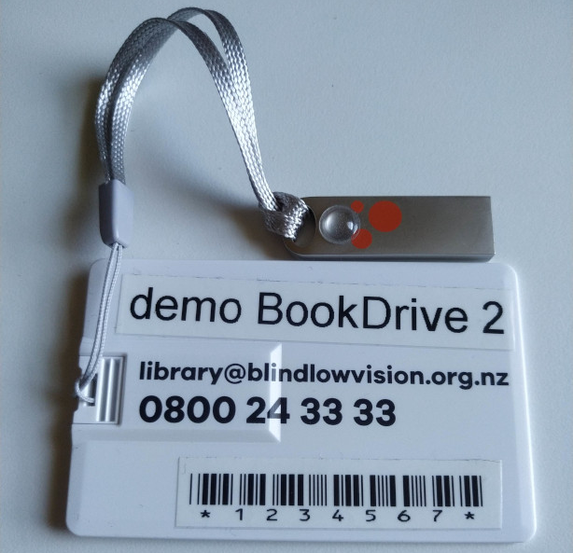
The metal BookDrive 2 is about 3.5 cm or 1 1/3 inches long by 1.2 cm or 1 ½ inches wide. It has a metal case and is smooth to the touch.
One side has a plastic bump. The other side is smooth.
One end has a rectangle shaped hole. This is the end that plugs into the Daisy player.
The other end is rounded and has a lanyard (cord) attached.
Running your fingers along the lanyard a plastic card is attached at the other end. It is similar to the original BookDrive. This card will have your member number and account on it. This is to ensure that when you have returned your BookDrive, we can make sure that the correct drive goes back to you. The lanyard and card will also make it easier for you to find your BookDrive should you need to remove it from your Daisy Player.

Reading from your BookDrive
To read from your BookDrive 2, insert the USB stick into the port on the DAISY player.
- Orient the BookDrive between your thumb and forefinger so that the plastic bump is facing up and the rectangular end is facing away from you.
- Finding the USB port:
First, position the DAISY player so the CD slot is facing towards you. Now feel along the left hand side of the player to find the USB port, which is the hole furthest away from you. The port is a horizontal rectangle shape, slightly larger than the thickness of the USB stick.

- Insert the USB stick into the port on the DAISY player.
The BookDrive will be resting with the bump-on side facing up, not down or side to side.
- Gently push the connector into the port until it feels sound. It will take the DAISY player 20-30 seconds to analyse the contents of your BookDrive.

- When it is ready to start reading, you will hear “USB DAISY Title: One.” The player will then read out the details of the first book on the drive.
- Use the arrow-shaped title select buttons at the front right of your player to move forward and back between the different books and magazines on your drive. Each title will have a sequential number, with any magazines coming after your 50 books.
- If you take the drive out of your player, and put it back in later to continue reading, it will resume playback from where you left off, just like a compact disc.
- All of the controls on the player work with BookDrive the same as with a CD, including forward and back buttons, volume, tone, and reading speed.
- If you have magazines on your BookDrive as well as books, you can go backwards from the first book to check your magazines first. When you hear the player say, “DAISY Title: One”, press the title back button (left pointing arrow) to go straight to your last magazine.

Returning your BookDrive
When you have finished with the books you are reading, you need to return your BookDrive to the Library to get more books and magazines. Please note that you can be allocated one new BookDrive (50 titles) each month.

To return your BookDrive
- Gently remove the USB stick from the DAISY player with your thumb and forefinger / index finger. Don’t pull on the lanyard to take it out.
- Place the BookDrive with the lanyard and card back into the cardboard mailer that it came in. Make sure you fold the back flap into the slit on the back of the mailer to keep it shut. Pop the mailer into the nearest NZ post box or Postshop. There is no charge for return postage.

- When we receive your BookDrive we will load the next allocation of talking books and magazines for you and send it back.

Hints, tips and advice
- If you don’t want to go without talking books or magazines when you’re returning your BookDrive, please call us on 0800 24 33 33 at least one week before post it back. We can then set up and send out your next allocation of books, so that the new BookDrive will arrive in plenty of time.

- If your BookDrive is faulty, or breaks, please give us a call to arrange a replacement, and return of the faulty drive if possible. There is no charge for replacements.

- If you would like to change your magazine subscriptions, update your subject selections, or request a particular book or series of books by an author, please call us on 0800 24 33 33 so we can add your requests to your next BookDrive delivery.

Need help or answers?
If you have any other questions, or need help with BookDrive, please call us on 0800 24 33 33, from 8:30am – 5pm, Monday to Friday.

This is the end of the document.

